The Krebs Cycle
The Krebs cycle (also known as the citric acid cycle or the tricarboxylic acid cycle) is a sequence of oxidation reactions that convert acetyl-CoA into CO₂. It is called a cycle because it begins with the condensation of oxaloacetate with acetyl-CoA and ends with the regeneration of oxaloacetate. The nine reactions of the cycle can be grouped into three main stages: preparation, energy release, and regeneration (Fig. ).

1. Preparation Stage
This stage consists of three reactions: Acetyl-CoA condenses with oxaloacetate to form citric acid (citrate). The next two reactions involve the rearrangement of the hydroxyl (–OH) group of citrate, resulting in the formation of isocitric acid (isocitrate).

2. Energy Release Stage
This stage includes four reactions: The first reaction releases two electrons that reduce NAD⁺ to NADH + H⁺, accompanied by the elimination of one molecule of CO₂ (a decarboxylation reaction) and the formation of α-ketoglutarate. α-Ketoglutarate then undergoes oxidative decarboxylation to produce a compound that combines with coenzyme A to form succinyl-CoA. This reaction also generates one molecule of NADH + H⁺. The high-energy bond of succinyl-CoA is cleaved, releasing one molecule of GTP and forming succinic acid (succinate). Succinic acid is then oxidized to form fumaric acid (fumarate), during which one molecule of FAD is reduced to FADH₂.

3. Regeneration Stage
The final stage of the cycle occurs through two reactions: One molecule of water is added to fumaric acid to form malic acid (malate). This molecule is then oxidized to oxaloacetate.
The oxidation reaction also releases two electrons that reduce NAD⁺ to NADH + H⁺.
With the regeneration of oxaloacetate, the cycle can start again with the incorporation of another acetyl-CoA molecule. The presence of oxaloacetate is therefore essential for the initiation of the cycle.
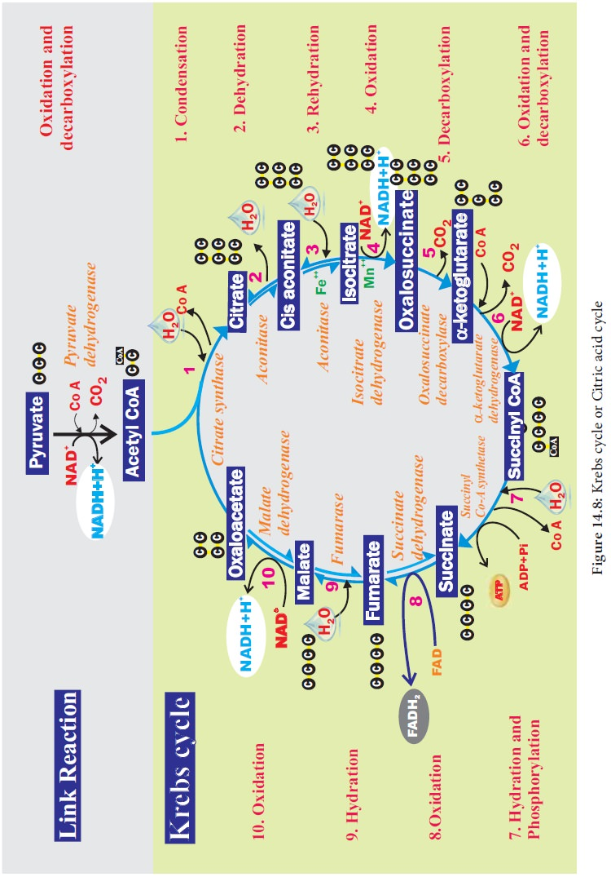
Overall equation of the Krebs cycle:
Acetyl-CoA+3 NAD++FAD+GDP+Pi+2 H2O→2 CO2+3 NADH+3 H++FADH2+GTP+CoA−SH

The Amphibolic Nature of the Krebs Cycle
The Krebs cycle functions not only in the direction of catabolism, serving as the terminal oxidative pathway for nutrient degradation, but also in the direction of anabolism, since many of its intermediates (such as α-ketoglutarate, oxaloacetate, and succinyl-CoA) act as precursors for the synthesis of a wide variety of cellular metabolites (including amino acids, porphyrins, and other essential biomolecules) (Fig. ).
This dual catabolic and anabolic role gives the Krebs cycle its amphibolic character.
However, if these intermediates are continuously withdrawn from the cycle for biosynthetic purposes, the cycle could come to a halt if oxaloacetate is not regenerated. To compensate for such losses, anaplerotic reactions take place; they replenish the cycle with intermediate compounds required for its proper operation. These anaplerotic reactions are particularly important in organisms that grow on simple carbon compounds (C₁ and C₂) or on substrates metabolized through such simple compounds, ensuring the continuity of both energy production and biosynthetic metabolism.

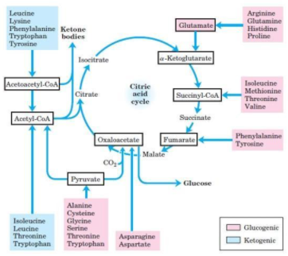

Accessory Cycles and Gluconeogenesis
During growth on glucose, this compound serves as a carbon source for the synthesis of all molecules containing glucose, ribose, deoxyribose, or other sugar derivatives. In this case, anaplerotic reactions primarily function to replenish the intermediates of the Krebs cycle. During growth on lactate, pyruvate, acetate, glyoxylate, or other carbon compounds, additional metabolic pathways are required — not only to maintain the operation of the Krebs cycle but also to provide the intermediate products necessary for sugar biosynthesis, i.e., gluconeogenesis.

1. Glucose as a substrate
The most important anaplerotic reactions for replenishing the intermediates of the Krebs cycle are the carboxylation of pyruvate and phosphoenolpyruvate (PEP) into oxaloacetate.
These reactions occur in animals, plants, and microorganisms, catalyzed respectively by the enzymes pyruvate carboxylase and phosphoenolpyruvate carboxylase.
Pyruvate+CO2+ATP→Oxaloacetate+ADP+Pi
Both reactions are essentially irreversible and play a crucial role in maintaining the pool of oxaloacetate necessary for the Krebs cycle and gluconeogenesis.

2. Lactate, pyruvate, and other C₃ compounds as substrates
In animal tissues, pyruvate is first carboxylated into oxaloacetate by pyruvate carboxylase.
This reaction is immediately followed by the decarboxylation and phosphorylation of oxaloacetate by phosphoenolpyruvate carboxykinase (PEPCK) to form phosphoenolpyruvate (PEP):
Oxaloacetate+GTP→PEP+CO2+GDP
In Escherichia coli and other bacteria, pyruvate can be directly phosphorylated by PEP synthase, according to the reaction:
Pyruvate+ATP+H2O→PEP+AMP+Pi
The synthesis of oxaloacetate in these organisms is catalyzed by PEP carboxylase, since E. coli does not possess pyruvate carboxylase.
Some microorganisms, such as Propionibacterium, Acetobacter aceti, Entamoeba histolytica, and Fusobacterium, contain another enzyme, pyruvate orthophosphate dikinase, which catalyzes the reversible interconversion between pyruvate and PEP:
Pyruvate+ATP+Pi⇌PEP+AMP+PPi

3. Acetate as a substrate — The Glyoxylate Cycle
Microorganisms capable of growing on acetate or on compounds catabolized to acetate (such as fatty acids or hydrocarbons) utilize the glyoxylate cycle (also known as the Krebs–Kornberg cycle) (Fig. ).
This cycle bypasses the two decarboxylation steps of the Krebs cycle, allowing the conversion of acetyl-CoA into four-carbon intermediates (such as succinate and malate) that can be used for gluconeogenesis.
The key enzymes unique to this pathway are isocitrate lyase and malate synthase, which enable the net synthesis of carbohydrates from two-carbon compounds.
Figure: glyoxylate cycle

The glyoxylate cycle exists only in plants and microorganisms.
It is used specifically for the biosynthesis of carbohydrates from fatty acids, as observed in germinating seeds and in microbes growing on acetate.
Animals, however, cannot perform such a synthesis from acetate because the two carbon atoms of acetyl-CoA are completely oxidized to CO₂ through the Krebs cycle.
The glyoxylate cycle bypasses (or shunts) the decarboxylation steps of the Krebs cycle, thereby allowing the net conservation of carbon for carbohydrate formation.

Key Enzymes and Reactions
This anaplerotic sequence involves two key enzymes that are absent in animals:
- Isocitrate lyase
- Malate synthase
The reactions catalyzed by these enzymes are as follows:
- Isocitrate lyase cleaves isocitrate into succinate and glyoxylate:
Isocitrate→Succinate+Glyoxylate
Malate synthase catalyzes the condensation of glyoxylate with acetyl-CoA to form malate:
Glyoxylate+Acetyl-CoA+H2O→Malate+CoA−SH
The malate produced is then oxidized to oxaloacetate, which can subsequently be converted to pyruvate and then used in gluconeogenesis to synthesize sugars.

Overall Net Reaction
The overall balance of the glyoxylate cycle can be summarized as:
2 Acetyl-CoA+NAD++2 H2O→Succinate+2 CoA−SH+NADH+H+
This process enables the conversion of acetyl-CoA (derived from fatty acid β-oxidation) into four-carbon intermediates that serve as precursors for carbohydrate synthesis.

Physiological Significance
In higher plants and microorganisms, both the Krebs and glyoxylate cycles can function simultaneously:
- The Krebs cycle provides energy (ATP, NADH, FADH₂).
- The glyoxylate cycle supplies pyruvate and other precursors necessary for the formation of carbohydrates from fatty acids.
This dual operation allows these organisms to maintain metabolic flexibility, especially during periods when carbohydrates are scarce but lipid reserves are available — such as in germinating oil seeds or bacteria utilizing acetate as the sole carbon source.

