Practical Work 02

Biochemical Identification of Bacteria Using Differential Media

Objectives
- To identify bacterial metabolic characteristics using biochemical tests.
- To learn how to inoculate and interpret results from differential media.
- To understand the role of each medium component in bacterial growth and metabolism.
Used media:
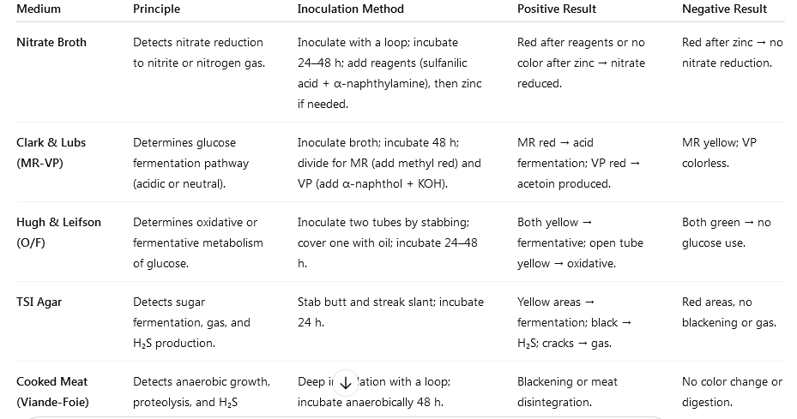

Student Method
- Label all test tubes with the bacterial strain code.
- Inoculate the following media using sterile technique:
  - Nitrate broth
  - Clark and Lubs broth (MR-VP)
  - Hugh and Leifson (O/F)
  - TSI agar
  - Cooked meat (Viande-Foie) medium
- Incubate at the appropriate temperature (usually 30–37 °C for 24–48 h).
- After incubation, perform the required color indicator tests and observe results (next practical work )
- Record all observations carefully (next practical work).

Rapport:
Complete the table and write the expected result for each test.
Example:
TSI : Yellow slant and butt indicate sugar fermentation.

