Third directed work of biochemistry
Structure and physicochemical properties of carbohydrates

Exercise1 : Indicate which of these statements is (are) correct
Question 1 : Amylopectin and glycogen are:
- linear polymers.
- both of plant origin.
- polymers containing the same types of bonds.
- of plant and animal origin respectively.
Question 2 : Concerning the physicochemical properties of carbohydrates:
- The sugars are crystallized with ethanol.
- Sugars exhibit absorption in the visible.
- Ribose is a ketopentose.
Exercise 2: β-fructosidase hydrolyzes sucrose: α D-Glucopyranosyl (1-2) β-D-Fructofuranoside
- Write the equation for the hydrolysis reaction by giving the structural formulas of the compounds.
Exercice 3: Write the structural formula of lactose: β -D-galactopyranosyl 1-4 D-glucopyranose
Exercise 4: Identify the 2 sugars that are part of the composition of this disaccharide.
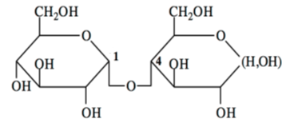

- Give the chemical name of this disaccharide accounting for the 2 sugars involved, the shape of their cycle and the types of bonds between the carbohydrates.

