Second directed work of biochemistry
Structure and physicochemical properties of carbohydrates

Exercise1 : Indicate which of these statements is (are) correct
Question 1 : Concerning the cyclic structure of sugars:
- The ring is formed by a bond in the sugar molecule between two carbonyl functions.
- The pyranic form corresponds to a hererocycle with 6 vertices.
- Anomeric OH gives rise to carbon number 1 in the case of ketosis.
Question 2 : Concerning the carbohydrates :
- 20% of calories provided by the human diet are carbohydrates.
- Two sugars having the same number of carbons and the same chemical form, but diﬀering in the stereoisomeric conﬁguration of their carbons are called enantiomers.
- Ribose is a ketopentose.
Exercise 2: Give the cyclic form and the names of the compounds above. (α anomer, pyran form for compound 1 and β anomer, furan form for compounds 2 and 3).
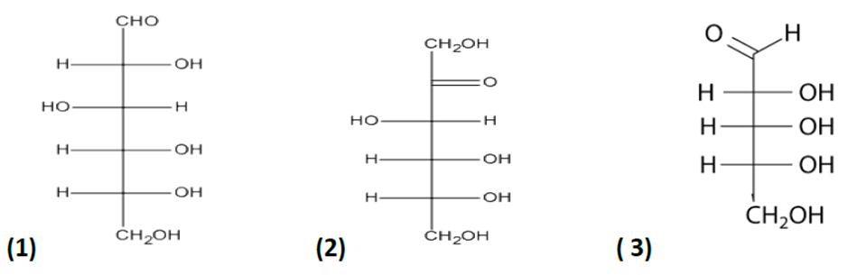
Exercice 3: Consider the following carbohydrates:
Carbohydrate A : α-D-Glucopyranosyl (1-2) β-D-Fructofuranoside;
Carbohydrate B : β-D-Galactopyranosyl (1-4) D-Glucopyranose.
Give their formulas in the cyclic representation.

