Chapter III: Carbohydrate Catabolism
There are several ways to convert glucose into three-carbon (C3) compounds such as pyruvate, which is one of the most important intermediates in metabolism. The most common degradation pathway is glycolysis (also known as the fructose biphosphate pathway or the Embden-Meyerhof-Parnas pathway). Another sequence of reactions that can occur in many living organisms is the pentose phosphate pathway (also called the hexose monophosphate shunt, phosphogluconate pathway, or Warburg-Dickens-Horecker pathway).
The third glucose degradation pathway is the Entner-Doudoroff pathway (or the 2-keto-3-deoxy-6-phosphogluconate – KDPG pathway). This pathway is found only in some Gram-negative bacteria, such as Pseudomonas, Rhizobium, and Agrobacterium.
Table 2: Contribution of different pathways to hexose catabolism (%) in some microorganisms

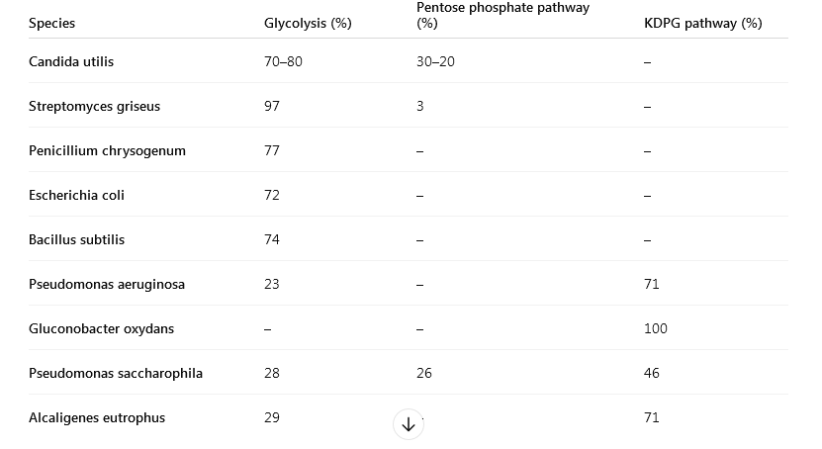

1- Glycolysis
Glycolysis is an anaerobic pathway consisting of ten reactions organized into four main stages: Activation, Cleavage, Oxidation, ATP generation.

a. Activation stage
This stage involves the phosphorylation of a glucose molecule. The first ATP molecule is consumed to form glucose-6-phosphate (G6P). Two additional reactions convert G6P into fructose diphosphate, and a second ATP molecule is used during the third reaction of this stage.

b. Cleavage stage
The fructose diphosphate is split into two three-carbon compounds:
- phosphoglyceraldehyde (3-PGA),
- and dihydroxyacetone phosphate (DHAP).
The DHAP molecule is enzymatically converted into a second molecule of 3-PGA.

c. Oxidation stage
This stage involves the removal of two electrons and two protons. The electrons and one proton are captured by NAD⁺, forming NADH, while the second proton is released into the cellular environment. The oxidation of 3-PGA leads to the formation of a high-energy phosphorylated compound, which will later be used for ATP generation.

d. ATP Generation Stage
The final stage of glycolysis, known as the ATP generation stage, consists of four reactions that convert the oxidation product into pyruvate. During this stage, two molecules of ATP are produced. In terms of energy balance, the net gain is two molecules of ATP, since each molecule of glucose is split into two molecules of 3-phosphoglyceraldehyde (3-PGA).


Thus, the final outcome of glycolysis is a net gain of 2 ATP per molecule of glucose.
Although glycolysis is not highly efficient in terms of energy production, it provides essential intermediate molecules that serve as building blocks for biosynthesis in both prokaryotic and eukaryotic cells. Nevertheless, the energy produced is crucial during fermentative processes, where glycolysis is the main source of ATP. All glycolytic reactions are reversible, except for three irreversible steps catalyzed by the enzymes: hexokinase, phosphofructokinase, and pyruvate kinase.

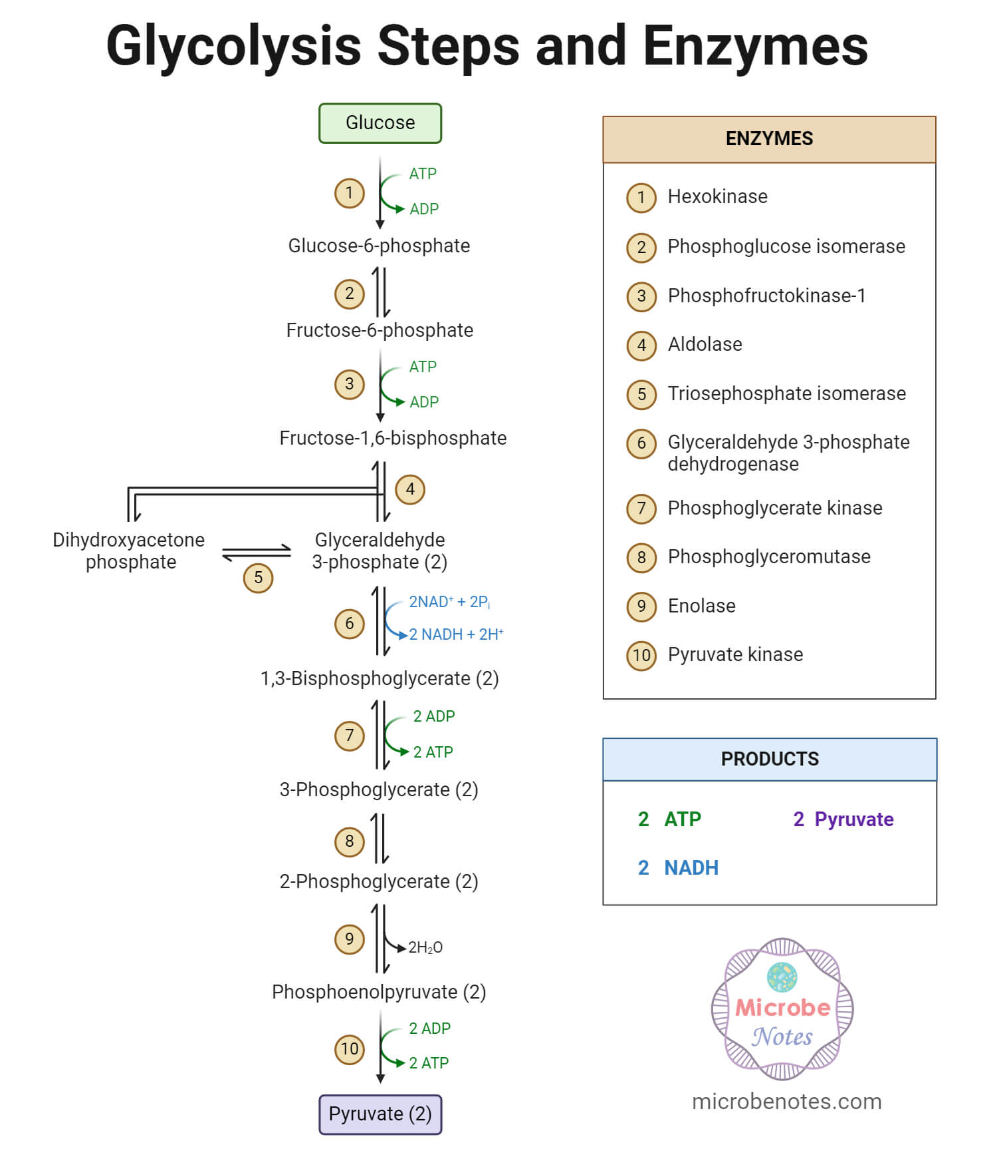
Figure: different stages of glycolysis

2- The Pentose Phosphate Pathway
The pentose phosphate pathway consists of two major stages: an oxidative stage starting from glucose-6-phosphate (G6P), and an interconversion stage in which pentose phosphates are converted into hexose phosphates and vice versa. Together, these two processes form a metabolic cycle (Fig. 2).

a. Oxidative Stage
Glucose-6-phosphate (G6P) is dehydrogenated to form 6-phosphogluconolactone, with the production of one molecule of NADPH₂.
The 6-phosphogluconolactone is then hydrolyzed to 6-phosphogluconate, which undergoes oxidative decarboxylation (producing another NADPH₂) to yield ribulose-5-phosphate.

b. Interconversion Stage
Ribulose-5-phosphate is in equilibrium with two other compounds:
- ribose-5-phosphate, and
- xylulose-5-phosphate.
These pentose phosphates can be transformed, through the action of the enzymes transketolase and transaldolase, into fructose phosphate and 3-phosphoglyceraldehyde (3-PGA) molecules.
As a result, one complete cycle converts three molecules of G6P into two molecules of F6P and one molecule of 3-PGA, with the formation of three molecules of CO₂ and six molecules of NADPH₂ (3 × 2 NADPH₂).

c. Metabolic Role
The pentose phosphate pathway is a secondary pathway to glycolysis, whose main function is to: provide essential precursors (pentose phosphates, erythrose phosphate, and 3-PGA), and produce NADPH₂, required for various biosynthetic reactions. Ribose-5-phosphate is indispensable for the synthesis of nucleic acids and nucleotides. Ribulose monophosphate is involved in the formaldehyde fixation cycle in methylotrophic bacteria, while ribulose diphosphate plays a key role in the CO₂ fixation cycle (Calvin cycle).
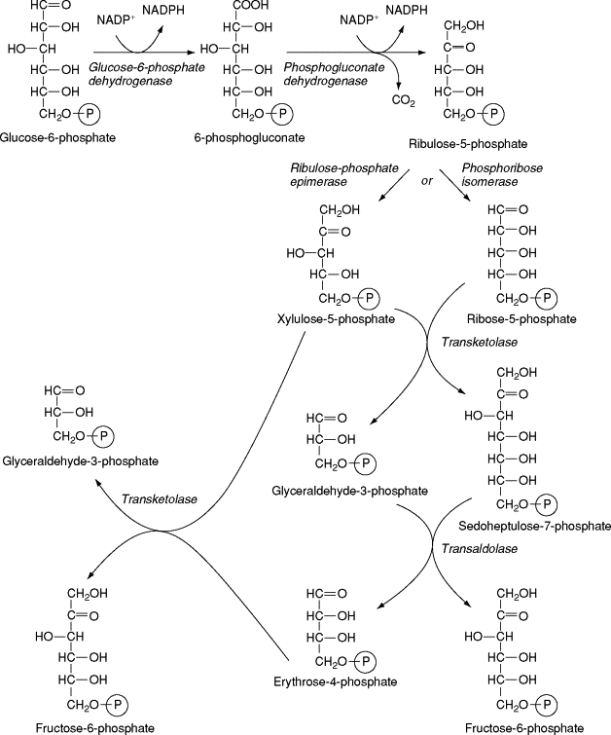

Figure. The pentose phosphate pathway. Glucose-6-phosphate dehydrogenase, phosphogluconate dehydrogenase, ribulose phosphate epimerase, phosphoribose isomerase, transketolase, transaldolase.
The 2-Keto 3-Deoxy 6-Phosphogluconate (KDPG) Pathway
G6P is first dehydrogenated into 6-phosphogluconate (as in the pentose phosphate pathway). The elimination of a water molecule leads to the formation of 2-keto 3-deoxy 6-phosphogluconate, which is then cleaved by a specific aldolase into pyruvate and 3-PGA. The 3-PGA can, of course, be further oxidized to pyruvate via glycolysis (Fig. 3).

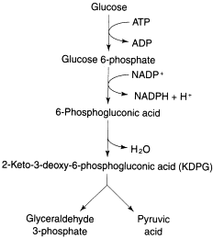

Figure3 . The Entner–Doudoroff pathway of glucose catabolism in aerobic and anaerobic Gram-negative bacteria.
Oxidation Of Pyruvate
Pyruvate constitutes the center of intermediate metabolism and can be converted into several anabolic products. In many organisms, pyruvate produced by catabolic reactions is mainly oxidized to acetyl-CoA. In bacteria, three reactions predominate:
(1) pyruvate + CoA + NAD⁺ → acetyl-CoA + NADH + H⁺ + CO₂
(2) pyruvate + CoA + 2Fd⁻ → acetyl-CoA + 2FdH + CO₂
(3) pyruvate + CoA → acetyl-CoA + formate
Reaction 1 is catalyzed by a multienzyme complex, pyruvate dehydrogenase. It is present in all aerobic organisms and mainly serves for the formation of acetyl-CoA to enter the Krebs cycle.
Reaction 2 is catalyzed by pyruvate:ferredoxin oxidoreductase, which plays a major role in many anaerobic bacteria such as Clostridia.
Reaction 3 is catalyzed by pyruvate:formate lyase. It is found in several anaerobic bacteria producing formate, especially in Enterobacteriaceae, but also in phototrophic organisms.
Yeasts and some bacteria excreting ethanol possess a fourth enzyme (pyruvate decarboxylase) that cleaves pyruvate into acetaldehyde and CO₂.
(4) pyruvate → acetaldehyde + CO₂
The acetaldehyde is then reduced to ethanol.

