Chaptre 2: Energetique Metabolism Of Microorganisms

1/ Trophic Types
The concepts “heterotrophic” and “autotrophic”, established to distinguish the nutritional modes of plants and animals, are insufficient to characterize the highly diverse nutritional types of microorganisms. Current designations refer instead to the source of energy, the hydrogen donor (source of reducing power or electron donor), and the carbon source. To transform nutrients and build their living matter, microorganisms must obtain energy.
This is, of course, chemical energy, which is stored in the cells essentially in the form of ATP.
Energy can originate from two modes of transformation:
• transformation of light energy into chemical energy (phototrophs or photosynthetic organisms);
• or transformation of chemical energy into chemical energy (chemotrophs).
Organisms that use organic compounds as their electron source are called organotrophs.
Those capable of using inorganic compounds such as NH₃, H₂S, S, CO₂, Fe²⁺, etc., as their electron source, are called lithotrophs.
Table 1: Microbial trophic types
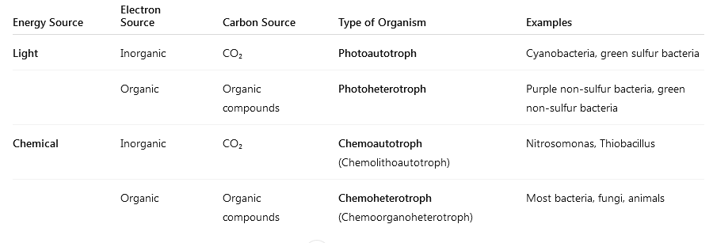

2/ Autotrophic And Heterotrophic Concepts
The concepts “autotrophic” and “heterotrophic” have a restricted meaning and refer only to the carbon source. Microorganisms are autotrophic if they can obtain most of their cellular carbon through CO₂ fixation. They are heterotrophic if they obtain their cellular carbon through the assimilation of organic compounds. Mixotrophs can assimilate either mineral or organic carbon while using the same metabolic characteristics.
Prokaryotes are the only representatives of the chemolithotrophic and photoorganotrophic types of energetic metabolism. It should be noted from the outset that this classification does not correspond to taxonomy and that many bacteria are capable of exhibiting two or even three types of metabolism depending on the conditions in which they occur.

3/ Types Of Respiration
The oxidation of organic compounds involves the transfer of electrons. Electrons are transferred from an electron donor to an electron acceptor. In oxidation reactions, substrates are usually accompanied by the simultaneous loss of hydrogen from the substrate. This type of oxidation is called dehydrogenation.
The following terms are used as synonyms: hydrogen donor and electron donor, hydrogen acceptor and electron acceptor; oxidation and dehydrogenation; reduction and hydrogenation.
The enzymes that transfer hydrogen atoms are dehydrogenases. They transfer hydrogen to NAD or NADP.
Reduced substrate+NAD+→Oxidized substrate+NADH+H+
Example:
Lactate+NAD+→Pyruvate+NADH+H+
• Oxidation = Dehydrogenation (lactate loses H)
• Reduction = Hydrogenation (NAD⁺ gains H)

Depending on the nature of the final electron acceptor, three different situations can be encountered: aerobic respiration, anaerobic respiration, and fermentation.
If the final electron acceptor is molecular oxygen (O₂), the metabolism is aerobic, during which electrons pass along a transport chain located in a membrane — the respiratory chain (also known as the oxidative phosphorylation chain).
The resulting energy (38 ATP from glucose) is stored in the form of an electrochemical gradient between the two sides of the membrane and will be converted into ATP and reduced NAD (NADP).
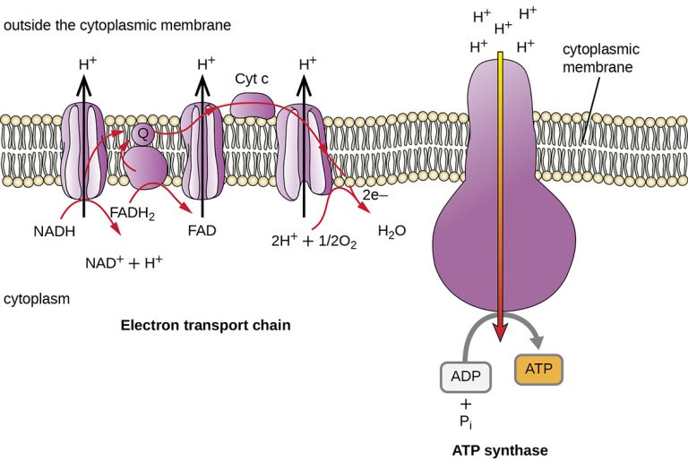
Fig.02: The bacterial electron transport chain is a series of protein complexes, electron carriers, and ion pumps that is used to pump H⁺ out of the bacterial cytoplasm into the extracellular space. H⁺ flows back down the electrochemical gradient into the bacterial cytoplasm through ATP synthase, providing the energy for ATP production by oxidative phosphorylation.

Overall reaction of glucose oxidation
C6H12O6+6O2→6CO2+6H2O+Energy (38 ATP)
Simplified energy coupling
- Electron transport and proton gradient formation
NADH+H++12O2→NAD++H2O+Energy (proton gradient)
- ATP synthesis using the gradient
ADP+Pi+Energy (H+ gradient)→ATP+H2O
Under anaerobic conditions, that is, in the absence of oxygen, anaerobic respiration and fermentation occur. In anaerobic respiration, microorganisms produce energy without oxygen (O₂). Instead of O₂, they use other molecules (like nitrate, sulfate, or iron) as final electron acceptors to release energy (ATP). The process allows them to survive and grow in oxygen-free environments such as soil, sediments, and the gut.
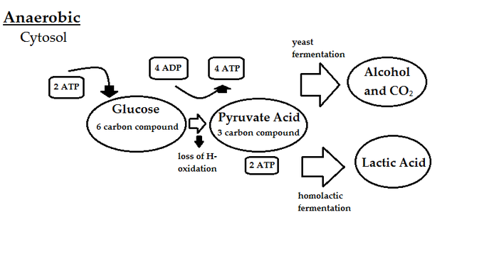
If the final electron acceptor is not oxygen but ions such as nitrate, sulfate, carbonate, or sulfide, for example, this is referred to as anaerobic respiration (nitrate respiration, sulfate respiration, etc.). It also involves the functioning of an electron transport chain containing cytochromes.
The microorganisms involved are facultative anaerobes or strict anaerobes. These include nitrate reducers, denitrifiers, sulfate reducers, sulfide reducers, methanogens, and acetogens.
Bacteria capable of performing anaerobic respiration with inorganic electron acceptors play an extremely important role in nature.

1. Nitrate Reduction and Denitrification
Bacteria use nitrate (NO₃⁻) instead of oxygen to accept electrons.
This process releases nitrogen gas (N₂) into the air.
2 NO₃⁻ + 10 e⁻ + 12 H⁺ → N₂ + 6 H₂O
NO₃⁻ (nitrate) is reduced step-by-step to N₂ (nitrogen gas). Electrons (e⁻) come from the oxidation of organic compounds (like glucose). Protons (H⁺) combine with oxygen from nitrate to form water (H₂O). This process is important in nature — it removes nitrates from soil and water (used in the nitrogen cycle). Example bacteria: Pseudomonas, Paracoccus.

2. Sulfate Reduction
Bacteria use sulfate (SO₄²⁻) as the final electron acceptor, producing hydrogen sulfide (H₂S) the gas that smells like rotten eggs.
SO₄²⁻ + 8 H⁺ + 8 e⁻ → H₂S + 4 H₂O
Sulfate acts as the electron acceptor. Electrons come from organic molecules (like lactate) or hydrogen gas (H₂). The result is H₂S, which is toxic but common in sediments and animal intestines. This process happens deep in mud or oxygen-free marine zones. Example bacteria: Desulfovibrio, Desulfotomaculum.

3. Acetogenesis
Some bacteria use CO₂ as the electron acceptor and H₂ as the donor to make acetic acid (CH₃COOH).
2 CO₂ + 4 H₂ → CH₃COOH + 2 H₂O
CO₂ is reduced to acetate (CH₃COOH). H₂ gives the electrons for the reduction. This process is part of the carbon cycle, helping recycle CO₂ in anaerobic environments. Example bacteria: Acetobacterium woodii.

4. Iron Reduction
Some bacteria use ferric iron (Fe³⁺) as an electron acceptor, reducing it to ferrous iron (Fe²⁺).
Fe³⁺ + e⁻ → Fe²⁺
Example with acetate as donor:
CH₃COO⁻ + 8 Fe³⁺ + 4 H₂O → 2 HCO₃⁻ + 8 Fe²⁺ + 9 H⁺
These bacteria oxidize organic matter (like acetate) and use Fe³⁺ to accept electrons. The process helps remove toxic metals and pollutants from soil and groundwater (bioremediation).Example bacteria: Geobacter, Shewanella.

5. Manganese Reduction

Manganese dioxide (MnO₂) is reduced to Mn²⁺ in some anaerobic environments.
MnO₂ + 4 H⁺ + 2 e⁻ → Mn²⁺ + 2 H₂O
Manganese acts as the electron acceptor instead of oxygen. Found in sediments, deep water, and soils where oxygen is absent. Example bacteria: soil Bacillus, Shewanella.

6. Organic Electron Acceptors
Some bacteria can also use organic molecules as their final electron acceptors.

a. Fumarate Reduction
Fumarate + 2 H⁺ + 2 e⁻ → Succinate
Fumarate is reduced to succinate — part of the anaerobic respiration of E. coli when oxygen is absent.

b. Trimethylamine N-oxide (TMAO) Reduction
TMAO + 2 H⁺ + 2 e⁻ → Trimethylamine (TMA) + H₂O
Marine bacteria use TMAO as an electron acceptor; TMA gives a “fishy” smell.

c. Dimethyl Sulfoxide (DMSO) Reduction
DMSO + 2 H⁺ + 2 e⁻ → Dimethyl Sulfide (DMS) + H₂O
Some bacteria use DMSO as an electron acceptor and produce DMS, a gas released from oceans that affects cloud formation.
If the electron acceptor is an organic compound, this corresponds to an anaerobic organic metabolism or fermentation (“life without air”). In fermentations, organic compounds act as both electron donors and electron acceptors.
There is no electron transport, and ATP is generated by substrate-level phosphorylation.
However, the energy yield is minimal.
Several fermentative microorganisms are strict anaerobes, while others are facultative anaerobes. In the latter, oxygen inhibits fermentation in favor of aerobic respiration.

