PW 1: Esterification (synthesis of aspirin)
- Introduction
Esterification is a chemical reaction that forms an ester from an alcohol and a carboxylic acid. The reaction typically involves the following steps:
a. Reactants: An alcohol (R-OH) and a carboxylic acid (R'-COOH).
b. Condensation Reaction: During the reaction, a water molecule (H₂O) is eliminated.
c. Catalysis: The reaction often requires an acid catalyst (like sulfuric acid) to proceed more efficiently.
As applications, esters are commonly found in fats, oils, used in many fragrances also, in many medications like aspirin. This multi-use chemical product, is one of the most used medicines, it’s good for body pain, it reducing inflammations, decreasing fever and more other remediations.
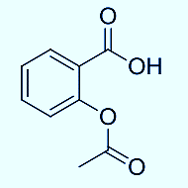
The first scientist to prepare aspirin was Felix Hoffmann, a chemist at Bayer, in 1897. He synthesized acetylsalicylic acid, the active ingredient in aspirin, while looking for a less irritating form of salicylic acid for his father, who suffered from rheumatism. Bayer subsequently patented the compound, and it was marketed under the name "Aspirin." Actually, Aspirin is prepared industrially throw a reaction between acetic acid anhydride and salicylic acid.
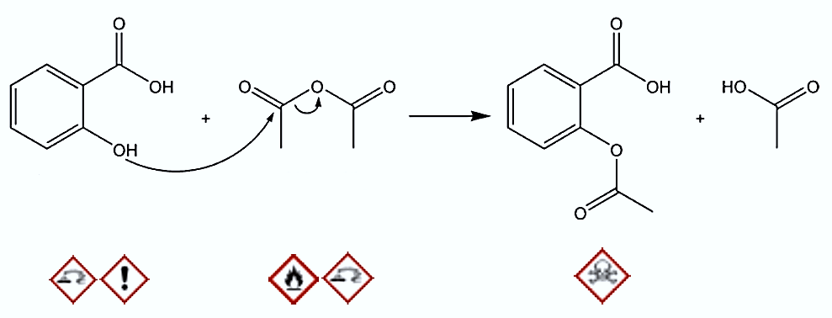
- Objectives of the manipulation
- Discover the reaction of esterification
- Perform the synthesis of aspirin in the laboratory.
- Purify the obtained product and identify it.
- Calculate the reaction yield.
- Equipment and chemicals
Equipment | Chemicals
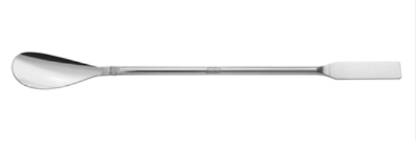  Spatula | Salicylic acid
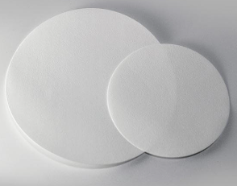  Filter paper | Acetic anhydride
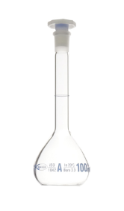  Vial | Concentered Sulfuric acid
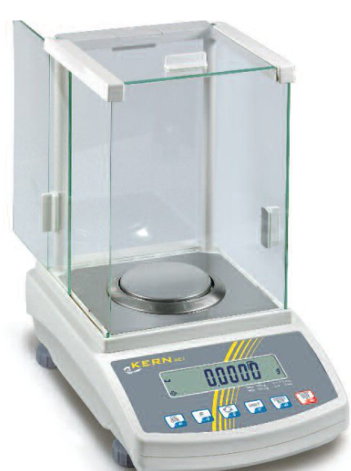  Balance | Iced distilled water
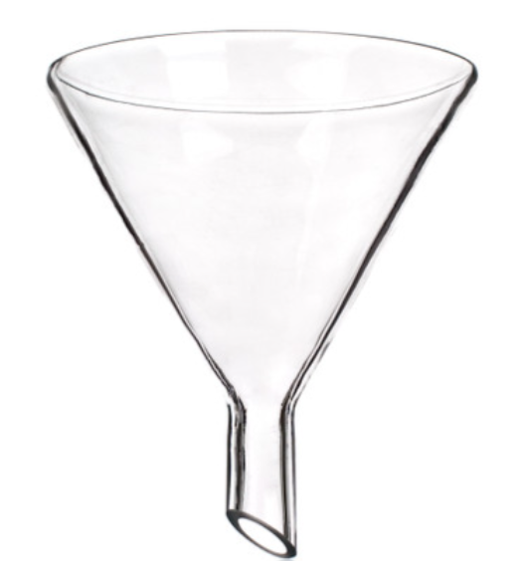
Funnel
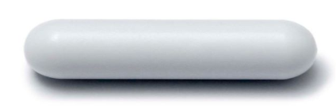
Magnetic bar
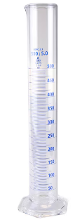
Graduated cylindre
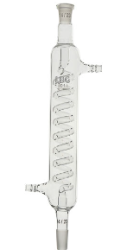
Refrigerant
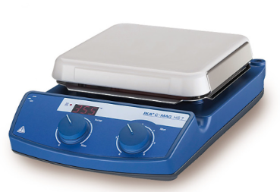
Heating magnetic stirrer
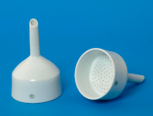
Büchner
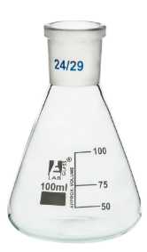
100ml Erlenmeyer

- Operating mode

- Before start the experiment, place water in the crystallizer and heat it moderately such as keeping the temperature between 50°C and 60°C during the experiment.
- Check the temperature of the water bath continuously with the electronic thermometer, provide cold water to add to the crystallizer if the temperature is too high.
- Into a very dry double neck flask, insert a magnetic bar.
- Add 2.5 g of salicylic acid and close the double neck flask.
- Under the extractor hood, gently and carefully and by using graduated cylinder, measure 5mL of acetic anhydride and then introduce it into the double neck flask.
- Add a few (3 to 4) drops of concentrated sulfuric acid (H₂SO₄) and close the double neck flask.
- Place the double neck flask in the water bath and immediately top it with the water condenser then circulate water.
- Maintain the water bath between 50°C and 60°C with magnetic stirring for 10 minutes approximately. After this, stop the heating by removing the crystallizer. Don't stop the circulation of cold water in the refrigerant.
- Pour immediately and in small quantities, from the top of the refrigerant, approximately 30 mL of distilled water, in order to destroy excess ethanolic anhydride by hydrolysis.
- Pull apart the refrigerant, stop the water circulation, remove the double neck flask from the assembly and close it.
- Cool the mixture by placing the double neck flask in an ice water bath. Add 30 mL of ice-cold distilled water and shake.
- Filter the contents of the double neck flask using a Büchner.
- Rinse the double neck flask with cold distilled water and pour this water over the Büchner in order to carry away the entire product.
- Collect the powder in a cup, previously weighed. Weigh the crystals obtained.

- Questions
- Give a general description of esterification reaction.
- give the brute formula of the reactants and the products.
- what’s the purpose of using a dry glassware?
- what’s the purpose of adding sulfuric acid?
- why could the final product have washed with cold water?
- Is it possible to replace acetic anhydride by acetic acid?
- Calculate the yield of this reaction.

