- Snow effect on buildings

- Introduction
The aim of the present section is to determine the snow action on the building according to the Algerian Regulatory Technical Document (D.T.R. C 2 - 4.7). Consequently, the representative values of the static load of snow on any surface located above ground and subjected to the accumulation of snow, mainly on the roofs, will be discussed.
- Calculations of snow loads
- Load of snow on ground
A statistical evaluation of maximum annual heights of snow observed in a day has allowed to calculate the heights of snow for a period of concurrent period of 50 years. The determination of loads of snow on ground from the calculated heights has been obtained by taking the density of snow equal to 1 kN/m³. It is to be noted that the density of snow is variable. Generally, it increases with the duration of exposure of snow and depends on the location of site, its climate and its altitude. However, the characteristic load of snow on the ground S_{k} per unit area is taken according to (D.T.R. C 2 - 4.7) by the laws of following variation according to the altitude H and the zone to be considered.
Zone A $S_{K}=\frac{(0.07×H)+15}{100}$
Zone B $S_{K}=\frac{(0.04×H)+10}{100}$
Zone C $S_{K}=\frac{(0.0325×H)}{100}$
Zone D No snow load in this region
Another characteristic value which is the main representative value, the other representative values entering in different combinations of actions are described as follows:
- The combination value equal to ψ₀.S_{k} with ψ₀ = 0.6;
- The frequent value equal to ψ₁.S_{k} with ψ₁ = 0.6;
- The quasi-permanent value is equal to ψ₂.S_{k} with ψ₂ = 0.6;
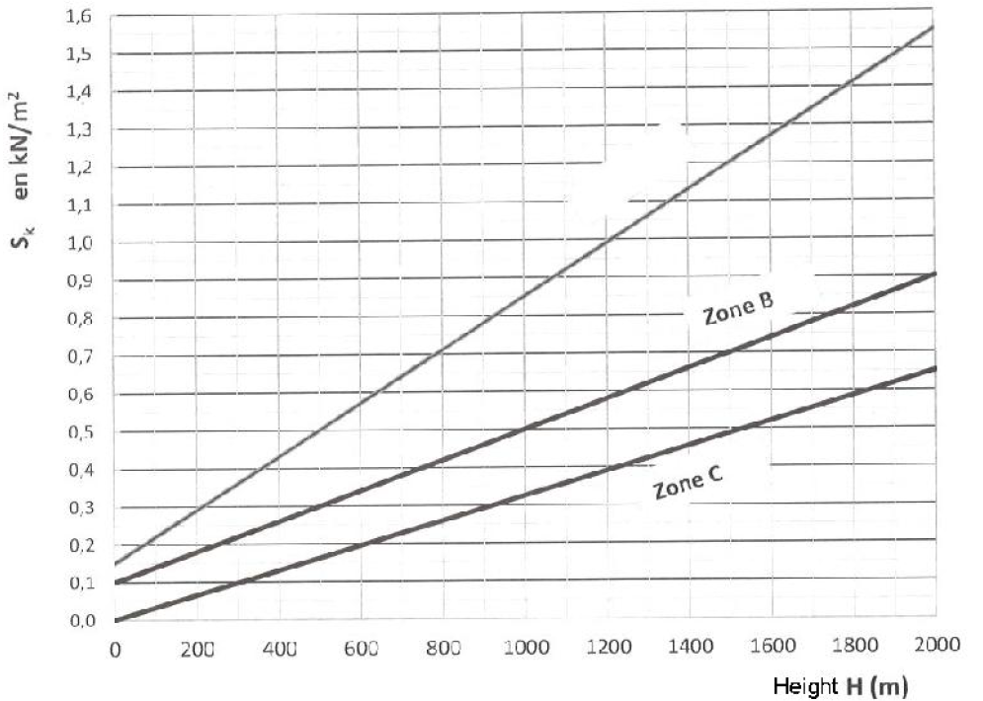
Figure III - 1 : Snow loads function of altitude and zone

- Load of snow on roofs
The characteristic load of snow S per unit area on horizontal surface of roofs or any other area submitted to the accumulation of snow is obtained by the following formula:
$$S=μS_{K} kN/m^{2}$$
Where:
$S_{K}$ (in kN/m²) is the load of snow on ground according to altitude and area of snow.
$μ$ is the coefficient of regulation of loads, according to the roof form and called coefficient of form.
- Sloping Roofs
Roofs with simple and two slopes
The coefficients of form of side roofs and/or with tow slopes without obstacle retaining the snow, (the snow is supposed to fall freely) are given in table 1. In the case where a side of the roof ends in an obstacle to retain snow, as guard rails, snow barrier or others, the coefficient of form of roof cannot be reduced to a value less than 0.8.

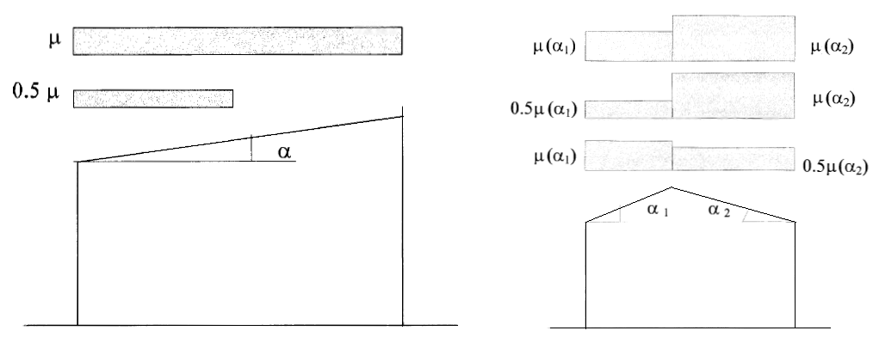
Figure III - 2: Form coefficient for Roofs with simple and two slopes
The arrangements of loads to be taken into account are those producing the most unfavorable effects among the case of figure (III - 2).
Table III - 1: Form coefficient for roofs with simple and two slopes
Sloping angle with reference to horizontal | 0 < α < 30° | 30° < α < 60° | α $≥$ 60°
$$μ$$ | 0.8 | $$0.8×\left(\frac{60- α}{30}\right)$$ | 0
Roofs with multiple slopes (angle of slope less than 60°)
The coefficients of form of roofs with multiple slopes (figure III - 3) are given by the table (III - 2). The arrangements of load to be considered are represented on same figure and corresponding to the case (i) without accumulation of snow and the case (ii) with accumulation of load.

Table III - 2: Coefficients of forms – Roofs with multiple slopes
Sloping angle with reference to horizontal | 0 < α < 30° | 30° < α < 60° | α $≥$ 60°
$$μ_{1}$$ | 0.8 | $$0.8×\left(\frac{60- α}{30}\right)$$ | 0
$$μ_{2}$$ | $$0.8+0.8×\left(\frac{α}{30}\right)$$ | 1.6 | -

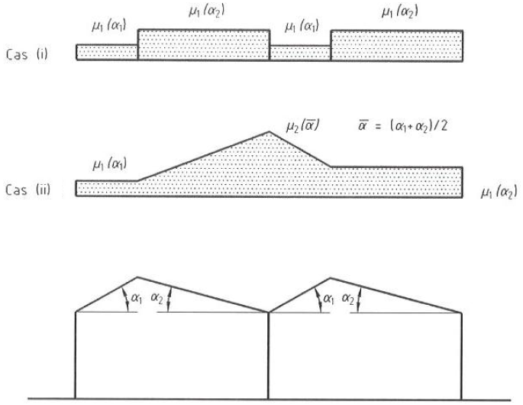
Uneven roofs (in sheds)
Figure III - 3: Coefficients of form: Roofs with multiple slopes
The coefficients of form applicable to valleys of multiple roofs when one or two slopes show a slope higher than 60°. For the external slopes, the values of μ are, if it is necessary, those corresponding to roofs with multiple slopes.
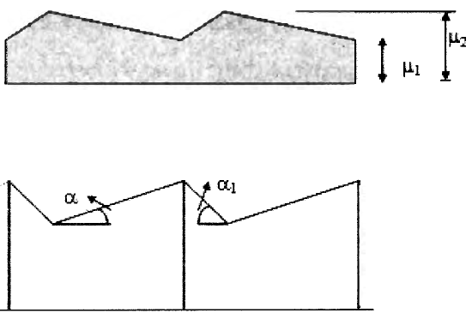
Figure III - 4: Form coefficients of roofs with valleys

Table III - 3: Form coefficients of roofs with valleys
Sloping angle with reference to horizontal | 0 < α < 30° | 30° < α < 45° | α $≥$ 45°
$$μ_{1}$$ | 0.8 | $$0.8+0.8×\left(\frac{α}{30}\right)$$ | Particular analysis is required according to the basics phenomena.
$$μ_{2}$$ | $$0.8×\left(\frac{60- α}{30}\right)$$ | 1.6

- Cylindrical roofs
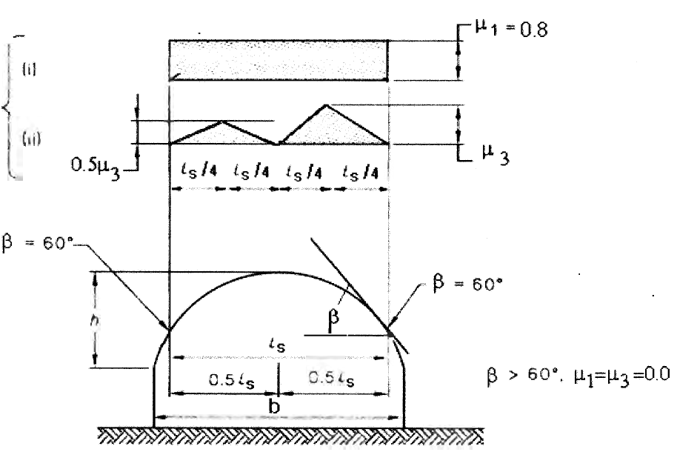
In the case of cylindrical roofs not having obstacles to snow, it is better to consider the case of loads illustrated in figure (III – 5). The distribution of load to be retained is that producing the most unfavorable effects. The cylindrical roofs include all those where the curve, uniform or not, is not alternated.
Figure III - 5: Form coefficient for Cylindrical roofs
The coefficient of forms is calculated as follows:
In case of $β≤60°$ $μ_{1}=0.8$ and $μ_{3}=0.2+10h/b$ with $μ_{3}≤2.0$
In case of $β>60°$ $μ_{1}=$ $μ_{3}=0$
- Roofs showing discontinuities of marked levels
In the case of discontinuity of marked level, the uniform or asymmetric loads of snow described for roofs with simple and two slopes, or the accumulated load illustrated in figure (III - 6) must be considered. The arrangements of loads to be retained being those producing the most unfavorable effects.
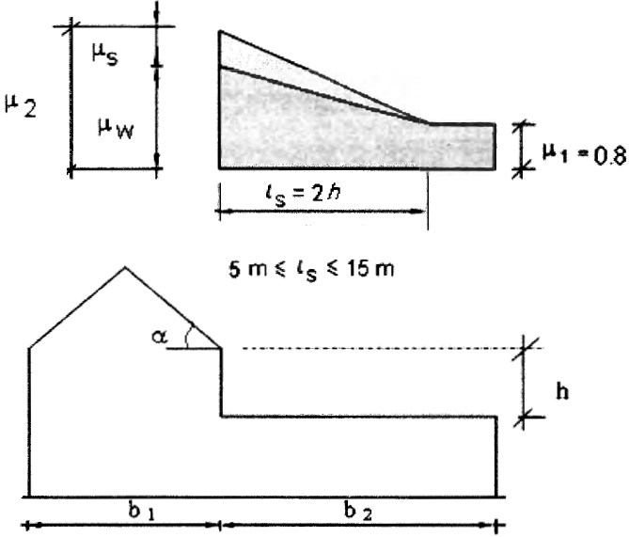
Figure III - 6: Coefficient of form – Discontinuities of marked levels

The accumulation of snow on the roofs at several levels results in moving of snow by the wind and sliding of snow from the higher roof. The coefficients of form are determined as follows:
$$μ_{1}=0.8$$
$$μ_{2}=μ_{s}+μ_{w}$$
Where:
- $μ_{s}$ is the form coefficient of snow load due to sliding. It takes the following values:

For α ≤ 15° $μ_{s}$ = 0
For α > 15° $μ_{s}$ is determined by application of an additional load equal to 50% of the maximum snow load applied on the slope adjacent to the higher roof, calculated conforming to roofs with two slopes section.
- $μ_{w}$ is the form coefficient of snow load due to wind. It takes the following values:
$μ_{w}=min⁡\left[\left(b_{1}+b_{2}\right)/2h ; γh/S_{k}\right]$ with $0.8{≤μ}_{w}≤4.0$
In wish:
$γ \left(kN/m^{3}\right)$ is the density of the snow taken as 2$kN/m^{3}$
$b_{1}$,$b_{2}$ , $h$ in (mm) and $S_{k}$ $\left(kN/m^{3}\right)$ is the load characteristic of the snow on ground.
The length of snowdrift ls (in mm) is equal to l_{s} = 2h with the limitation 5 m ≤ l_{s} ≤ 15m. If b₂ < l_{s}, the coefficient in edge of lower roof is determined by interpolation between μ₁ and μ₂ and the extremity of snow load is shortened along the lowest part of the roof b₂.
- Accumulation at right of projections and obstacles
The accumulations of snow can be produced in case of wind over the whole roof having obstacles; these create the zones of aerodynamic shadows which result in accumulation (see figure III - 7). It suits to adopt the following values for the coefficients of form of length l_{s}.
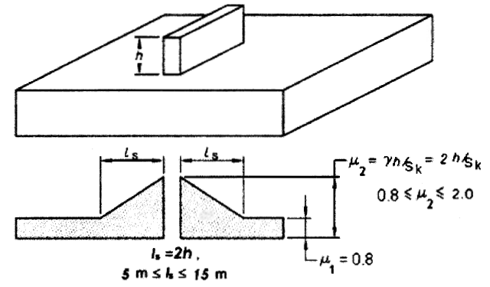
Figure III - 7: Form coefficients at right of projections and obstacles

$$μ_{1}=0.8$$
$μ_{2}= γh/S_{k}$ with $0.8{≤μ}_{2}≤2.0$
$l_{s}=2h$ with $5m{≤l}_{s}≤15m$
$γ \left(kN/m^{3}\right)$ is the density of the snow taken as 2$kN/m^{3}$and $S_{k}$ $\left(kN/m^{3}\right)$ is the load characteristic of the snow on ground.
- Load of snow on the obstacles
The obstacles such as chimneys, barrier to snow, guard-rails, parapets, or others must be checked under the action of a force Fs due to sliding of a mass of snow on the roof. This force acting in the direction of this sliding per unit of width is given by the following formula and on the assumption of a coefficient of friction between the snow and the roof as equal to zero.:
$F_{s}=S×b×sin{α}$ (kN/m)
Where:
S (in kN/m² ) is the load of snow on the roof in the case of load without accumulation and the most heavy corresponding to the area of the roof on which the snow can slide.
b (in m) is the distance, measured horizontally, between the bar of snow or the obstacle and the following bar or ridge beam of roof.
$α$ (in degree) is the angle at side of roof.
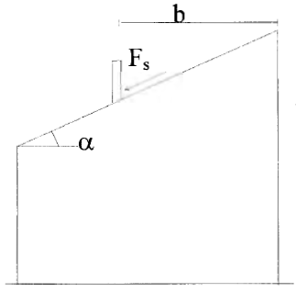
Figure III - 8: Forces acting on the obstacles

- Snow dangling at the edge of roof
In the constructions located at altitudes higher than 1000M, the design of parts of roof above the walls of the façade must take the suspended snow along into account, in addition to the load of snow on this part of roof. The suspended load is supposed to be applied at the edge of roof and is determined as follows:
$S_{c}=\frac{{K×S}^{2}}{γ}$ (kN/ml)
Where:
S_{c} (in kN/m) is the load of suspended snow, per linear meter.
S (in kN/m²) is the load of snow for the case in the most severe non-accumulated load for the considered roof.
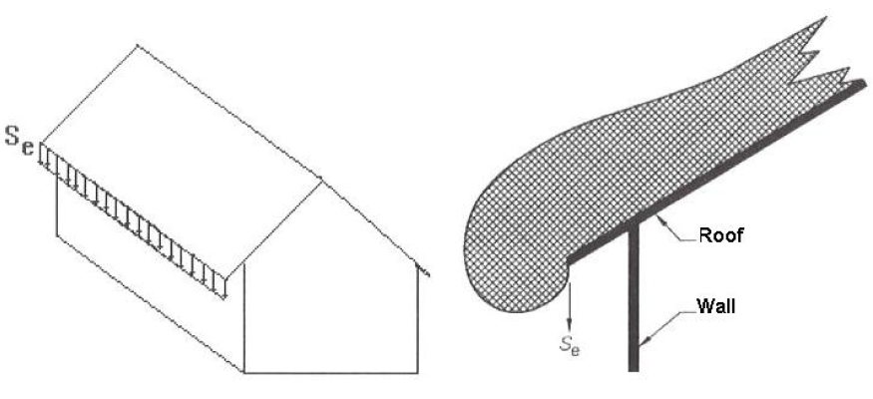
K is a coefficient taking the irregularity of the form of snow into account. it must be taken as equal to 2.5.
Figure III - 9: Snow suspended at edge of roof
$γ \left(kN/m^{3}\right)$ is the density of the snow taken as 3$kN/m^{3}$.
- Sand loads in zone ‘D’ of Algeria
Algerian Regulatory Technical Document (D.T.R. C 2 - 4.7) establishes the nominal load of sand on the roofs of constructions situated in the zone ‘D’ of the sand chart of Algeria. These sand loads are resulting from the accumulation of sand grains deposited by wind on the roofs or other parts not covered by floors. The values of the loads given below are considered as snow load variable.
- Action of sand load
- Flat roofs or with slight slopes
In the case of flat roof or with slight slope (slopes less than 5%) the sand load must be taken into account as uniform distributed load (table III - 4).

- Rampant roofs
In the case of rampant terraces and inclined roofs (one or several slopes, roof in shed, arches and domes, etc.) it is necessary to consider a localized linear load along the lower edges of slopes or at the start of arches and domes (figure III - 10).
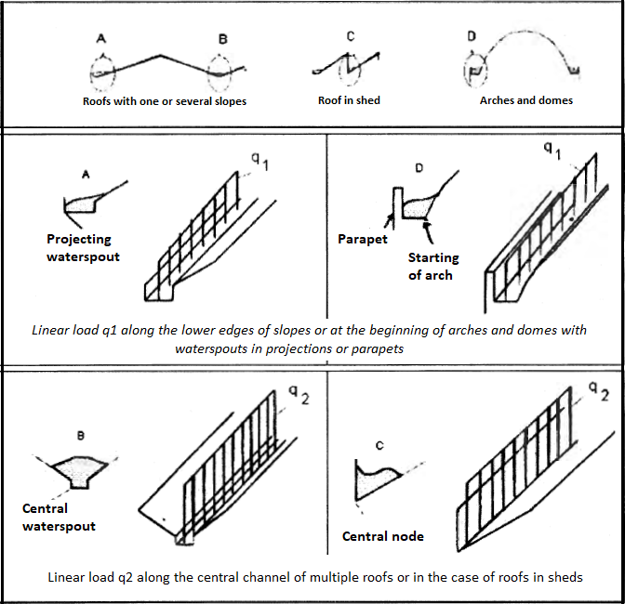
The values of loads q₁ and q₂ (in kN/ml) to be taken for calculations are given in table (III - 4) according to the location to be considered.
Figure III - 10 : Linear Loads taken in case of rampant and inclined roofs

Table III - 4: Sand load in zone D af Algeria.
Wilaya | Town | uniform sand load  (kN/m²) | q₁  (kN/ml) | q₂  (kN/ml)
Adrar | Adrar  Timimoun | 0.2 | 0.3 | 0.4
Adrar | Reggane  Aoulef  Bourdj Badji Moukhtar | 0.15 | 0.25 | 0.35
Laghouat | Laghouat  Hassi R’mel  Ain Madhi  Sidi Makhlouf  Ksar El-Hiran | 0.15 | 0.20 | 0.30
Laghouat | Aflou  Brida  Gueltet Sidi Saad  Oued Merra+El Ghicha | Zone C
Bechar | Bechar  Abadla  Kenadsa  Beni-Ounnif | 0.15 | 0.25 | 0.35
Bechar | Beni-Abbes  Igli  Tabelbala  Ouled khedir  Kerzaz  El-Ouata  Taghit | 0.20 | 0.30 | 0.40
Tamenghasset | Tamenghasset  Silet  Tazrouk | 0.10 | 0.20 | 0.30
Tamenghasset | Ain-salah  In-Ghar  In-Guezzam  Tin-Zaouatine | 0.20 | 0.30 | 0.35
Ouargla | Ouargla  Tougourt | 0.20 | 0.30 | 0.40
Ouargla | The rest town of Ouargla | 0.25 | 0.30 | 0.50
Illizi | Illizi | 0.15 | 0.25 | 0.35
Illizi | In-Amenas | 0.20 | 0.30 | 0.40
Illizi | Djanet  Bourdj-El-Houass  Debdeb  Bordj-Omar-Driss  Tarat | 0.10 | 0.20 | 0.30
Tindouf | Tindouf | 0.20 | 0.30 | 0.40
Tindouf | Oum-Laasel | 0.25 | 0.40 | 0.50
El-oued | Djemaa  M’gheier | 0.15 | 0.25 | 0.35
El-oued | The rest town of El-oued | 0.30 | 0.40 | 0.60
Ghardaia | Ghardaia  Zelfana  Metlili  Sebseb  Berriane  Guerara  Daia  Mensoura | 0.25 | 0.40 | 0.50
Ghardaia | El-menia  Hassi Lefhal  Hassi El-Gara | 0.25 | 0.40 | 0.50

- Actions of wind
- Introduction
The present part gives the general procedures and principles for the determinations of actions of wind on the group of buildings and constructions according to the Algerian Regulatory Technical Document (D.T.R. C 2 - 4.7) such as:
- Group of buildings (houses, administration, study, industrial, health, kitchen)
- Chimneys and similar works.
- Storage works (tanks, water tower, silos).
- Vertical and horizontal structures in trellis (columns, cranes, scaffolding, gangways).
- Signaling panels, surrounding walls and flags.
In case of Bridges, works at sea (off-shore platforms) or some special works (for example nuclear power plants) this DTR is not applicable directly.

- Terms associated with the wind speed
- Point Speed: the point speed is the quasi-instantaneous value of the speed of wind.
- Average speed: The average speed V_{m} of wind is the average speed in an interval of 10 minutes.
- Characteristic average speed: the characteristic average speed (or characteristic speed) is the characteristic value of the average speed of wind.
- Average reference speed: The average reference speed V_{ref} (or reference speed) is the characteristic value of the average wind speed measured under conventional conditions.
- Wind pressure: Each speed V corresponds to a wind pressure W: the pressure of wind can be positive (overpressure) or negative (depression, suction) representing the action of wind on a wall of construction.
- Critical speed: the critical speed of wind V_{crit} is the average speed of wind from which an additional dynamic effect can be produced.
- Direction of wind
The calculation must be done separately for each of the perpendicular directions at different walls of construction.
- For a rectangular construction, we consider the two directions of wind.
- For a circular construction, we consider a direction of wind.
- For a polygon, we consider as many directions as the sides. However, a regular polygon of more than six sides can be considered as a circular construction whose diameter is that of the confined circle.
- For the added constructions or in trellis, other directions are to be considered.

- Dynamic pressure of point
The dynamic pressure of point $q_{p}\left(Z_{e}\right)$ at the reference height $Z_{e}$ is given by:
$q_{p}\left(Z_{e}\right)=q_{ref}×C_{e}\left(Z_{e}\right) (N/m^{2})$
Where:
q_{ref} (in N/m²) is the dynamic pressure of reference given by the table (III-5) according to the wind zone.
C_{e} is the coefficient of exposure to wind.
Z_{e} (in m) is the reference height.

Zone | q_{ref} (N/m²)
I | 375
II | 435
III | 500
IV | 575
Table III - 5 : Values of dynamic pressure of reference

- Reference height Ze
The reference height, Z_{e}, for windward walls of rectangular plan buildings is determined as indicated by figure (III - 11).
For the leeward wall and sidewalls, Z_{e} is taken equal to the height of the building above ground level.
For the roofs, Z_{e} is taken equal to the maximum height of building.
For all other works, the reference height is equal to the maximum height of the element considered.
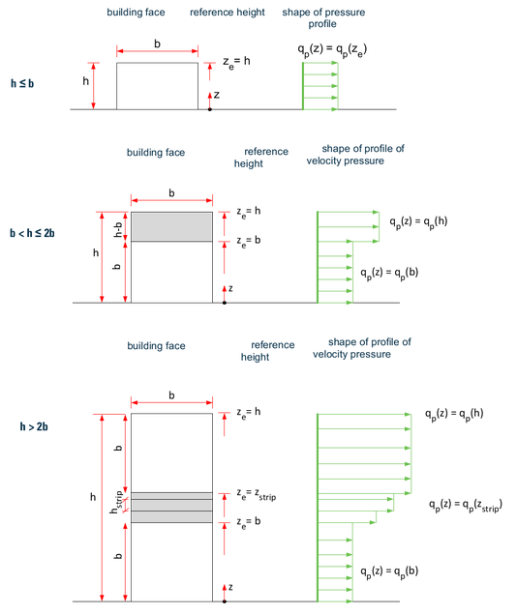
- Coefficient of exposure
Figure III - 11 : Reference height, Ze, depending on h and b.
The coefficient of exposure to wind $C_{e}\left(Z_{e}\right)$ takes account of effects of the terrain, the site topography and the height above ground. In other words, it takes account of turbulent nature of wind. However, the coefficient of exposure $C_{e}\left(Z_{e}\right)$ is given by:
$$C_{e}\left(Z_{e}\right)=C_{t}^{2}\left(Z_{e}\right)×C_{r}^{2}\left(Z_{e}\right)×\left[1+7 I_{V}\left(Z_{e}\right)\right]$$
Where:
- C_{r} is the coefficient of roughness.
- C_{t} is the coefficient of topography.
- I_{v}(Z_{e}) is the intensity of turbulence.
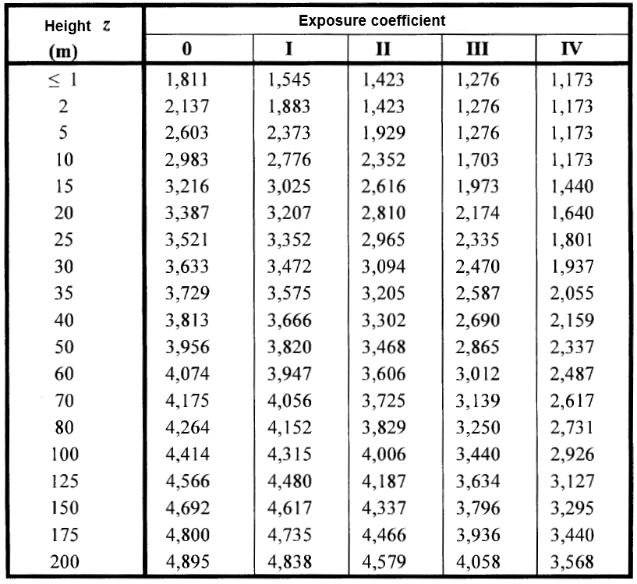
In case of topography coefficient $C_{t}\left(Z_{e}\right)=1$ the exposure coefficient can be directly obtained from the table (III - 6) below:
Table III - 6 : Value of exposure coefficient for case of Ct (Ze) = 1

- Categories of terrain and roughness coefficient
The categories of terrain are given in the table (III - 7) as well as the following parameters:
- K_{T} factor of terrain.
- Z₀ (in m), parameter of roughness.
- Z_{min} (in m), minimum height.
- ε coefficient used for the calculation of coefficient C_{d}.
Table III - 7 : Description of the terrain categories
Zone | Description | K_{T} | Z₀ | Z_{min} | ε
0 | Sea or coastal area exposed to the open sea | 0.156 | 0.003 | 1 | 0.38
I | Lakes or flat and horizontal area with negligible vegetation and without obstacles | 0.170 | 0.01 | 1 | 0.44
II | Area with low vegetation such as grass and isolated obstacles (trees, buildings) with separations of at least 20 obstacle heights | 0.190 | 0.05 | 2 | 0.52
III | Area with regular cover of vegetation or buildings or with isolated obstacles with separations of maximum 20 obstacle heights (such as villages, suburban terrain, permanent forest) | 0.215 | 0.3 | 5 | 0.61
IV | Area in which at least 15 % of the surface is covered with buildings and their average height exceeds 15 m | 0.234 | 1 | 10 | 0.67

The values of coefficient of roughness are given by table (III - 8) according to the category of terrain and height.
Table III - 8 : Values of roughness coefficients (C_{r}) function of terrain categories and the height
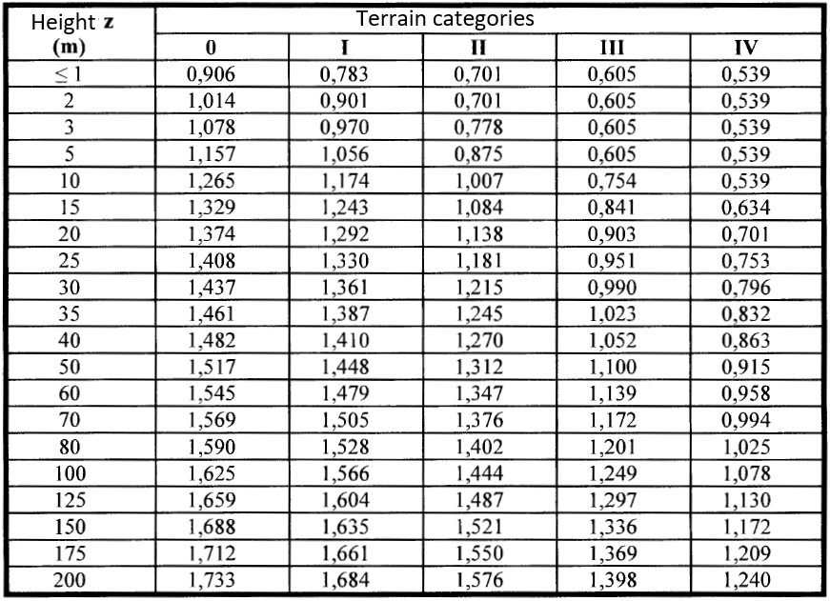
- Coefficient of topography
The coefficient of topography C_{t} (z) takes into account of the increase in wind speed when it blows over obstacles such as hills, isolated difference in heights as shown in figure (III - 12). The effect of topography is to be taken within the limits of the hatched zones.

$$\left\{\begin{matrix}C_{t}\left(Z_{e}\right)=1 for ∅<0.05 \\ C_{t}\left(Z_{e}\right)=1+S_{max}×\left(1-\frac{\left|x\right|}{k_{red}×L}\right)×e^{-∝(Z/L)} for ∅≥0.05\end{matrix}\right.$$

Where:
$∅$ is the slope of up wind ($∅=H/L$)
$H$ is the height of the slope in m.
$L$ (in m) is the characteristic length of the up wind and taking its value as: Max (0.5 L_{u} ; 2H).
$x$ (in m) is the horizontal distance between the place considered and the peak of the obstacle;
$Z$ (in m) is the vertical distance measured from the ground level of the place considered.
$S_{max}$ , $k_{red}$ and $∝$ are coefficients given in DTR according to the obstacle form and the reference H/L.
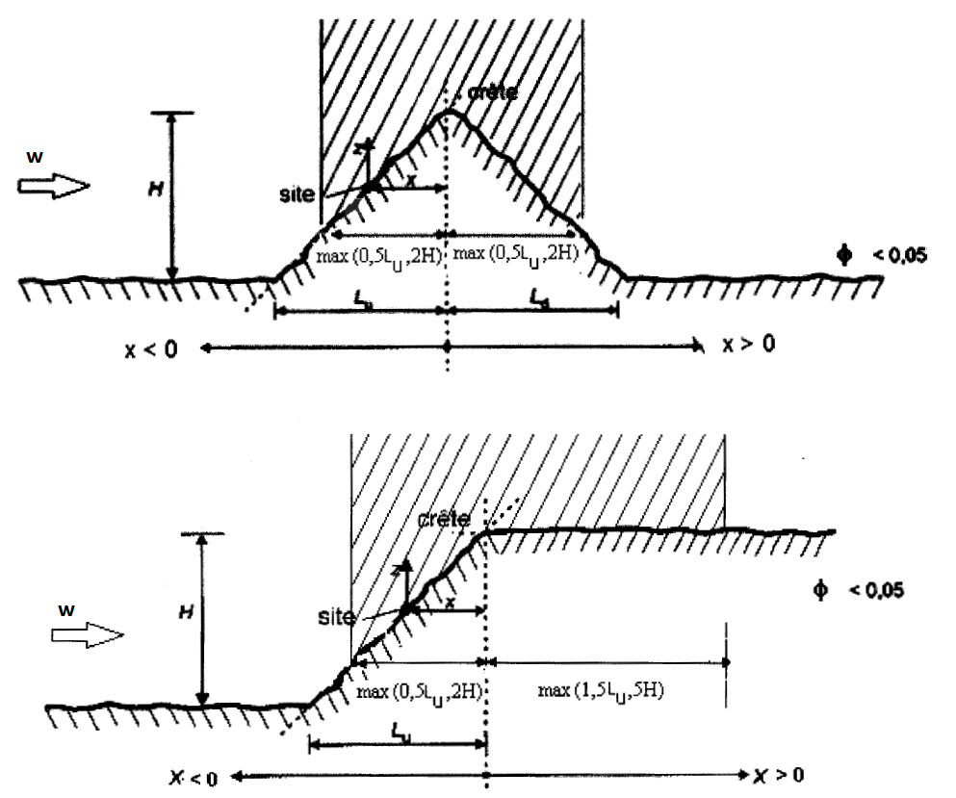
Figure III - 12 : Wind obstacles and the associated parameters
The terms $(S_{max})$ , $\left(1-\frac{\left|x\right|}{k_{red}×L}\right)$ and $(e^{-∝\left(\frac{Z}{L}\right)})$ can be obtained from table (III - 9) as function of ($H/L$), ($x/L$) and ($Z/L$).
Table III - 9 : Values of topography coefficient terms
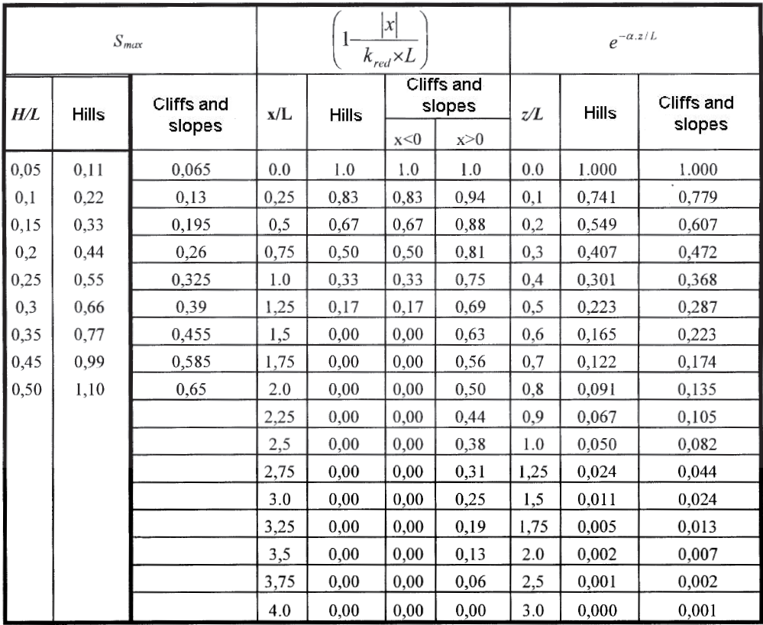
- Intensity of turbulence
The intensity of turbulence is defined as being the deviating type of turbulence divided by the average speed of wind and is given by the following equation:
$$\left\{\begin{matrix}I_{v}\left(Z_{e}\right)=\frac{1}{C_{t}\left(Z_{e}\right)×Ln\left(\frac{Z}{Z_{0}}\right)} for Z>Z_{min} \\ I_{v}\left(Z_{e}\right)=\frac{1}{C_{t}\left(Z_{e}\right)×Ln\left(\frac{Z_{min}}{Z_{0}}\right)} for Z≤Z_{min}\end{matrix}\right.$$
Where:
- $C_{t}\left(Z_{e}\right)$ is the topography coefficient.
- Z₀ (in m), parameter of roughness (Table III - 7).
- Z_{min} (in m), minimum height (Table III - 7).
- Calculation of wind pressure
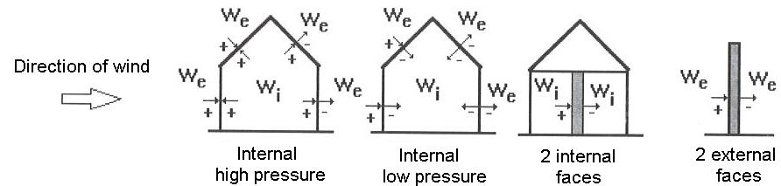
The pressures, W_{e} and W_{i} (pressure on the external face and internal faces respectively) are taken positive if they represent a high pressure and negative in low pressure case. W represents the pressures by the vectors perpendicular to the walls. If the vector is oriented towards the wall so the pressure is high, otherwise it is a low pressure (see figure III - 13).
Figure III - 13: Pressures conventions

- Determination of aerodynamic pressure
The aerodynamic pressure W(z_{j}) acting on a wall can be obtained by the following formulae:
- If a face of the wall is inside a construction and the other is outside, then:
$$W\left(Z_{j}\right)=q_{p}\left(Z_{e}\right) ×\left[C_{pe}-C_{pi}\right] \left[N/m^{2}\right]$$
- If the two faces of the wall are outside (case of isolated elements such as isolated roofs, balconies, etc.):
$$W\left(Z_{j}\right)=q_{p}\left(Z_{e}\right) ×C_{p.net} \left[N/m^{2}\right]$$
- If the two faces of the wall are inside the construction:
$$W\left(Z_{j}\right)=q_{p}\left(Z_{e}\right) ×\left[C_{pi,1}-C_{pi,2}\right] \left[N/m^{2}\right]$$

Where:
$q_{p}\left(Z_{e}\right)$ is the dynamic pressure of the point calculated at a height $\left(Z_{e}\right)$ related to the surface of the element j.
$C_{p.net}$ (note also C_{p} coefficient of pressure) is the coefficient of net pressure given in the following sections for certain elements of construction (isolated roofs, balconies, etc.);
$C_{pe}$ is the coefficient of external pressure.
$C_{pi}$ is the coefficient of internal pressure.

- Coefficients of external pressure
The coefficients of external pressure C_{pe} of constructions with rectangular base and their individual constitutive elements depending on the dimensions of the loaded areas. They are defined for the loaded area of 1 m² and 10 m², to which correspond the coefficients of pressure noted respectively C_{pe.1} and C_{pe.10}. The coefficients of external pressure C_{pe} can be obtained by the following formulae:
$$C_{pe}=C_{pe,1} if :S≤1 m^{2}$$
$$C_{pe}=C_{pe,1}+\left(C_{pe,10}-C_{pe,1}\right)×\log_{10}\left(S\right) if : {1 m}^{2}≤S≤10 m^{2}$$
$$C_{pe}=C_{pe,10} if :S≥10 m^{2}$$
Where (S) is the loaded area of the wall considered.
- Vertical walls
The wall in this case is can be divided as indicated in figure (III - 14). The values of C_{pe.1} and C_{pe.10} are given in the table (III - 10).
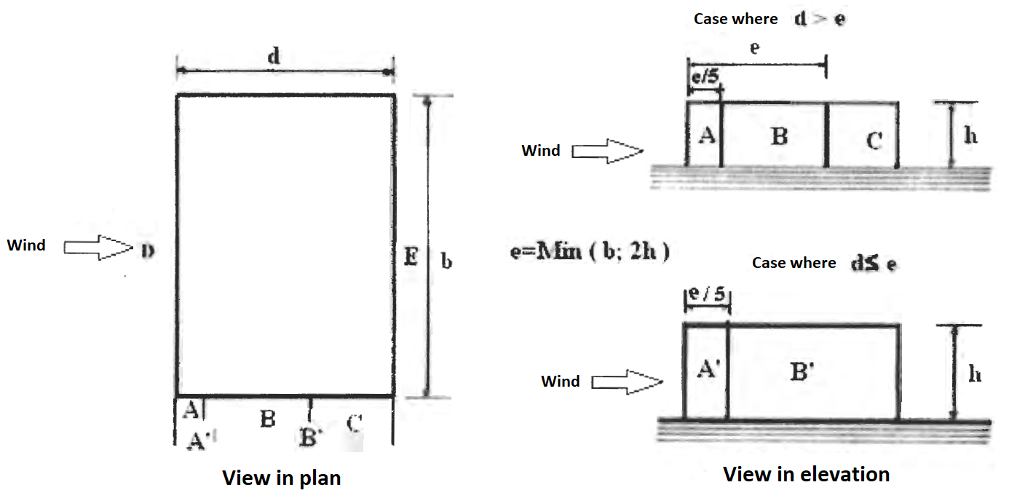
Figure III - 14 : Vertical wall division

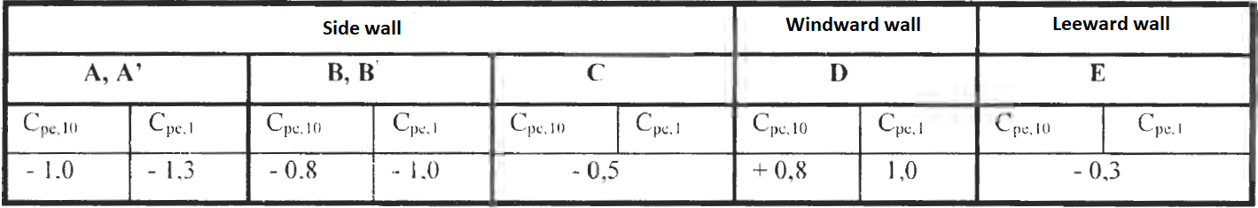
Table III - 10 : Cpe coefficients for vertical walls of constructions with rectangular base
- Flat roofs
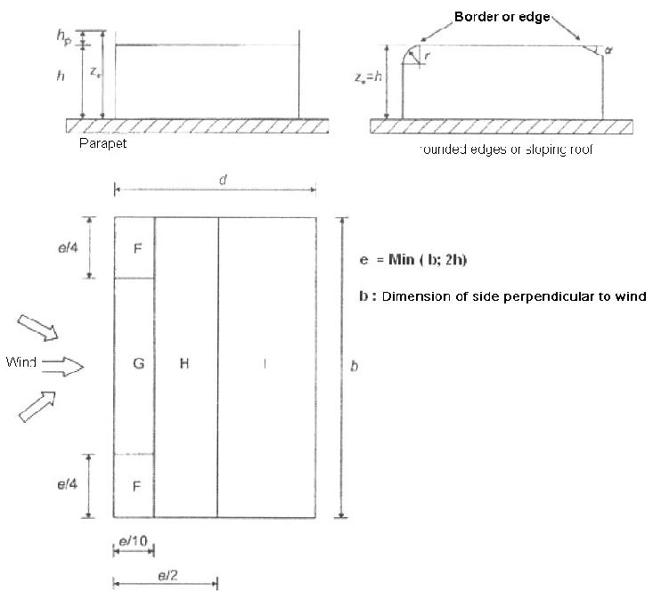
The flat roofs are those whose angle of slope is less than or equal to 5⁰. It is alright to divide the roof as indicated in figure (III - 15). The coefficients C_{pe.10} and C_{pe.1} are given in the table (III - 11).
Figure III - 15 : Flat roofs division
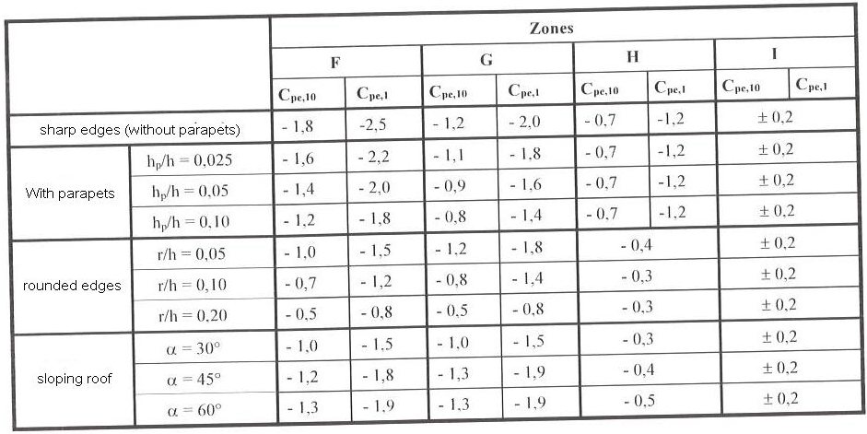
Notes :
Table III - 11 : The coefficients of external pressure for plat roofs
- For the roofs with parapets or rounded off edges, a linear interpretation can be made for the intermediate values of h_{p}/h and r/h;
- For the roofs with sloping roofs, the linear interpolation is admissible between α = 30⁰, 45⁰ and α = 60⁰. For α > 60⁰, the linear interpolation is made between the values of α = 60⁰ and those corresponding to the flat roofs with sharp edges;
- In zone I, where the indicated values are positive or negative, each of the values must be considered.

- Inclined roof with a slope
The direction of wind is defined by an angle θ (see figure III - 16):
- θ = 0⁰ correspond to a wind whose direction is perpendicular to factors and striking the lower edge of the roof (fig. III – 16 - a)
- θ = 180⁰ correspond to a wind whose direction is perpendicular to factors and striking the higher edge of the roof (fig. III – 16 - b).
- θ = 90⁰ correspond to a wind whose direction is parallel to factors (fig. III – 16 - c).
It suits to divide the roof as indicated in figure (III - 16). The coefficients C_{pe.10} and C_{pe.1} are given in tables (III – 12 and 13).
Table III - 12 : Coefficients of external pressure for roofs with a slope cases $θ$ = 0⁰ and 180⁰
Figure III - 16 : Legend for the roofs with a slope

Notes
Table III - 13 : Coefficients of external pressure for roofs with a slope Wind direction $θ$ = 90⁰
- For θ = 0⁰, the pressure passes quickly from positive values to negative values for the slopes of α of the order of 5⁰ to 45⁰. This is the reason for which positive values and negative values are given for these slopes. For these roofs, it is agreeable to consider two cases: one case showing all the positive values and a case showing all the negative values. It is not admissible in the case of roofs with a slope to take the positive and negative values at the same time.
- For the intermediate slopes, the linear interpolation between values of the same sign is admissible; the values equal to 0.0 are given at the end of this interpolation.

- Roofs with two slopes
The direction of wind is defined by an angle θ
θ = 0⁰ for wind whose direction is perpendicular to generating line;
θ = 90⁰ for wind whose direction is parallel to the generating line.
It is agreeable to divide the roof as indicated in figure (III-17). the coefficients of pressure Cpe.1 and Cpe.10 are given in table (III – 14).

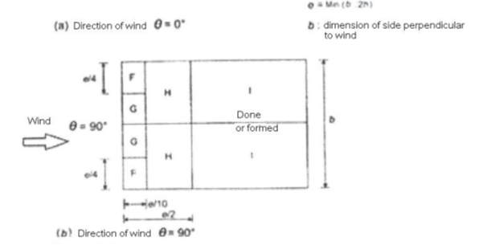
Figure III - 17: Roofs with two slopes

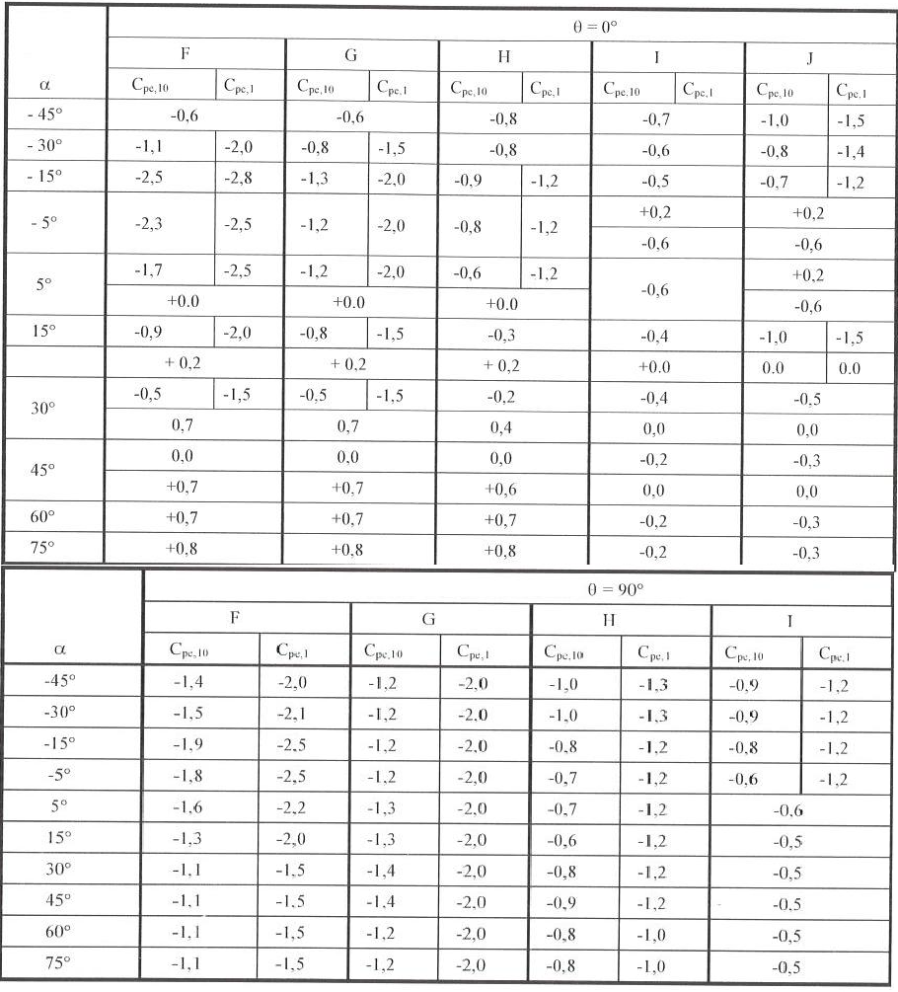
Notes
Table III - 14: Coefficients of external pressure for roofs with tow slopes $θ$ = 0⁰ and 90⁰
- When θ = 0⁰, the pressure passes quickly from positive values to negative values for the slopes α of the order of 15⁰ to 30⁰. This is the reason for which the positive and negative values are given;
- For the intermediary slopes of same sign, the linear interpolation between the values of the same sign is admissible (not to interpolate α = + 5⁰ and α = - 5⁰ but use the data concerning the flat roofs;
- For dissymmetric roofs, the coefficients of pressure are always determined by the slope of flow of wind.
- Roofs with four slopes
The direction of wind is defined by an angle θ:
θ = 0⁰ for a slope whose direction is perpendicular to ridge beam
θ = 90⁰ for a slope whose direction is parallel to ridge beam.
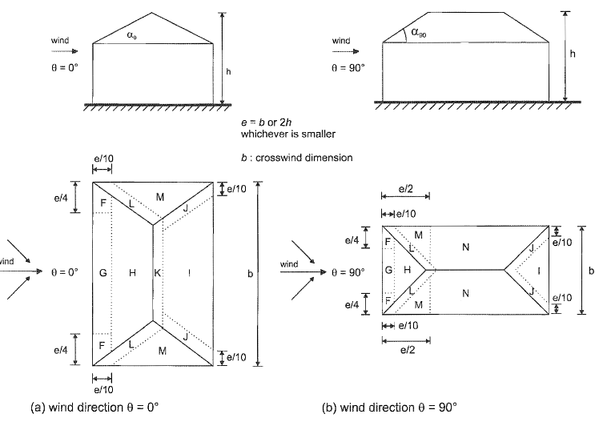
It is agreeable to divide the roof as indicated in the figure (III-18). the values of Cpe.1 and Cpe.10.are given in table (III-15).
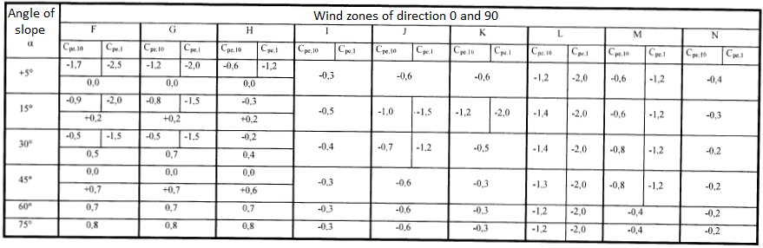
Table III - 15 : Coefficients of external pressures of roofs with four slopes
Figure III - 18 Roofs with four slopes

- When θ = 0, the pressure changes quickly from positive value to negative values of wind flow on the slopes of the order of +15⁰ to +30⁰: this is the reason for which the positive and negative values are given;
- For the intermediate slopes of the same sign, the linear interpolation, between the values of the same sign, is admitted (not to interpolate between α = + 5⁰ and α = - 5⁰ but use the data of paragraph (b) related to flat roof);
- The coefficients of pressure are always determined by the slope of flow of wind.
- Coefficients of internal pressure
The most unfavorable combination of external and internal pressures considered as acting simultaneously must be envisaged simultaneously for each potential combination of openings and other sources of air leaks. The values of coefficients of internal pressure Cpi given below are valid for all types of wall (single or double with air space).
When, at least two faces of the building (facades or roof), the total area of the existing openings on each of the faces represents 30% of the area of this face, it suits to calculate the actions exercised on the construction from the rules defined for the isolated roofs.
A face of a building is considered as dominant when the area of openings in the said face is at least equal to twice the area of openings in the other faces of the building.
Values of Cpi
In the case of a building having a dominant face, the coefficient of lower pressure is given by:
- Cpi = 0.75 Cpe, when the area of openings in the dominant face is equal to twice the area of openings in the other faces, and;
- Cpi = 0.90 Cpe ; When the area of openings in the dominant face is at least equal to thrice the area of openings in the other faces.
Where:
Cpe is the coefficient of external pressure at level of openings of the dominant face. When these
openings are located in the zones with different values of external pressures, it is recommended to utilize a mean value balanced in area of Cpe.

For the buildings without dominant face, the coefficient of internal pressure Cpi is determined from the figure (III-19) with (h) height of the building, (d) its depth and μp the index of permeability given by the following equation. For the values included between h/d = 0.25 and h/d = 1, a linear interpolation can be used.

Figure III - 19 : Coefficient of internal pressure Cpi of buildings without dominant face

Notes:
- The height of reference of internal pressures is equal to the height of reference ze for the external pressures exerted on the faces which contribute to the creation of internal pressures by their openings. When there exist many openings, the largest value of ze is used.
- The coefficient of internal pressure of open silos and chimneys is equal to Cpi = 0.60.
- The coefficient of internal pressure of ventilated tanks by opening of small dimensions is equal to Cpi= 0.40.

