Chapter I :
Generalities

- Introduction
In construction, materials refer to all the substances used in the building of structures: residential, industrial, as well as infrastructure such as bridges and roads.
A structure, for example, must be calculated and designed to remain suitable for the intended use, considering its expected lifespan and cost:
- It should not be damaged by events such as explosions, shocks, or other phenomena.
- It must withstand all actions and influences that may occur both during construction and throughout its operation, ensuring a suitable durability in relation to maintenance costs.
To meet these requirements, materials must be carefully selected and appropriate design, sizing, and construction details must be defined. The materials should be chosen thoughtfully to maximize their use, ensuring the safety of the structures while also considering economic factors.
- Classification of Construction Materials
Several types of classifications can be distinguished, such as:
a) Scientific Classification: This classifies materials into three types:
- Metals and alloys
- Polymers
- Ceramics
b) Base Materials and Composite Products:
- Base Materials: Cement, aggregates, clay, bitumen, steel, etc.
- Composite Products: Hydraulic concrete (aggregates + cement + water), bituminous concrete (aggregates + bitumen), etc.
c) In Construction: Materials are classified according to their use, including:
- Load-bearing Materials: These materials, also called construction materials, such as stone, wood, steel, and concrete, are used for building structures and primarily serve to resist various loads exerted on the structure (self-weight, overload, seismic forces, heat, etc.).
- Protective Materials: These materials are designed to protect and envelop load-bearing materials from external attacks, ensuring greater longevity of the structure (coatings, paints, bitumen, waterproofing products, etc.).

- History of Construction Materials
Building has always been one of humanity's primary concerns and one of its major occupations. Today, construction is experiencing significant growth in most countries, with many professionals engaged in this activity.
However, while the profession of building is among the oldest practiced by humans, it must be acknowledged that in recent decades, builders have had to adapt to the evolution of construction and, more importantly, to new techniques that ensure maximum reliability of structures against natural hazards such as earthquakes.
Initially, primitive humans used caves for shelter, and gradually they began to discover various materials that helped them construct homes. For thousands of years, many materials have been employed, including raw earth (mud), timber, straw, and plant materials, as well as stones and even snow (ice). Hydraulic concretes and mortars, though less known, were also used. Builders of antiquity made them from fat lime, gypsum, mixed with crushed brick and pozzolana, and even cattle blood.
The emergence of artificial binders (Portland cement, etc.) in the first half of the 19th century marked a radical change in construction methods. In 1848, LAMBOT imagined combining steel bars and cement concrete to create a boat (shown at the 1855 World Fair). A few years later, J. MONIER, a gardener from Versailles, used a similar process to make flower boxes. He is credited with the invention of reinforced concrete, which was later utilized in Germany by the company MONIER BETON BRAU (patent filed in 1868).
Then, HENNEBIQUE developed the calculation bases for its rational use, but it wasn't until 1897 that RABUT taught the first reinforced concrete course at ENPC. Previously, in 1891, COIGNET used prefabricated reinforced concrete beams to construct a building.
In 1906, the first regulations appeared, based on a method of calculation known as permissible stresses. The 1906 circular was replaced by regulations for reinforced concrete in 1945, followed by others in 1960, 1968, and finally BAEL 91, which was revised in 1999; Algeria also has CBA93. Currently, the EUROCODES are being implemented.
Reinforced concrete does not always rely on scientific theories. The calculation formulas and numerous coefficients used often have an empirical nature, but it is essential that they were established following numerous tests and that the calculation results conform to experience. Until 1980, reinforced concrete was calculated using the method of permissible stresses. These permissible stresses were defined based on the rupture or elastic limit stresses of materials, multiplied by a safety coefficient. The safety coefficient for concrete long remained at 28% of the rupture limit at 90 days, while the safety coefficient for steel was 60% of its elastic limit.
It was then sufficient to calculate the stresses in the steel and concrete under the most unfavorable load conditions and verify that these permissible stresses were not exceeded. This notion of safety has since evolved, seeking to consider all factors of insecurity separately, such as: the intrinsic strength of materials, the most probable value of permanent and variable loads, the favorable or unfavorable aspect of these actions, calculation approximations of loads (shear forces, bending moments, etc.), geometric defects of materials and their positioning, and cracking.
Other types of concrete are also used in construction, such as prestressed concrete, high-performance concrete, and self-leveling concrete, etc. Therefore, based on what we have seen, we can find several types of construction throughout time, each with its advantages and disadvantages.
- Stone Constructions:
Stone constructions have been used for thousands of years, known for their durability and aesthetic appeal. Ancient civilizations, such as the Egyptians and Greeks, employed stone in their monumental structures, including temples and pyramids.
Advantages:
- Longevity: Stone structures can last for centuries with minimal maintenance.
- Excellent Compressive Strength: Stone has a high resistance to compressive forces, making it ideal for load-bearing applications.
- Great Weather Resistance: It withstands various weather conditions and environmental attacks.
- Good Insulation Properties: Stone effectively captures and retains heat, enhancing energy efficiency.
- Minimal Ecological Impact: As a natural material, stone has a low environmental impact compared to many synthetic alternatives.
Disadvantages:
- Probable Settling: Due to its heavy weight, stone can experience settling over time.
- Highly Skilled Labor Required: Working with stone demands specialized skills and expertise.
- High Construction Costs: The cost of stone construction can be significant compared to other materials.
- Long Construction Duration: Building with stone often takes more time to complete.
- Limited Height: Stone structures may have restrictions on height due to their weight and stability.
- Poor Tensile Strength: Stone has low resistance to tensile forces, making it less suitable for applications requiring tensile strength.
- Wood constructions:
Wood has been a fundamental construction material for centuries, known for its versatility and natural appeal.
Advantage:
- Superior Insulation to Concrete: Wood provides better thermal insulation compared to concrete.
- Lightweight, Strong, Flexible, and Adaptable: Wood’s properties make it easy to work with and versatile for various designs.
- Simple and Quick to Construct: Building with wood is often faster and less complex than other materials.
- Renewable Resource: As a natural material, wood is renewable and can be sustainably sourced
- Comfort: Wood contributes to a warm and inviting atmosphere in living spaces.
- Optimized Living Space: Wood allows for efficient use of space, enhancing livability.
Disadvantages:
- Low Thermal Inertia of Wood: Wood does not retain heat as effectively as some other materials, leading to temperature fluctuations.
- Requires Regular Maintenance: Wood structures need ongoing care to prevent deterioration.
- Termites and Other Pests: Wood is susceptible to damage from insects and pests, which can compromise its integrity.
- Vulnerability to Fire: Wood is more flammable than materials like steel or concrete, necessitating fire protection measures.
- High Cost: Quality wood can be expensive, increasing the overall construction budget.
- Properties of Construction Materials.
Over time and through experience, humans have developed various tests to study and understand the different properties of construction materials. These tests include evaluations of physical, mechanical, chemical, and even thermal properties. In the following section, we will discuss some of these tests.
- Physical Properties:
- Apparent Density:
This is the mass of the dry material divided by unit volume, i.e., after drying in an oven at 105°C and without compaction of the material or leveling, including voids and pores. The apparent density is expressed in (g/cm³; kg/m³; T/m³). For solid bodies, precise geometric shapes such as cylinders, cubes, and other shapes are used..
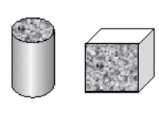
Figure I.1. Geometric shapes used for calculating the apparent mass of solid bodies.
In the case of a set of grains, the determination of the apparent density can be done using a container of known volume.
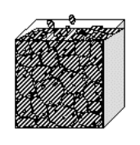
Figure I.2. Methods used for calculating the apparent mass of solid grains with a container.
$$ρ_{app}=\frac{M_{d}}{V}$$
Where:
- ρ_{app} ​: Apparent density
- M_{d}​: Dry mass of the body
- V: Volume of the body
For materials with inconsistent shapes that have significant dimensions and cannot use a container, the apparent density is calculated indirectly by immersing the paraffin-coated material in water. Paraffin is used to prevent water from penetrating the bodies, and then the apparent density is calculated with the following formula:
$$ρ_{app} = \frac{M_{d}}{\frac{M_{d+p}-M_{\left(d+p\right)L}}{1}-\frac{M_{p}}{ρ_{p}}}$$
Where:
- M_{d}​: Dry mass of the sample
- M_{(d+p)}​: Dry mass of the sample after being coated with paraffin
- M_{(d+p)L}​: Dry mass of the sample after being coated with paraffin and weighed in water
- M_{p}​: Mass of paraffin coating the sample
- ρ_{p}​: Absolute density of the paraffin
- $\frac{M_{d+p}-M_{\left(d+p\right)L}}{1}$: Apparent volume of the sample absorbed by the paraffin
- $\frac{M_{p}}{ρ_{p}}$​​: Volume of paraffin
Absolute Density:
This is the mass of a body per unit absolute volume of the material (volume of the material only, not counting voids and pores). It is expressed in (g/cm³, kg/m³, or T/m³). If the studied materials are porous, they should be crushed and ground until the size of the material grains becomes less than 0.2 mm. The following image represents the method for measuring absolute density.
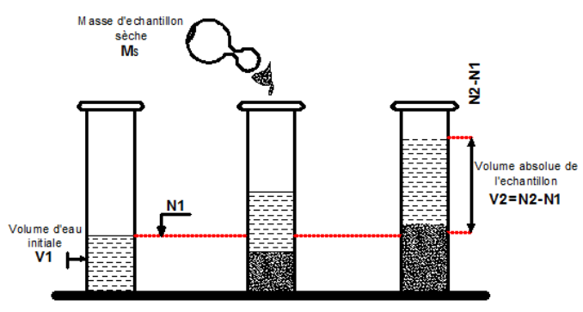
Figure I.3. Measurement of absolute density.
Absolute density is given by:
$$ρ_{Abs}=\frac{M_{d}}{V_{2}-V_{1}}$$
To calculate absolute density, the following procedure should be followed:
- Place the test sample in the plastic container.
- Pour water into the container (almost half full) and note V₁​.
- Prepare a sample of dry aggregates with mass M_{d} (approximately 300 g).
- Pour the sample into the container using a funnel and eliminate the air voids by stirring the mixture with a stirring rod.
- Note the new water volume in the container V₂​.
- Empty the aggregates into a plastic container and discard the contents.
- Repeat the operation at least 3 times
- Porosity
Porosity is the volume of voids divided by the total or apparent volume. It is expressed as a percentage:
$$P= \frac{Density of voids}{Total density} .100\%$$
- Compactness
Compactness is the volume of solids divided by the total or apparent volume. It is also expressed as a percentage:
$$C= \frac{Density of solids}{Total density} .100\%$$
Porosity and compactness are complementary, and their sum equals 1: P+C=1
- Moisture Content
Moisture has a significant influence on the properties of constructions and is a major cause of disorders and degradation. High moisture levels can lead to serious consequences, such as:
- Crumbling and flaking of surfaces,
- Cracking and bursting of materials,
- Swelling and warping of wood.
Moisture is an important property of construction materials. It indicates the actual water content of materials at the time of testing. Generally, moisture is denoted by W and expressed as a percentage (%). Moisture content can be determined using the following formula:
$$W=\frac{{M_{w}-M}_{d}}{M_{d}}.100\%$$
Where:
- M_{d}: ​ is the dry mass of the sample (after drying),
- M_{w}: is the wet mass of the sample.
The moisture content of materials depends on many factors, especially the atmosphere in which they are stored, wind, temperature, and the porosity of the material.

- Degree of Saturation (Water Content)
The degree of saturation is one of the most important factors influencing strength. It has been observed that water-absorbing materials have a significantly reduced strength. When all the voids in a body are filled with water, it is said to be saturated. The degree of saturation is the ratio of the volume of voids filled with water to the total volume of voids. It plays a major role in the destruction of porous materials by frost. As water transforms into ice, it expands by about 9% in volume. The degree of saturation can be calculated using the following formula:
$$S=\frac{V_{w}}{V_{V}} .100\%$$
Where:
- S: is the degree of saturation (%),
- V_{w}: is the volume of the water in the sample,
- V_{V}:​ is the volume of the voids in the sample,

- Air and Water Permeability
Permeability is the property of a material that allows water or air to pass through its thickness. It is characterized by the quantity of water or air that flows through the material over a time period t at constant pressure. Controlling permeability is crucial for concrete intended to be used in confined environments in contact with water, such as dams, bridge piers, water towers, reservoirs, and basins, or in contact with gases, such as in nuclear reactors and storage tanks for chemical or radioactive waste.
Permeability is an indicator of durability. Construction materials are porous and, like any porous medium, consist of a solid phase and a void space filled with water and air, with proportions varying with the degree of saturation.

- Chemical Properties
- Alkalinity
The phenomenon of alkali-silica reaction (ASR) arises from the action of soluble alkalis (sodium oxide Na2O and potassium oxide K2​O) in concrete on a certain form of reactive silica, in the presence of water.
It corresponds to a set of complex chemical reactions that can occur between certain mineral phases contained in aggregates and the highly alkaline interstitial solution of the concrete, when several conditions are simultaneously met: the presence of a form of silica in the aggregates known as "potentially reactive," the alkalis in the concrete and sufficient quantities of water.
These are internal reactions within the concrete primarily involving elements originally present in the concrete and an external supply of water. If precautions are not taken, this pathology can appear in the parts of structures most severely exposed to moisture, generally after several years (or even several decades). The formation of a swelling gel can lead to deformations and micro-cracking of the material. The expansive stresses generated can exceed the tensile strength of the concrete, resulting in a separation at the paste-aggregate interface and the development of micro-cracks at the concrete/reinforcement interface, which appear on the surface as cracks aligned with the direction of the rebar.
Three simultaneous conditions are necessary to initiate and maintain the reactions of this exceptional phenomenon:
- A highly humid environment,
- A high concentration of soluble alkalis in the interstitial solution exceeding a critical limit,
- The presence of reactive silica in the concrete in sufficient quantity (from potentially reactive aggregates).
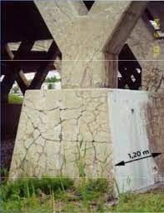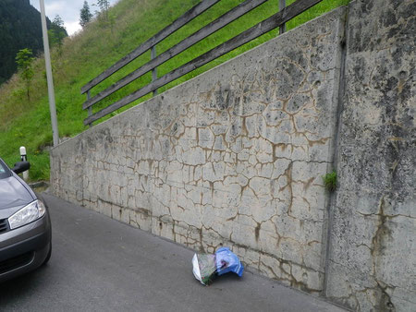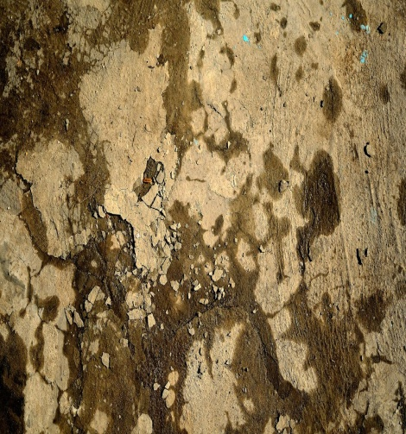
Figure I.4. ASR in concrete
Research conducted between the 1980s and 1990s, following the analysis of observational data on structures and laboratory experiments, has led to the implementation of effective preventive measures. A coherent set of prevention recommendations has stopped most manifestation of the phenomenon for over a decade. The alkali-silica reaction phenomenon is now well controlled, making it possible to prevent any risk of ASR in concrete and avoid any disorders.

- Recommendations for Preventing Alkali-Silica Reaction
The recommendations for preventing alkali-silica reaction phenomena are detailed in a document published by the LCPC in June 1994 titled "Recommendations for Preventing Disorders Due to Alkali-Silica Reaction." This will soon be replaced by the Documentation FD P 18-464 (the text below incorporates updates from this new document).
The principle of the preventive approach is to avoid situations where the three necessary conditions for initiating the reaction are simultaneously present. Therefore, it is important to avoid the conjunction of the three factors: water (relative humidity above 80-85%), a significant quantity of alkalis in the concrete (high concentration of soluble alkalis in the interstitial solution), and reactive silica (presence of reactive aggregates).
The prevention method consists of two steps:
- Based on the environment (specific exposure classes for alkali-silica reaction XAR1 to XAR3 - Table 1) and the category of the structure (category I to III - Table 2), determine the level of prevention to achieve (levels A, B, or C - Table 3), and then verify that the proposed concrete formulation is satisfactory.
- Implement prevention recommendations adapted to the importance of the structure and its environment.

Table I.1: Environment
Exposure Class | Environment
XAR1 | Dry or slightly humid (humidity below 80%)
XAR2 | Humidity above 80% or in contact with water
XAR3 | Humidity above 80% with freeze and thaw

Table I.2: Structure Categories
Structure Category | Risk Level | Examples of Structures
I | Low or acceptable risk | Non-load bearing elements, most precast concrete products
II | Tolerable risk | Most civil engineering structures
III | Unacceptable risk | Tunnels, dams, bridges, viaducts, nuclear power plants, prestigious buildings
Table I.3: Prevention Level
Structure Type | Exposure Class
Structure Type | XAR1 | XAR2 | XAR3
I | A | A | A
II | A | B | B
III | C | C | C
The choice of the prevention level to apply is the responsibility of the project owner. The recommendations to apply depend on the prevention level:
- Level A: No special specifications.
- Level B: Four acceptance possibilities for the concrete formula:
  - All aggregates NR (non-reactive),
  - Active alkalis in concrete < 3.5 kg/m³,
  - Performance testing on concrete (NF P 18-454),
  - PRP aggregates with specific conditions,
  - Sufficient proportions of mineral inhibitory additives.
- Level C: Exceptional precautions:
  - NR or PRP aggregates with satisfactory specific conditions,
  - PR aggregates with determination of the limit in alkalis triggering ASR (NF P 18-454 and low alkali cement) and application of a safety margin (1 to 2 kg/m³ less depending on the critical nature of the structure and the variability of the constituents).
- Types of Aggregates
Three types of aggregates are distinguished (according to FD P 18-542 and XP P 18-594 (February 2004)):
- Non-Reactive Aggregates (NR): Aggregates for hydraulic concrete that will never lead to disorders from alkali-silica reaction.
- Potentially Reactive Aggregates (PR): Aggregates that may, under certain conditions, lead to disorders from alkali-silica reaction.
- Potentially Reactive Aggregates with Pessimum Effect (PRP): Aggregates that can be used without risk of disorders if certain usage conditions are respected.
The establishment of a coherent set of prevention recommendations has reduced any manifestation of the phenomenon for over 20 years. The alkali-silica reaction phenomenon is now well controlled. It is therefore now possible to prevent any risk of alkali-silica reaction in concrete and thus avoid any disorder in structures.
- External Environmental Attacks
The solids involved are primarily soils and wastes of various origins. Four classes of aggressiveness are defined:
Table I.4 - Definition of Aggressiveness Classes
Environment | Symbol | Level of Protection
Slightly Aggressive | A₁ | 1
Moderately Aggressive | A₂ | 2
Highly Aggressive | A₃ | 3
Very Highly Aggressive | A₄ | 4
Aggressive environments can be varied and classified into three categories:
- Gases: From natural sources or resulting from atmospheric pollution and fermentation, the most commonly encountered are carbon dioxide, sulfur dioxide, nitrogen dioxide, hydrogen sulfide, chlorinated, brominated, and iodinated vapors, ammonia, etc.
- Inorganic or Organic Liquids: These act mainly through their acidic or basic nature and the aggressive ions they may contain, regardless of any purely physical effects.
- Environmental Classes: These can be classified as slightly aggressive, moderately aggressive, highly aggressive, and very highly aggressive, summarized in Table 4, which also includes their symbols and corresponding protection levels.

- Thermal properties:

Specific Heat
Specific heat is a material's ability to absorb and store a certain amount of heat to increase its temperature, characterized by the specific heat coefficient C.
To heat a body with mass G (kg) from an initial temperature t1​ to a final temperature t2​, a quantity of heat Q (kcal) must be expended, which is directly proportional to the mass of the body and the temperature difference.
Where C is the specific heat coefficient.
If we set Δt=(t₁−t₂)=1°C, G=1kg, the specific heat coefficient C will take the numerical value of the heat quantity Q. In other words, specific heat is the amount of heat in kcal required to raise the temperature of a 1 kg body by 1°C. The specific heat coefficients (C, Kcal / Kg °C) for certain materials are:
- Masonry: 0.18 to 0.22
- Steel: 0.11
- Water: 0.1
- Various woods: 0.57 – 0.65

- Thermal Resistance
Thermal resistance is a material's ability to slow down heat transfer through its thickness:
- For a single-layer wall: ,
- For a multi-layer wall:
Where:
- R_{th}​ – Thermal resistance
- e – Thickness of the wall in meters
- λ – Coefficient of thermal conductivity in [Watt/m °C]
- Thermal Conductivity
This is the amount of energy passing through 1 m² of material with a thickness of one meter, for a temperature difference of 1 degree. It is expressed in W/(m·°C). It represents the ability of the material to conduct heat. This is a constant intrinsic characteristic of homogeneous materials.

Table I.5 Coefficient of Thermal Conductivity of Construction Materials
MATERIAUX |  | MATERIAUX
Copper  Aluminium  Steel  Natural stones  Marble  Granite  Concrete  Light weight concrete  Cellular concrete  Glass  Foam glass | 390  125 – 230  37 – 60  0,5 – 5  3  2,5  1,5 – 2  0,3 – 1,2  0,1 – 0,4  0,8 – 1,15  0,05 - 0,07 | Glass wool  Fired clay  Brick  Wood  Oak  Spruce  Wood fibres  Cork  Plastics  Foam plastics  Still dry air | 0,04  0 ,3 – 0,96  0,7  0,1 – 0,25  0,23  0,12  0,04  0,04 – 0,05  0,1 – 0,5  0,025 – 0,5  0,024
- Mechanical Properties:
The materials used in construction must be sufficiently strong and suitable to effectively withstand the various forces they encounter. Structures can be subjected to a variety of forces that cause different types of stress. The duration for which construction materials are loaded directly impacts their mechanical behavior. In practice, structures are often exposed to long-term loads, while mechanical tests are typically performed on small-scale models with very short load durations. The strength capacity of a material is evaluated based on the maximum load it can bear before failure, which is related to the duration of the load.
- Compression Strength:
This is the stress at which a material yields under a compressive force. This measurement is generally obtained by crushing a standardized sample, either cubic or cylindrical, between the plates of a press.
Table I.6 Compression Tests
Materials | Shape | Diagram | Formula | Dimension (cm)
Concrete  Mortar  Rock | Cube | 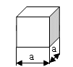 |  | a  10x10x10  15x15x15  20x20x20
Béton  Mortier  Roche | Cylinder | 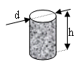 |  | d= 11, h = 22  d= 15, h = 30  d = 16, h = 32
Wood | Prism | 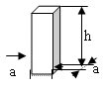 |  | a=2,  h=3
Brick | Assembled  Samples | 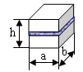 |  | a=12;  b=12,  h=14
Ciment | Half of  Mortar Sample | 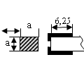 |  | a=4  S=25 cm²  S=16 cm²

- Tensile Strength:
Direct tensile testing is primarily performed on metals and wood, which exhibit relatively comparable strengths in both compression and tension. For steel, the samples used are generally round bars or strips.
Considering a curve obtained from a tensile test on a steel sample, three deformation phases can be identified:
- Elastic deformation phase (proportionality)
- Plastic deformation phase
- Rupture phase
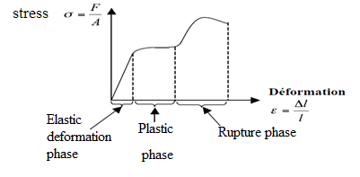
Fig I.6. Stress deformation diagram

Table I.7 – Direct Tensile Tests
Samples |  | Formula | Material
Cylinder  Prism | 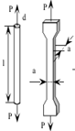  a b | 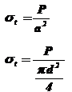 | Steel  Wood

For concrete or materials with relatively low tensile strength, indirect calculation methods will be adopted, such as bending tests on prism samples. These methods can also be applied to other materials.
Table I.8 – Bending Tensile Tests
Samples |  | Formula | Materials | Dimension (cm)
Prismatical | 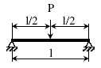 |  | Ciment  Brick | 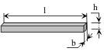  4x4x16  15x15x15
Prismatical | 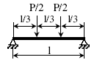 |  | Concrete  Wood | 15x15x60  2x2x30
- Non-Destructive Testing:
Non-destructive testing (NDT) techniques are used to evaluate the properties of a material, component, or structure without causing damage. In simple terms, this means that the test objects are not altered or destroyed. NDT is essential in many fields, including construction, as it allows for the inspection of the quality, reliability, and safety of materials used. Here are some commonly used non-destructive tests in construction:
- Ultrasonic Testing: This method uses high-frequency sound waves to detect internal defects such as cracks or inclusions in materials. It is commonly used for testing metal and concrete structures.
- Industrial Radiography: Similar to how X-rays are used in medicine, industrial radiography helps visualize internal defects in materials. It is commonly used to inspect welds and other assemblies.
- Eddy Current Testing: This method uses magnetic fields to detect surface cracks or other defects in conductive materials.
- Surface Penetration Testing: This test is commonly used to detect surface cracks or defects. It involves applying a dye or fluorescent fluid to the surface, which penetrates into the defects and becomes visible.
- Thermography: This technique uses infrared cameras to detect temperature variations that may indicate defects in a material or structure.
- Acoustic Resonance Testing: This method uses sound vibrations to detect defects in a material. Changes in sound resonance can indicate issues such as cracks or internal defects.
These techniques are crucial for maintaining the safety and integrity of structures, as they allow for the detection of potential problems before they become serious.

