

GP
Course : Earthquake Engineering
Tutorial : EXERCICES SÉRIES N° 01
(Master’s Degree 2)

MILA UNIVERSITY CENTER
Department of Civil & Hydraulic Engineering

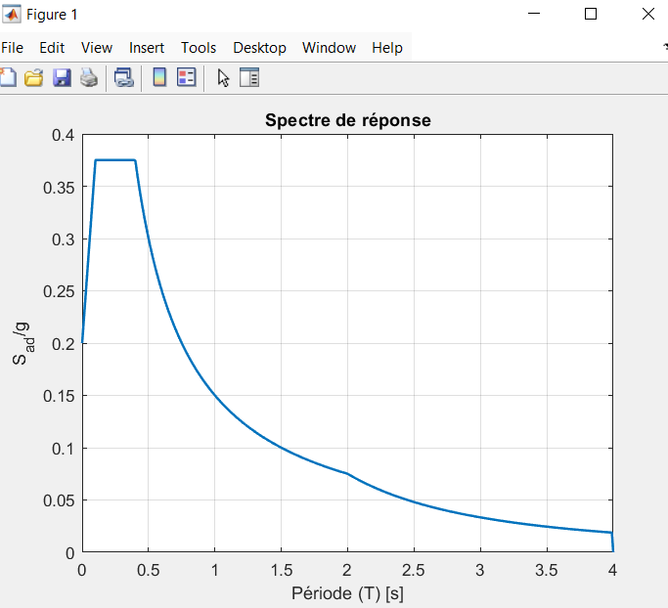
Exercice N° 01 : An elevated water tank has a reservoir of 150 m³ at 20 meters height. It rests on a cylindrical reinforced concrete shaft of 2.00m exterior diameter and 30cm thickness subjected to horizontal seismic motion. It is located in the city of Mila (heigh seismicity). It is on a class A soil (rock). Knowing that its 28-day strength Fc28 = 25MPa.
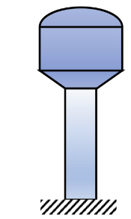
Calculate the displacement of a water tower:

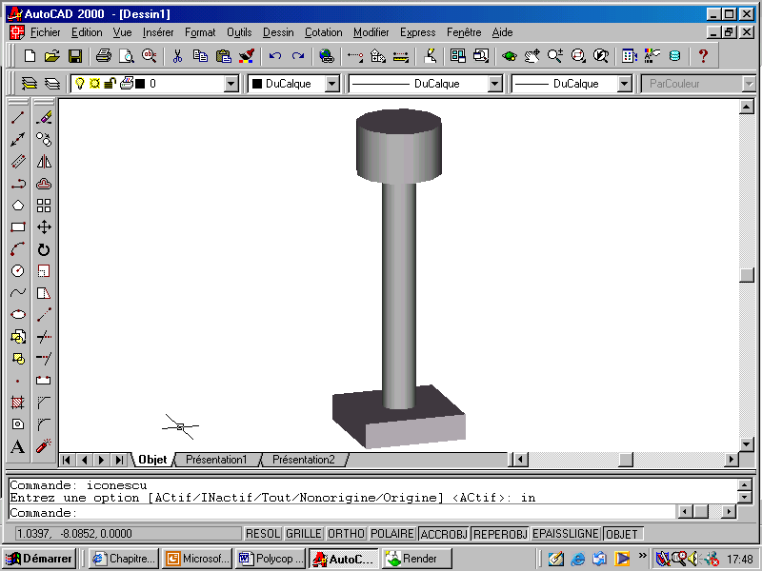
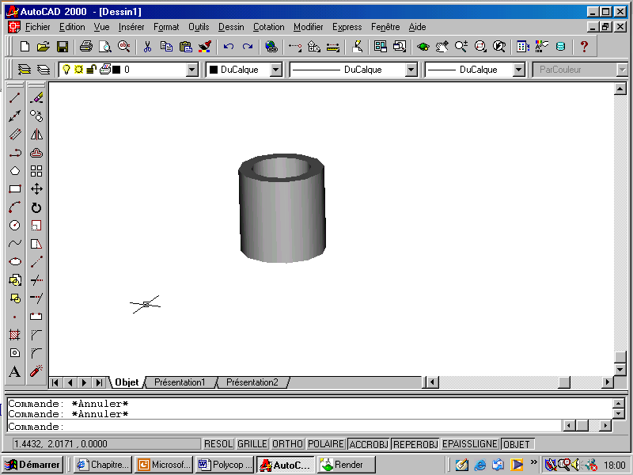
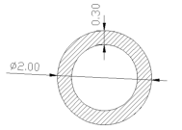
Section du fût

Exercice N° 02 : Consider the system represented by the figure below (primary school). It is located in zone IIA (moderate seismic risk). It is built on rocky soil. The school is considered to be constructed of reinforced concrete with a 28-day characteristic concrete strength Fc28 = 25MPa.
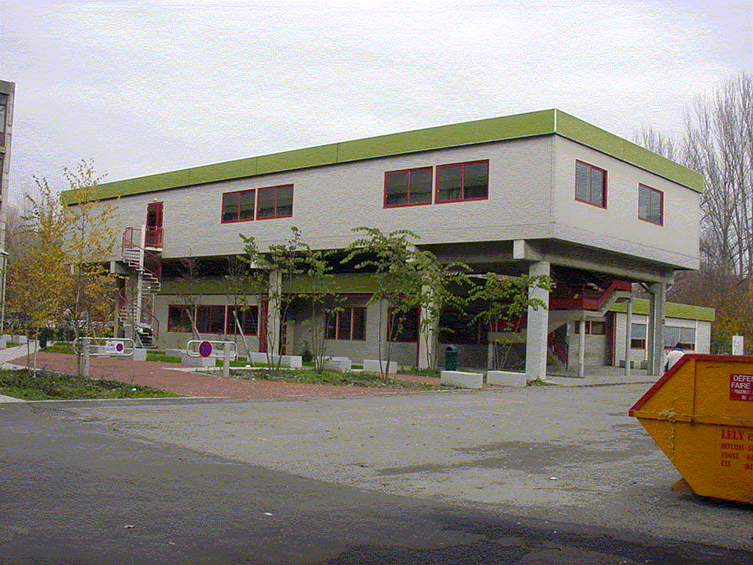
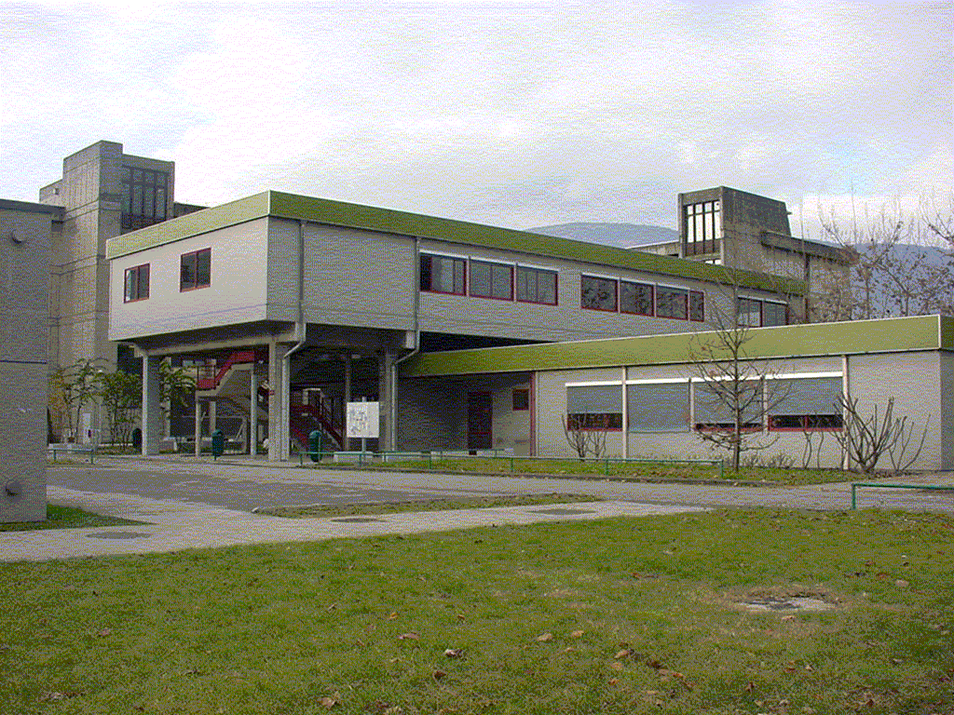

- Model this building as a 2D frame ?
- Calculate the fundamental period of this building using modal analysis ?
- Determine the displacement of this building using response spectrum analysis ?
Given:
- Column height H = 4.25m, column section 40cm x 40cm
- Floor mass: M = 274t
- Stiffness: k = stiffness of 10 columns with KColumn = 3EI/h3
- Slab = rigid diaphragm, Mass concentrated at the slab

