PW 2: Purification of benzoic acid by recrystallization
- Introduction
Recrystallization is a purification technique commonly used in chemistry to separate a substance from impurities or to obtain a pure crystalline form of a compound. The process involves dissolving the impure compound in a suitable solvent at elevated temperatures and then allowing it to cool slowly. As the solution cools, the solubility of the compound decreases, leading to the formation of crystals. As advantages, this technic gives products with very high purity and it requires minimal equipment.
The recrystallization reaction passes throw 6 steps which are:
a/ Dissolution: The impure solid is dissolved in a hot solvent. The choice of solvent is crucial; it should dissolve the compound well at high temperatures but poorly at low temperatures.
b/ Filtration: Any insoluble impurities are removed from the hot solution through filtration.
c/ Crystallization: The hot solution is allowed to cool slowly, which encourages the formation of pure crystals.
d/ Isolation: Once crystallization is complete, the crystals are collected, often via filtration.
e/ Washing: The crystals may be washed with cold solvent to remove any remaining impurities.
f/ Drying: Finally, the crystals are dried to obtain the purified compound.
- The compound to be purified must be soluble cold and hot in the solvent. When the hot solubility is 5 times higher than the cold solubility, the solvent is correct. For this we can, use pairs of miscible solvents whose solubility of the compound is different in each solvent.
- Like any purification step, this operation generates losses. Choosing an adequate solvent will limit these losses as much as possible.
- It is very important to dissolve the crystals in the minimum amount of solvent when boiling, to obtain a hot saturated solution.
Benzoic acid is a colorless crystalline solid that has a faint, pleasant odor. It is a simple aromatic carboxylic acid with the chemical formula C₇H₆O₂. It is widely used in various applications, such as food preservative (known as E210), it enters also in the production of various chemicals, and in the pharmaceutical industry. Benzoic acid can be synthesized from toluene (methylbenzene) using potassium permanganate 𝐾𝑀𝑛𝑂₄ through a process known as oxidation.
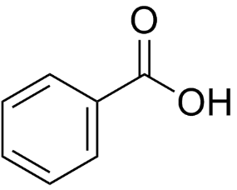
- Objectives of the manipulation
- Become familiar with the purification techniques of the organic chemistry.
- Become more familiar with the chemical function and the interactions between them.
- benefit of the physico-chemical properties of the different constituents in order to purify benzoic acid.

- Equipment and chemicals
Equipment | Chemicals
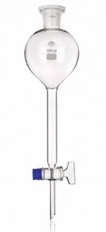  Separating funnel | Potassium permanganate KMnO₄
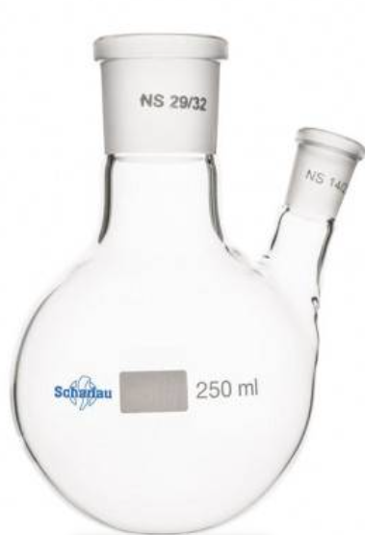  Double necked flask | Toluene
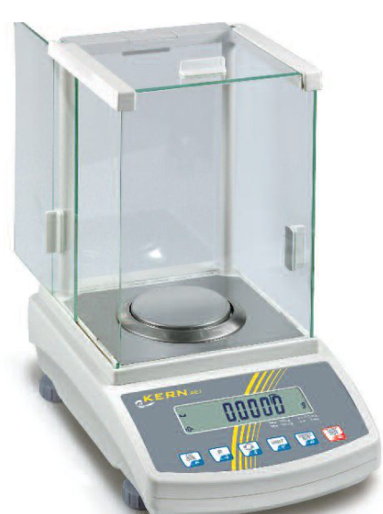  Balance | Methanol
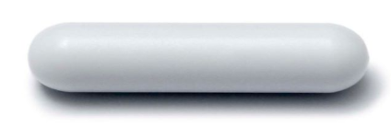  Magnetic bar | Hydrochloric acid (concentered solution of HCl)
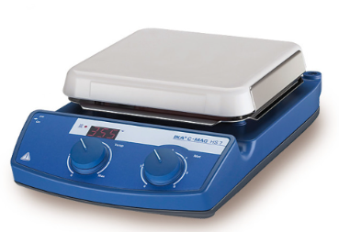  Heating magnetic stirrer | Distilled water  +  Iced distilled water
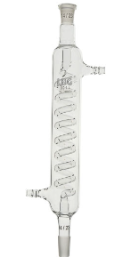
Refrigerant
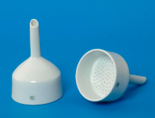
Büchner
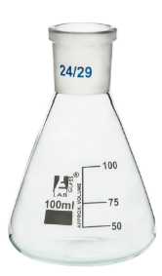
100ml Erlenmeyer
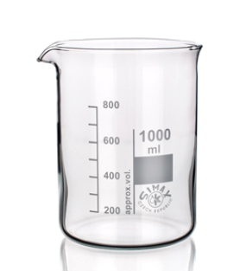
Beacker
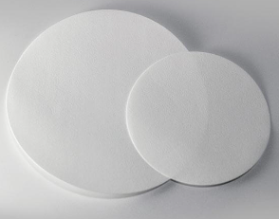  Filter paper | Acetic anhydride
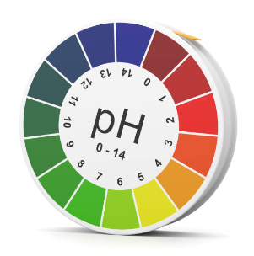
pH paper

- Operating mode
- Before starting, check if the glassware is clean and dry.
1/ Weight 10g of potassium permanganate KMnO₄, then put it in a double-necked flask.
2/ Add 50mL of distilled water. Keep the mixture on gentil boil.
3/ Using a separating funnel, introduce, drop by drop, 8mL of toluene, then maintain boiling for 2 hours.
4/ After this, add 5mL of methanol and keep heating for 5 minutes.
5/ Stop heating and keep cooling the processes basing on circulation of water.
6/ Remove the double-necked flask, cool it with water and filter the content of the flask.
7/ Filter the composition and then put the filtrate into a beaker placed in iced water.
8/ Add carefully a concentrated solution of HCl. notice that a white precipitate of benzoic acid is formed.
9/ After being sure that the mixture is well cooled, bring it to Büchner filtration.
10/ Dry well the obtained solid then put it into a watch glass. weigh it ones dry.
11/ Recrystallize the benzoic acid in a water/methanol mixture.
- Questions
- Give both: the topologic and the developed representation of toluene.
- Give the detailed mechanism of the reaction of synthesis of benzoic acid.
- Why should we add methanol to the mixture?
- Why should we add concentrated solution of hydrochloric acid?
- Explain why should we dissolve the crystals in the minimum amount of solvent when boiling.

