Technology verbs
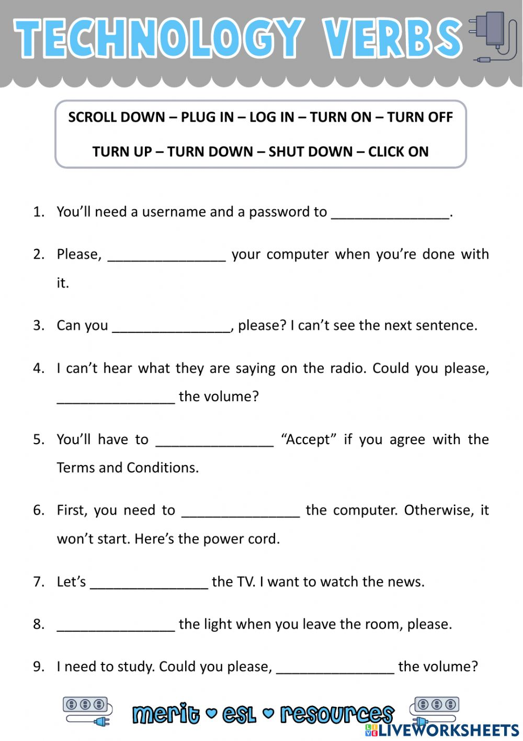
Answers :
Log in
Shut down
Scroll down
Turn up
Click on
Plug in
Turn on
Turn off
Turn down

