MILA UNIVERSITY CENTER

Department of Civil Engineering and Hydraulics

Course : Structural Dynamics
TD : SERIES OF EXERCISES No. 03
(Response of an S.D.O.F. system to an harmic load)

Exercice N° 01 : (Cutch‐up exam 2023)

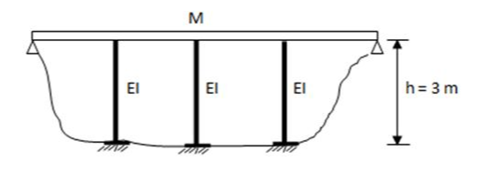
1/ The system is set into free oscillation (X0=3cm) and the time is measured for it to pass six (6) times through the same point (t=2.4 s) where the displacement is reduced to 0.2 cm
M
3m
EI
EI
EI
a) Determine the natural frequency of the system
b) Determine the damping factor ξ
c) Determine the stiffness K of the system
2/ By placing on the platform an electric motor that exerts on it a horizontal force:
F(t) = 250 sin (10t) (KN)
If the mass of the motor is neglected, determine:
a) The maximum response of the platform
b) The maximum stress in each pole, knowing that the cross-sectional shape is a 30 cm square

Exercice N° 02 : (Cutch‐up exam 2020)
Consider the structure represented by the figure below: M= 1000kg and E= 2×104 MPa
The stiffness of a column is K=3EI/h³
a) By recording the free vibration response of this structure, it is observed that the ratio between two successive peaks is 1.37.
- Determine the damping factor ξ of this structure?
b) For the rest of the exercise, consider that the base of this structure is subjected to an earthquake that can be assimilated to a harmonic excitation of the form Xg(t) = 5sin30t (cm)
- Determine the dimension a of the pole's cross-section necessary to introduce resonance in the structure.
x(t)
C
K/2
K/2
M
h=3 m
a
a
L=3 m

Exercise N° 03 :
A rotating machine, supported by the structure shown in the figure below, generates a horizontal harmonic force with an amplitude of 550 N at a frequency of 835 Hz in the plane of the structure. The mass of the machine m = 7500 Kg is added to the mass of the structure M= 8300kg
F(t)
F(t)
M=7500kg
M=8300kg
K/2
K/2
Question:
- Determine the steady-state amplitude if ξ is equal to 5%
- Determine the steady-state amplitude if the frequency of the external
force is equal to the natural frequency of the structure.
With: K = 6.5 10⁶ N/m

------- Fin de la série. -------

