
UNIVERSITY CENTER OF MILA
Department of Civil Engineering and Hydraulics

Course : Dynamics of structures 1
TD : Series of Exercises N° 01

Exercise N° 01 :
If the frequency of vibration of a suspended spring with stiffness K = 500 N/m is 1.59 Hz
a) Calculate the value of M?
Exercise N° 02:
Calculate the mass (M) and the stiffness (K) of the following system.
m = 5000kg
K/2
K/2
M
T₂= 0.25s
K/2
K/2
M
T₁= 0.15s

Exercise N° 03:
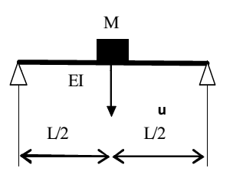
For the simply supported beam shown below:
Determine:
a) The angular frequency ω?
b) The natural frequency f?
c) The natural period T?
EI = constant"
Exercice N° 04:
Calculate ω, T, and f for the following systems.

K₁=20KN/m
x(t)
M
M=20kg
K
K=10KN/m
K₁=5N/m
x(t)
M 2kg
K₂=10N/m
K=125N/m
x(t)
M
M = 5kg

------- End of the series. -------

