2. Develop Spring Boot Backend Application

2.1: Create a Spring Boot Application
You can refer to the below address to create a Spring Boot application.
https://start.spring.io/
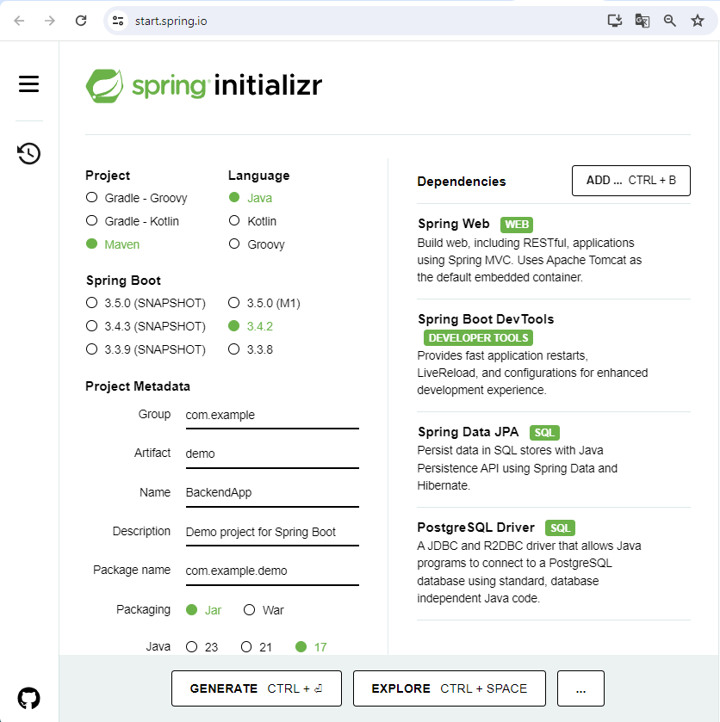
2.2: Configure application.properties to connect to your MySQL database. Add the following content to the application.properties file:
spring.application.name=BackendApp
spring.datasource.url=jdbc:postgresql://localhost:5432/emploi
spring.datasource.username=postgres
spring.datasource.password=1234
spring.datasource.driver-class-name=org.postgresql.Driver
spring.jpa.hibernate.ddl-auto=update
spring.jpa.properties.hibernate.dialect=org.hibernate.dialect.PostgreSQLDialect
2.3: You need to create the database emploi in PostgreSQL server from the PgAdmin
In the folder demo you should create the 4 folders: model, repository, controller and exception

2.4. Create JPA Entity - Employee.java
Create the Employee class inside the model package with the following contents –
import jakarta.persistence.*;

@Entity
@Table(name = "employees")
public class Employee {

@Id
@GeneratedValue(strategy = GenerationType.IDENTITY)
private long id;

@Column(name = "first_name")
private String firstName;

@Column(name = "last_name")
private String lastName;

@Column(name = "email_id")
private String emailId;

public Employee() {

}

public Employee(String firstName, String lastName, String emailId) {
super();
this.firstName = firstName;
this.lastName = lastName;
this.emailId = emailId;
}
public long getId() {
return id;
}
public void setId(long id) {
this.id = id;
}
public String getFirstName() {
return firstName;
}
public void setFirstName(String firstName) {
this.firstName = firstName;
}
public String getLastName() {
return lastName;
}
public void setLastName(String lastName) {
this.lastName = lastName;
}
public String getEmailId() {
return emailId;
}
public void setEmailId(String emailId) {
this.emailId = emailId;
}}

2.5. Create a Spring Data Repository - EmployeeRepository.java
Create the following interface inside the repository package –
import org.springframework.data.jpa.repository.JpaRepository;
import org.springframework.stereotype.Repository;

import net.javaguides.springboot.model.Employee;

@Repository
public interface EmployeeRepository extends JpaRepository<Employee, Long>{

}

2.6. Create Custom Exception
create an ResourceNotFoundException class and add the following code to it:
import org.springframework.http.HttpStatus;
import org.springframework.web.bind.annotation.ResponseStatus;

@ResponseStatus(value = HttpStatus.NOT_FOUND)
public class ResourceNotFoundException extends RuntimeException{

private static final long serialVersionUID = 1L;

public ResourceNotFoundException(String message) {
super(message);
}
}

2.7. Create Spring Rest Controller - EmployeeController.java
Create an EmployeeController class and add the following code to it:
import java.util.HashMap;
import java.util.List;
import java.util.Map;

import org.springframework.beans.factory.annotation.Autowired;
import org.springframework.http.ResponseEntity;
import org.springframework.web.bind.annotation.CrossOrigin;
import org.springframework.web.bind.annotation.DeleteMapping;
import org.springframework.web.bind.annotation.GetMapping;
import org.springframework.web.bind.annotation.PathVariable;
import org.springframework.web.bind.annotation.PostMapping;
import org.springframework.web.bind.annotation.PutMapping;
import org.springframework.web.bind.annotation.RequestBody;
import org.springframework.web.bind.annotation.RequestMapping;
import org.springframework.web.bind.annotation.RestController;

import com.example.demo.exception.ResourceNotFoundException;
import com.example.demo.model.Employee;
import com.example.demo.repository.EmployeeRepository;
@CrossOrigin(origins = "http://localhost:4200")
@RestController
@RequestMapping("/api/v1/")
public class EmployeeController {

@Autowired
private EmployeeRepository employeeRepository;

// get all employees
@GetMapping("/employees")
public List<Employee> getAllEmployees(){
return employeeRepository.findAll();
}

// create employee rest api
@PostMapping("/employees")
public Employee createEmployee(@RequestBody Employee employee) {
return employeeRepository.save(employee);
}

// get employee by id rest api
@GetMapping("/employees/{id}")
public ResponseEntity<Employee> getEmployeeById(@PathVariable Long id) {
Employee employee = employeeRepository.findById(id)
.orElseThrow(() -> new ResourceNotFoundException("Employee not exist with id :" + id));
return ResponseEntity.ok(employee);
}

// update employee rest api

@PutMapping("/employees/{id}")
public ResponseEntity<Employee> updateEmployee(@PathVariable Long id, @RequestBody Employee employeeDetails){
Employee employee = employeeRepository.findById(id)
.orElseThrow(() -> new ResourceNotFoundException("Employee not exist with id :" + id));

employee.setFirstName(employeeDetails.getFirstName());
employee.setLastName(employeeDetails.getLastName());
employee.setEmailId(employeeDetails.getEmailId());

Employee updatedEmployee = employeeRepository.save(employee);
return ResponseEntity.ok(updatedEmployee);
}

// delete employee rest api
@DeleteMapping("/employees/{id}")
public ResponseEntity<Map<String, Boolean>> deleteEmployee(@PathVariable Long id){
Employee employee = employeeRepository.findById(id)
.orElseThrow(() -> new ResourceNotFoundException("Employee not exist with id :" + id));

employeeRepository.delete(employee);
Map<String, Boolean> response = new HashMap<>();
response.put("deleted", Boolean.TRUE);
return ResponseEntity.ok(response); }}

2.8. Running Application

Or you can start the spring boot application via the command line using mvn spring-boot:run command

2.9. Testing REST APIs using Postman
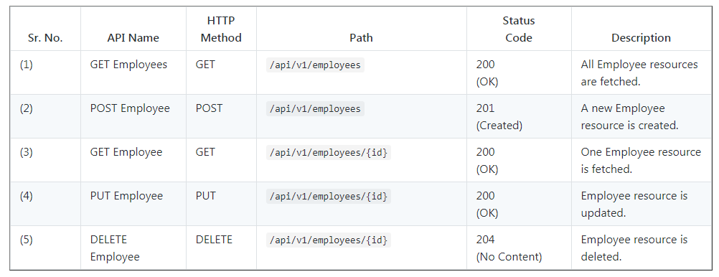
Use below Rest endpoints to test CRUD Rest APIs and in Angular application.

Get All Employees:
HTTP Method: GET
http://localhost:8080/api/v1/employees

Get Employee By Id:
HTTP Method GET
http://localhost:8080/api/v1/employees/{employeeId}

Create Employee:
HTTP Method - POST
http://localhost:8080/api/v1/employees

Update Employee
HTTP Method - POST
http://localhost:8080/api/v1/employees/{employeeId}

Delete Employee By Id:
HTTP Method - DELETE
http://localhost:8080/api/v1/employees/{employeeId}
This completes the development of Spring boot CRUD Rest APIs.
