Translated from French to English - www.onlinedoctranslator.com

Chapter 01: Magnetic materials

Translated from French to English - www.onlinedoctranslator.com

  - Introduction

Just like electric current, we can only observe the effects of magnetism. We cannot see the lines of force that exist around a magnet. The magnetic properties of some materials are due to the rotation of electrons on themselves in the atom: This phenomenon is called SPIN.
  - Magnetic materials are classified into three categories

1.2.1. Ferromagnetic materials:They can be strongly magnetized. Their magnetization persists more or less when the magnetizing field is removed. Examples: Iron, Nickel, Steel, Cobalt.
1.2.2. Paramagnetic materials:They are weakly magnetized in the direction of the magnetizing field. Their magnetization ceases as soon as the magnetizing field is removed. Examples: Aluminum, Platinum, Manganese.
1.2.3. Diamagnetic materials:They are weakly magnetized in the direction opposite to the magnetizing field. Their magnetization ceases as soon as the magnetizing field is removed. Examples: Copper, Zinc, Gold, Silver.
To explain these different types of magnetization, we must consider the magnetic moment of each atom and that of a particle of a body comprising a large number of atoms.
The atomic magnetic moment results from the movements of electrons that gravitate around the nucleus and at the same time rotate on themselves. The rotation of the electron on itself, Spin, causes a magnetic moment
The rotation of the electron on itself, Spin causes a magnetic moment${\vec{ M}}_{s}$
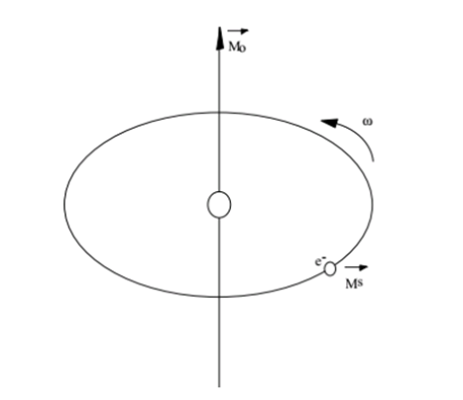

In an atom, these different magnetic moments combine to give the
Atomic magnetic moment${\vec{M}}_{a}= \sum{{\vec{M}}_{o}+ {\vec{M}}_{s}}$
For diamagnetic materials this moment is zero. For paramagnetic materials it is not zero, but the moments of all the atoms are zero.${\vec{M}}_{a}$
For ferromagnetic materials, patches of matter called Weiss domains have a non-zero magnetic moment. But in the absence of an external magnetic field, all the moments of these patches cancel each other out.${\vec{M}}_{a}$
In the presence of an external magnetizing field, the body becomes magnetized and all the particles of this body have a magnetic moment. The magnetization thus obtained depends on the nature of the body.
Diamagnetic materials become magnetized proportionally to the field in which they are placed, but in the opposite direction. The ratio between the value of the magnetization of the body and that of the field that produces it is small
Paramagnetic materials exhibit a magnetization proportional to the field in which they are placed, and in the same direction. The ratio between the value of the magnetization of the body and that of the field which produces it is small

Ferromagnetic materials are capable of magnetizing themselves much more strongly. Their magnetization is in the same direction as the inducing field, but it is not proportional. It increases with the inducing field and tends towards a limit
The materials we are going to study are part of the last category. They are the ones used for all magnetic applications in electrical engineering.

  - Permanent magnets

Permanent magnets were first developed from steel or cobalt-chromium. Around 1935, research began on alloys of iron-aluminum, nickel, cobalt, and copper. These fused or sintered alloys are known as ticonal or alnico. In 1951, barium and strontium ferrites were used. Today, ticonal and ferrite alloys are in common use and are the two most commonly used types of permanent magnet materials.
With modern materials, demagnetization due to aging or the action of a magnetic field (not too intense) can be considered negligible. This property also makes it possible to produce magnets with opposite poles very close to each other. These different properties have made it possible to abandon the classic forms of permanent magnets in horseshoe or long bar. It is now possible to produce magnets of various and very practical shapes.
In electrical measuring devices (galvanometers, ammeters and voltmeters), they have allowed in particular a great improvement in sensitivity and reliability. In some engines and generators (car alternators, dynamos, magnetos), they are used instead of electromagnets. They are also used in electronics for loudspeakers and microphones.

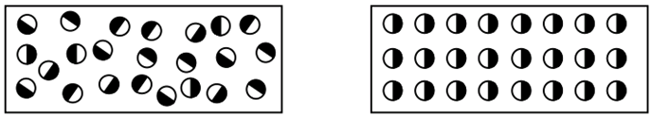
non-magnetic bar magnetic bar
In the region around a permanent magnet, there is a magnetic field that can be represented by means of magnetic lines of force similar to electric lines of force. Unlike electric lines of force, magnetic lines of force do not start from any point and do not end at any point; instead, they appear as loops

The lines of force run from the north pole to the south pole on the outside of the bar magnet, and from the south pole to the north pole on the inside. They are equally spaced and symmetrically distributed around the bar.
The lines of force occupy the smallest possible area and their interpolar length is minimal. The strength of the magnetic field of any region depends directly on the number of lines of force per unit area. In the figure above, the field strength is twice as great at point a as at point b, while the two areas are identical.

The intensity of the magnetic field H ⃗ has the same characteristics as the electric field E ⃗.
By analogy with the electric field E ⃗ , we see that when they move, the electrostatic charges Q ⃗ cause an electromagnetic force F ⃗ capable of attracting the needles of a compass.

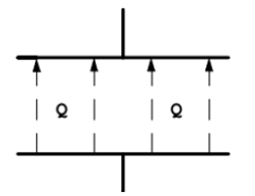

  - Magnetic potential

In a vacuum or in air, the intensity of the magnetic field H is a source of current and can be defined by the notion of magnetic potential.
To imagine this notion of potential, let's compare it to the flow of cars on a three-lane highway.
Each track is a road traffic tube with a different number of cars on a well-defined length due to different speeds. We can therefore compare it to a certain potential for car passage.

  - Magnetic potential difference

Magnetic potential difference is defined as the presence of a magnetic field intensity H between points A and B. Charges move in air with some ease.

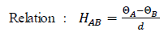

  - Lines of force or lines of induction

The induction lines or lines of force represent the vectors of the induction field influencing space.

  - Magnetic spectrum

The magnetic spectrum represents ALL the lines of force
These lines of force come from a pole admitted by convention, the North pole, perpendicular to area A, passing through a medium which could be space or something else, to close at another pole admitted by convention, the South pole.
Each line of force necessarily closes. As with the electric current I, it circulates in a closed circuit.
Which implies a line of force flowing from the South Pole to the North Pole inside the element constituting the induction field generator B. This generator can be a permanent magnet, an electromagnet or a current passing through a conductor.

  - Relationship between magnetic field strength, air permeability μ0 and relative permeability μr$\vec{H}$

Charges Q moving in a magnetic tube with a certain speed cause an electromagnetic force.$\vec{F}$ . This force is related to the material of the magnetic tube and the intensity of the magnetic field.$\vec{H}$
$$\frac{F}{Q.v}= μ_{0}.μ_{r} .H$$

The quotient$\frac{F}{Q.v}$is called the magnetic induction field.$\vec{B}$
We therefore obtain the following relation, assuming the perpendicularity between the vectors:
$$B= μ_{0}.μ_{r} .H$$

  - Magnetic induction field B

In the vicinity of permanent magnets and electric current conductors, that is to say near moving electric charges, space is modified by a magnetic induction field. Symbol of the quantity: B Symbol of the unit: T tesla
An induction of 1 tesla corresponds to a magnetic flux of weber for a surface of 1 [m²] Once again, induction can only be demonstrated by its effects.

Average values ​​of the magnetic induction field B
Earth | 0.3$μT$ | electromagnet | 0.1 to > 1$T$
Sun | 5$mT$ | Magnet to  Superconductor | - 10

To describe the properties of space, it is necessary to give a vector character to the quantity B. The electromagnetic force F exerted on electric charges can be characterized by a vector representing a set of elementary electromagnetic forces.

A coil of great length and having a large number of contiguous circular turns is called a solenoid. When an electric current passes through this coil, an induction B is produced. The magnetic field inside the solenoid is almost uniform, which is an advantage

  - Properties of the induction field B

As soon as a current passes through a conductor, magnetic lines of force are established around it. The DIRECTION of the induction lines can be defined as circular relative to the conductor through which the current I flows. The DIRECTION of the lines of force is defined by several rules. That of the right hand, the corkscrew, or that of the screw.
In the drawings we will always find the current in the conductors represented in the same way. It relates to the screw rule. When the current enters the conductor, we see the head of the screw, so we will draw a cross. When the current leaves the conductor, we will see the tip of the screw and we will draw a point.

The point indicatesthat the current flows out of the conductor.
The arrow gives the direction of the lines of force

The cross indicatesthat the current enters in the driver. The arrow gives the sense of lines of force

