Chapter 6: Torsion

1. Definition
A beam or a segment of a beam is said to be subjected to simple torsion if the internal force system can be reduced to:
$\left\{τ_{i}\right\}=\left\{\begin{matrix}0 & M_{t} \\ 0 & 0 \\ 0 & 0\end{matrix}\right\}$ Where M_{t}​ is the torsion moment around the x-axis.
Note: In this course, we only consider the torsion of beams with circular cross-sections.

2. Stress/Strain Relation
Consider a beam with a circular cross-section fixed at one end and subjected to a torsion moment M_{t} ​at the other end. It is experimentally observed that each cross-section of the beam rotates by an angle proportional to its abscissa. There is no longitudinal deformation, so there is no normal stress; only tangential stresses exist.
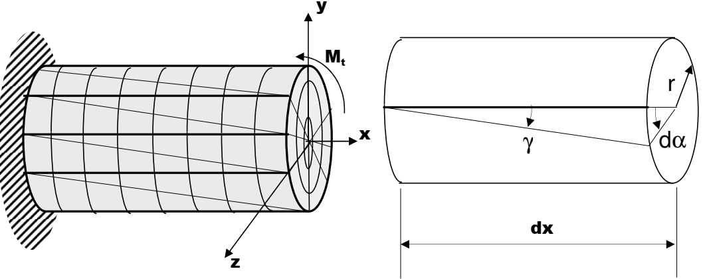
The angle of deformation γ is called the distortion. Since γ is small, we can approximate γ by tan(γ), and we obtain:
γ = r .(dα/dx)= r.θ​
Where:
- γ is the angular distortion,
- r is the radius of the section,
- θ is the rotation of the section,
- dx is the infinitesimal length.
The diagram resulting from the torsion test is similar to that from a tensile test, and it has an elastic domain and a plastic domain.
The elastic domain is governed by the shear Hooke's law:
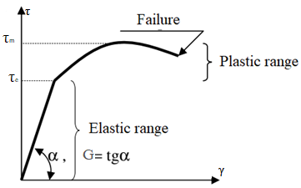
τ=G.γ
τ=G.r. θ
Where:
- τ is the shear stress,
- G is the shear modulus of the material.

We note that G is related to the Young's modulus E by the formula:
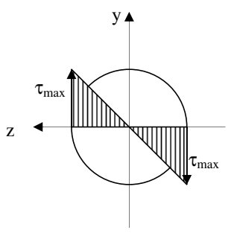
G=E/2(1+ν)
Where ν is Poisson's ratio.
The formula τ=G.r.θ​ also gives the distribution of shear stress .
over the beam's cross-section.
The shear stress is zero at the center and maximum at the outer surface.

3. Stress/Moment Relation
Consider a surface element ds of a beam's cross-section subjected to a torsion moment. This surface element, located at a distance r from the center of the section, is subjected to the shear stress τ.
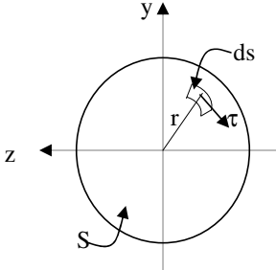
The torsion moment relative to this surface element ds is:
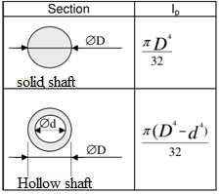
dM_{t} = τ.ds.r
Since τ=G.r.θ ​, we obtain:
dM_{t}=G.r².θ.ds
The total moment is obtained by integrating dM_{t}
over the surface S:
M_{t}=∫_{S}G.r².θ.ds = G. θ ∫_{S} r².ds = $\frac{τ}{r}$ ∫_{S} r².ds; then M_{t} = $\frac{τ}{r}$ . I_{p}
The term ∫_{S} r².ds is the polar moment of inertia I_{p}​
of the section and can be easily calculated.
The maximum shear stress occurs at r=R, and is given by:
τ_{max} = Mt.R / I_{p}

4. Relation between Rotation Angle and Moment
To calculate the rotation angle of a cross-section at abscissa x:
θ = dα /dx = M_{t} / (G.​I_{p})​ then α = ∫^{x}₀ (M_{t} / (G.​I_{p}))​ dx
Thus, the rotation angle between two extreme sections of a beam of length L is:
α=∫^{L}₀ (M_{t} / (G.​I_{p}))​ dx = M_{t} .L / (G.​I_{p}) Where:
- I_{p}​ is the polar moment of inertia of the cross-section,
- G is the shear modulus,
- M_{t}​ is the torsion moment.

5. Design Criteria
As with tension, two criteria can be used to calculate the transverse dimensions of a beam subjected to simple torsion:
- The stress criterion and
- The rotation criterion.
The stress criterion imposes that the material stays within the elastic domain (with a safety factor):
τ_{max} ≤ τ_{e}/s Where:
- τ_{max}​ is the maximum applied shear stress,
- τ_{e}​ is the shear yield strength of the material,
- s is the safety factor (s≥1s \geq 1s≥1).
The rotation criterion imposes that the angle between the extreme sections does not exceed a given limit.

6. Power Transmission
In mechanics, a shaft rotating at an angular speed ω (rad/s) and subjected to a torsion moment M_{t}​ transmits power P such that:
P = M_{t} . ω = 2 π f M_{t}
Where f is the rotational speed (in revolutions per second).

