Exercise 1:
1. What is recombinant DNA?
A DNA molecule that has been created by the joining two or more DNA molecules obtained from different sources.

2- What is a restriction-modification system?
A restriction-modification system is a defense system identified in bacteria to protect themselves against bacteriophages.
To destroy the DNA of the parasite (bacteriophages), the bacterium expresses restriction and methylation genes. The restriction genes allow the synthesis of endonucleases that cut the DNA at very specific sites.
In order to protect bacterial DNA from hydrolysis by the enzyme, a methylase, encoded by the methylation gene, will modify the nucleotides of bacterial DNA by methylating them so that they are no longer recognized by the restriction enzyme.
The restriction gene and the methylation gene together constitute a defense system of the bacterium against phages .

Exercise 2
You have just discovered a restriction enzyme in Escherichia coli strain S whose restriction site is G'AATTC.
- Write the palindromic sequence and specify its restriction site.

5'- GAATTC -3'
3'- CTTAAG -5'

- Suggest a name for this enzyme knowing that 3 other restriction enzymes have already been discovered in this bacterium.
To name a restriction enzyme, we take the first ^{letter} of the genus of the bacterium in which the enzyme was discovered in uppercase, followed by the first two letters of the species in lowercase, followed (if applicable) by the letter of the strain in uppercase, followed by the order of discovery of the enzyme.

So the name of the enzyme would be EcoS IV
Exercise 3
Restriction enzymes are widely used in molecular biology. Here are the recognition sites of two of these enzymes, BamHI and BGLII .

BamH I Bgl II

A
1- BamHI cleaves after the first G. Does cleavage by BamHI results a 5' or 3' overhang end? What is the sequence after cleavage?

BamH I gives a sticky 5' overhang end.

5'-G-3' 5'-GATCC-3'
3'-CCTAG-5' 3'-G-5'

2- Bgl II cleaves after the first T. Does cleavage by Bgl II result in an outward 5' or 3' end? What is the sequence after cleavage?
Bgl II gives a sticky 5' overhang end
5'-T-3' 5'-GATCA-3'
3'-ACTAG-5' 3'-T-5'

The DNA sequence is provided below.
5' ATTGAGGATCCGTAATGTGTCCTGATCACGCTCCACG 3'
3' TAACTCCTAGGCATTACACAGGACTAGTGCGAGGTGC 5'

3. If this DNA was cut with BamHI , how many DNA fragments would you expect? Write the sequence of these double-stranded DNA fragments.

2 FRAGMENTS
5' ATTGAG3' 5' GATCCGTAATGTGTCCTGATCACGCTCCACG 3'
3' TAACTCCTAG 5' 3' GCATTACACAGGACTAGTGCGAGGTGC 5'

4- If this DNA was cut with Bgl II , how many DNA fragments do you expect?
Write the sequence of these double-stranded DNA fragments

2 FRAGMENTS
5' ATTGAGGATCCGTAATGTGTCCT3' 5' GATCACGCTCCACG 3'
3' TAACTCCTAGGCATTACACAGGACTAG 5' 3' TGCGAGGTGC 5'

5- Can you link the small restriction fragment at 3 to the smallest restriction fragment produced at 4? Write the sequence of the resulting recombinant fragment.

YES BECAUSE BOTH ENTRIMIES ARE COMPATIBLE
5' ATTGAG3' 5' GATCACGCTCCACG 3'
3' TAACTCCTAG 5' + 3' TGCGAGGTGC 5'
GIVEN :
5' ATTGAGGATCACGCTCCACG 3'
3' TAACTCCTAGTGCGAGGTGC 5'

6- Could you cut fragment 5 with BamH I or Bel II ? Explain.

NO, BECAUSE THERE IS NO RESTRICTION SITE FOR BOTH ENZYMES

Exercise 4
The image below shows the result of agarose gel electrophoresis of three different DNA samples.

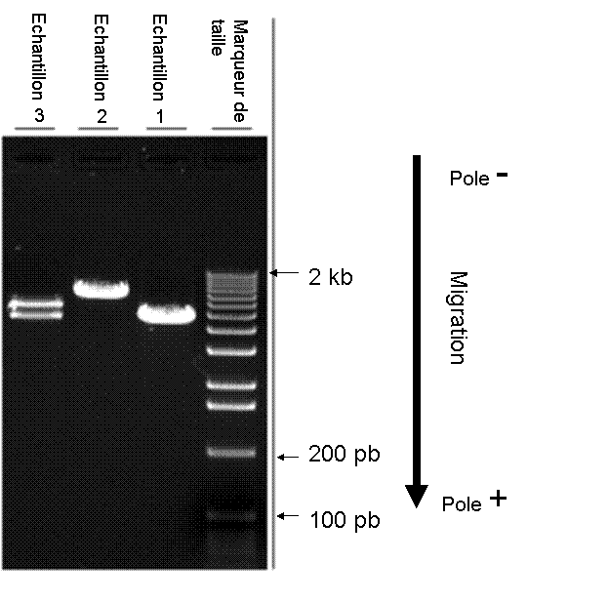

1) What is the principle behind this technique?
Agarose gel electrophoresis is a technique that separates DNA fragments based on their size. This technique has many applications, such as visualizing and analyzing DNA fragments resulting from enzymatic digestion.
In this technique, DNA is loaded into pre-molded wells in the gel, and a current is applied. An electric current is used to move the DNA molecules through an agarose gel, which is a polysaccharide matrix that acts like a sieve.
DNA (and RNA) molecules are negatively charged due to their phosphate group, so when placed in the negative pole, the DNA fragments will migrate towards the positively charged anode (positive pole).
After migration, the DNA fragments are revealed using ethidium bromide (ETB) and ultraviolet light. Ethidium bromide is an agent that can intercalate between DNA bases. When exposed to ultraviolet radiation, it becomes fluorescent, allowing visualization of the DNA bands.

2) Sample 3 contains two mixed DNA fragments. How are these two DNA fragments of different sizes separated?
The agarose gel electrophoresis technique is based on the separation of negatively charged nucleic acids under the influence of an electric field . Smaller molecules move faster and migrate further than larger molecules.

3) How can we identify the size of each fragment?
DNA samples of unknown size are typically migrated onto the same gel along with a "size marker." The size marker is a DNA sample in which the size of each band is known. This allows you to compare the unknown fragments to the size marker and determine the exact size of each fragment.

