Exercise 1:
1. What is a recombinant DNA?
2- What is a restriction-modification system?

Exercise 2
You have just discovered a restriction enzyme in Escherichia coli strain S whose restriction site is G'AATTC.
- Write the palindromic sequence and specify its restriction site.
- Suggest a name for this enzyme, knowing that three other restriction enzymes have already been discovered in this bacterium. What would be the palindromic sequence of its restriction site?

Exercise 3
Restriction enzymes are widely used in molecular biology. Here are the restriction sites of two of these enzymes, BamH I and Bgl II.

BamH I Bgl II

A
1- BamH I cleaves after the first G. Does cleavage by BamH I results a 5' or 3' overhang end? What is the sequence after cleavage?

2- Bgl II cleaves after the first T. Does cleavage by Bgl II results a 5' or 3' overhang end? What is the sequence after cleavage?

The DNA sequence is provided below.
5' ATTGAGGATCCGTAATGTGTCCTGATCACGCTCCACG 3'
3' TAACTCCTAGGCATTACACAGGACTAGTGCGAGGTGC 5'

3. If this DNA was cut with BamH I , how many DNA fragments would you expect? Write the sequence of these double-stranded DNA fragments.

4- If this DNA was cut with Bgl II , how many DNA fragments do you expect?
Write the sequence of these double-stranded DNA fragments

5- Can you link the small restriction fragment produced in question 3 to the smallest restriction fragment produced in question 4? Write the sequence of the resulting recombinant fragment.

6- Could you cut fragment produced in question 3 with BamH I or Bel II ? Explain.

Exercise 4
The image below shows the result of agarose gel electrophoresis of three different DNA samples.

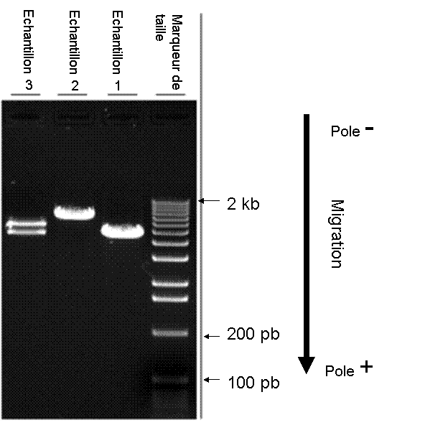

1) What is the principle behind this technique?
2) Sample 3 contains two mixed DNA fragments. How are these two DNA fragments of different sizes separated?
3) How can we identify the size of each fragment?

