Shapes in english:
- Triangles :
An isosceles triangle is a triangle with two congruent sides and one unique side and angle.
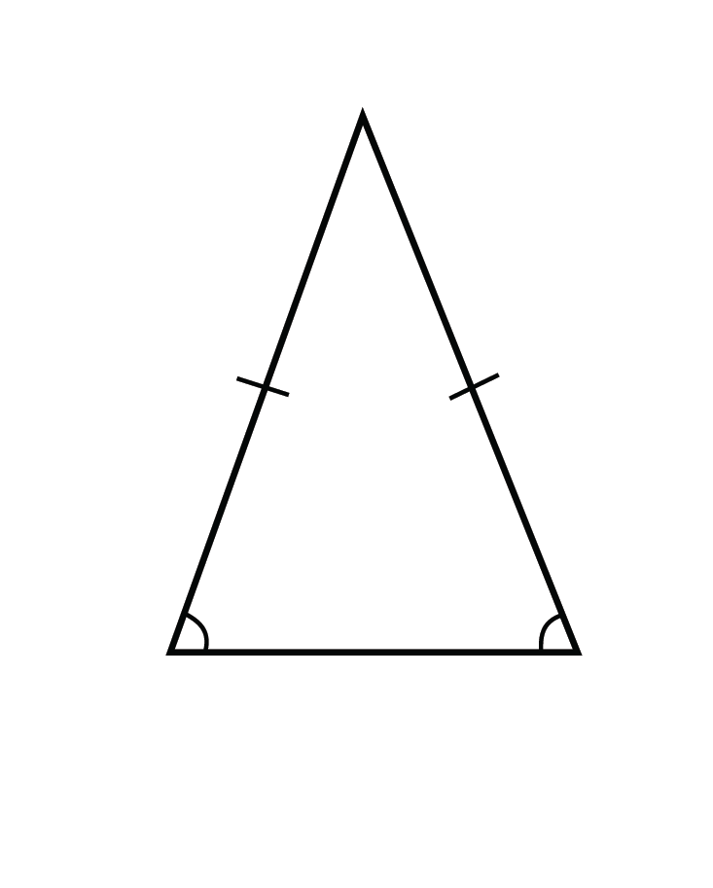
An equilateral triangle is a triangle with three congruent sides and three congruent angles.
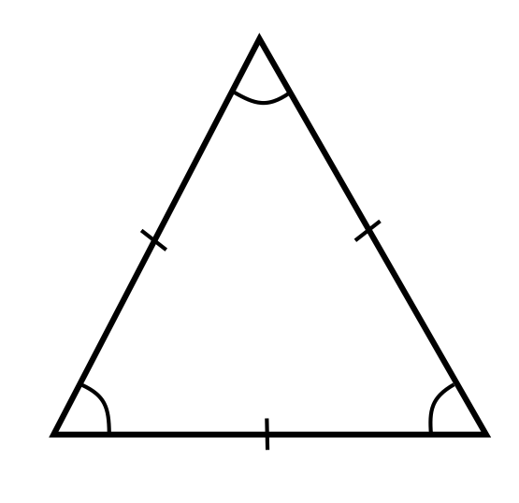
A right triangle is a triangle that has one right angle.
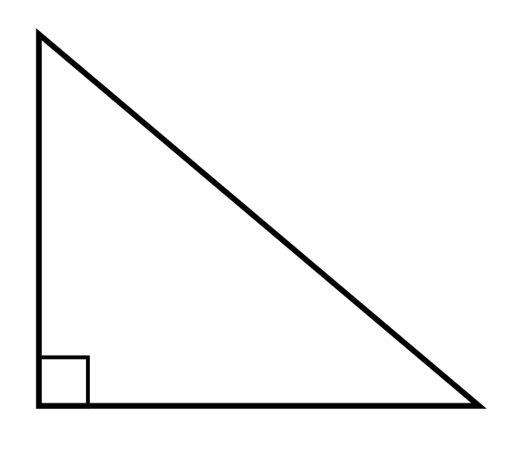

- Other shapes:
- Square : it has 4 equal sides and 4 equal angles.
- Rectangle: it has 4 sides and 4 right angles.
- Rhombuse: it has 4 equal sides.
- Parallelogram: it has 2pares of parallel sides.
- Trapezoid/ trapezium: it has one pair of parallel sides.
- Pentagon: it has 5 sides and 5 angles.
- Hexagon: it has 6 sides and 6 angles.
- Circle: it has a point in the centre from which each point on the diameter is equidistant.
- Ellipse: an oval shape.
- Cube: it has 6 faces, 12 edges and 8 vertices.
- cylinder

