Chapter 7: Simple Bending
- Definition
A beam or a section of a beam is said to be subjected to simple bending if the internal force system at each straight section is reduced to:
$\left\{τ_{i}\right\}=\left\{\begin{matrix}0 & 0 \\ T_{y} & 0 \\ 0 & M_{fz}\end{matrix}\right\}$ Where:
- T_{y}​: Shear force in the y direction
- M_{fz}​: Bending moment around the z-axis.
If in addition, T_{y}=0, the bending is pure bending.
- Relationship between normal stress and bending moment
Consider a beam subjected to bending. It is experimentally observed that the fibers located above the neutral axis shorten, while the fibers located below the neutral axis elongate. The neutral axis itself does not change in length and is referred to as the neutral fiber.
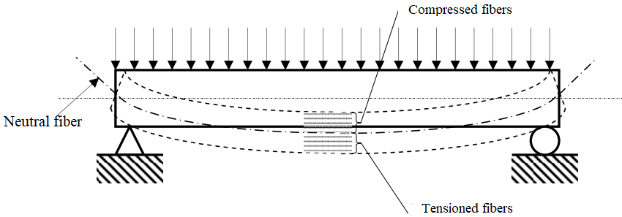
Let's study a segment d_{x} of the beam before and after deformation:
The relative deformation of the fiber ab, located at a distance y from the neutral axis, is given by:
$$ε=\frac{∆L}{L}=\frac{a^{'}b^{'}-ab}{ab}=\frac{\left(R+y\right)dθ-dx}{dx}=\frac{y}{R}$$
The length of the neutral fiber is given by dx=R⋅dθ.
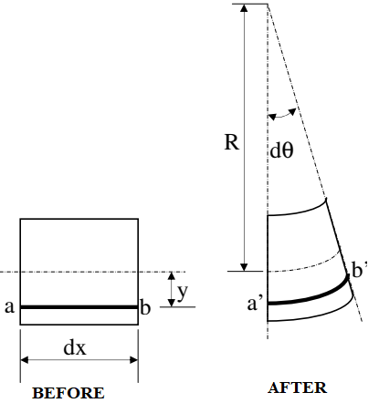
Knowing that the material obeys Hooke’s Law:
$ε=\frac{σ}{E}$ ; Then $σ=\frac{E}{R}y$
The normal stresses distributed across the cross-section
of the beam are statically equivalent to the bending moment:
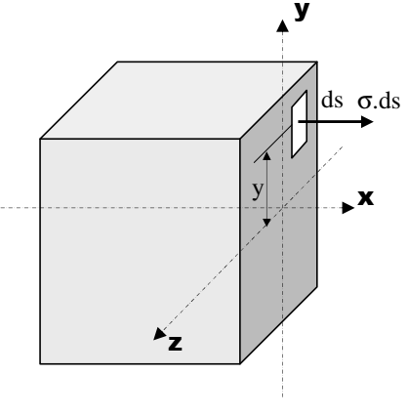

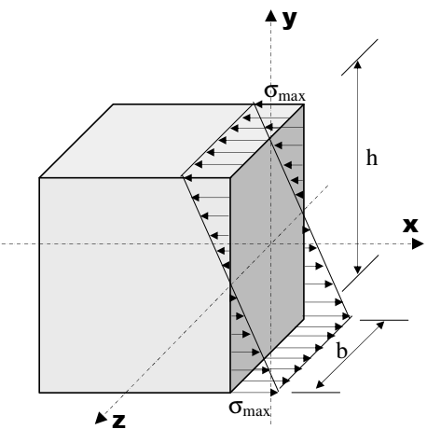
M_{f} = ∫_{s} y.σ.ds
Where: M_{f} = ∫_{s} $\frac{E}{R}$.y².ds = $\frac{E}{R}$ ∫_{s}.y².ds = $\frac{E}{R}$ . I_{GZ}
We can express the bending moment as:
Where I_{GZ}=∫s y2 ds is the second moment of area or quadratic moment
(also called the area moment of inertia) of the section S about the Oz-axis:
This formula leads to the relationship between the normal stress
σ and the bending moment M_{f}​:
σ=M_{f}⋅y/I_{GZ}
This equation informs us about the distribution of the normal stress
across the cross-section of the bent beam.
The stress is zero at the neutral fiber (y=0) and maximum at the extreme fibers (y=h/2, where h is the height of the section).
Thus, the maximum normal stress is:
σmax=M_{f}⋅h/(2⋅I_{GZ})

3. Relationship between Shear Stress and Shear Force
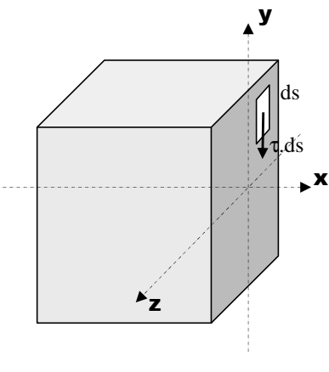
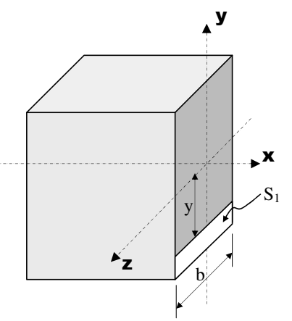
The shear stresses distributed across the cross-section of the beam
are statically equivalent to the shear force:
T_{y}=∫_{s} τ.ds
If we assume the shear stress is uniformly distributed across
the entire section, then the average shear stress can be expressed as:
τ = T_{y}/S
Where:
- T is the shear force,
- S is the cross-sectional area,
- τ is the shear stress at a point at distance yyy from the neutral axis.
In the general case, we have:
τ_{(y)}=T_{y}⋅A_{(y)}/ (B_{(y)}.I_{GZ})
Where:
- T is the shear force,
- b(y) is the width of the beam at distance y from the neutral axis.
- A(y) is the static moment of the section S1 at a distance y from the neutral axis,
- I_{GZ​} is the second moment of area (area moment of inertia) of the section.
4. Deformation of Bent Beams
The neutral axis of a bent beam is called the deformed line, and the value of the deflection at a point is called the deflection v(x). The deflection v(x) is determined by double integration of the equation:
E⋅I_{GZ}⋅v′′(x)=M_{fZ}
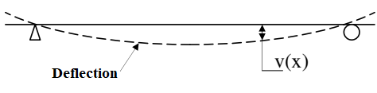
Where:
- E is the Young's modulus of the material,
- I_{GZ}​ is the second moment of area of the cross-section,
- v′′(x) is the second derivative of the deflection function (related to the curvature),
- M_{fZ}​ is the bending moment as a function of x.
The boundary conditions must be applied when solving this equation.
5. Design Criteria
As with tension, two criteria can be used to calculate the transverse dimensions of a beam subjected to simple bending: the stress criterion and the deformation criterion.
- Stress Criterion: This criterion ensures that the material remains within the elastic domain (with a safety factor). It is given by:
σ_{max}≤σ_{e}/s
Where:
- σmax​ is the maximum applied stress,
- σe​ is the yield strength of the material,
- s is the safety factor (which is ≥1).
- Deformation Criterion: This criterion ensures that the maximum deflection does not exceed a given limit:
f_{max}≤f_{lim}/S′
Where:
- f_{max}​ is the calculated maximum deflection,
- f_{lim}​ is the given limit on deflection,
- S′ is the safety factor (which is ≥1).

