Phylum Arthropoda (Arthropods)
. Phylum Arthropoda Characteristics
- They are bilaterally symmetrical, triploblastic, metamerically segmented animals.
- Body organization is of an organ-system level.
- The body is covered with a thick chitinous cuticle forming an exoskeleton which molts periodically and their appendages are joined.
- Body segments usually bear lateral and jointed appendages with varied functions as jaws, gills, legs, etc.
- Body divisible into head, thorax, and abdomen. Head and thorax often fused to form a cephalothorax.
- The musculature is not continuous but comprises separate striped muscles capable of rapid contraction.
- The body cavity is hemocoel. The true coelom is reduced to the spaces of the genital and excretory organs.
- The complete digestive system with mouth and anus. Mouthparts adapted for various modes of feeding.
- Open circulatory system with dorsal heart and arteries but without capillaries.
- Respiration by general body surface, gills in aquatic forms, trachea, or book-lungs in terrestrial forms.
- No true nephridia. Excretion organs are green glands or Malpighian tubules or coxal glands.
- The nervous system is typically annelidan, with a dorsal brain connected with a nerve ring to a double ventral nerve cord.
- Cilia are entirely absent from all parts of the body.
- Sensory organs comprise eyes (simple and compound), chemo- and tactile receptors, balancing and auditory organs.
- Sexes usually separate (dioecious). Reproduction organs and ducts paired.
- Internal fertilization. Oviparous or ovoviviparous.
- Development is usually indirect through larval stages. Parthenogenesis in some.
- Parental care is often well marked in many arthropods.
- Most diversified groups inhabiting the land, water, and air.

Phylum Arthropoda Classification
Subphylum 1- Trilobitomorpha (Gr., tria=tree+ lobos=lobe+ morphe=form)
- Represented by only fossil trilobites.
- All marine forms.
- All are bottom dwellers i.e. benthozoic and existed from Cambrian to Permian.
- The body is three lobes separated by two longitudinal furrows.
- Distinct head with one pair of antennae.
- Except for the last segments, all bears biramous appendages.
- Examples: Triarthrus, Dalmanites.
Subphylum 2- Chelicerata (Gr., chele=claw+ keros=horn+ ata=group)
- Body divisible into anterior cephalothorax or prosoma and posterior abdomen or opisthosoma.
- Prosomatic appendages 6 pairs. First pair of preoral chelicerae with claws with feeding in function.
- The second pair of appendages are postoral pedipalpi and followed by 4 pairs of walking legs.
- No antennae and true jaws.
- Mostly terrestrial and predaceous.
Class 1. Merostomata (Gr., meros=thigh+ stoma= mouth)
- Exclusively aquatic, all marine with median simple and lateral compound eyes.
- 5 to 6 pairs of abdominal appendages modified as gills or branchiae for respiration.
- Abdomen ending in a sharp telson or spine.
- Excretion by coxal glands. No Malpighian tubules.
Subclass 1. Xiphosura (Gr., xiphos=sword+aura=tail)
- Prosoma is convex covered by the abroad horseshoe-shaped carapace.
- Prosoma bears 6 pairs of appendages.
- Unsegmented abdomen with a long terminal telson.
- Genital openings paired covered by a genital operculum.
- Respiration is by lamelliform gills or book-gills attached to the abdominal appendages.
- Example: Limulus (horseshoe or king crab).
- 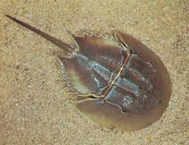
Subclass 2. Eurypterida (Gr., eurys=broad+ pteryx=wing)
- Extinct marine, giant water scorpions.
- Large-sized arthropods.
- Small cephalothorax covered by a dorsal carapace.
- 12-segmented abdomen followed by cephalothorax which is narrow behind.
- Cephalothorax with 6 pairs of appendages.
- Examples: Eurypterus, Pterygotus.
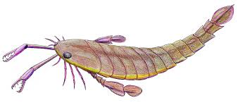

Class 2. Arachnida (Gr., arachne=spider+ oid=like)
- Terrestrial or aquatic forms.
- Simple eyes. No compound eyes.
- Prosoma bears 6 pairs of appendages; 1 pair of chelicerae, 1 pair of pedipalpi, and 4 pairs of walking legs.
- No appendages in the abdomen.
- Tracheae, book-lungs, or book-gills as a respiratory organ.
- Excretion by coxal glands and Malpighian tubules.
- Sexes separate (dioecious). mostly oviparous and courtship before mating.
- Development direct.
Order 1. Scorpionida (=scorpiones)
- Terrestrial forms found under stones in tropical and subtropical regions.
- Elongated fair-shaped true scorpions.
- Small prosoma broadly joined to large opisthosoma.
- Prosoma covered dorsally by carapace and bears a pair of chelicerae, pair of pedipalpi, and 4 pairs of walking legs.
- Opisthosoma divisible into broad anterior 7-segmented mesosoma and narrow posterior 5-segmented metasoma.
- Metasoma ending in a telson and poison sting.
- 2 ventral comb-like pectines on the 2nd abdominal segment.
- Book-lungs as a respiratory organ.
- Examples: Buthus, Palamnaeus, Androctonus.
- 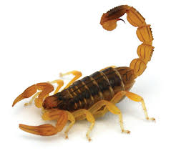
Order 2. Pseudoscorpionida (=Chelonethida)
- Tiny false scorpions.
- Found under the bark of a tree.
- Prosoma forms 6 fused segments covered dorsally by the carapace.
- Abdomen 11-segmented, without sting and telson.
- Chelicerae 2-jointed, with comb-like secretions.
- Respiration by trachea.
- Examples: Chelifer, Microcreagris.
Order 3. Palpigradi
- Small-sized micro whip scorpions.
- No eyes.
- Prosomal carapace made of large anterior and smaller posterior portions.
- Opisthosoma of 10-segments and jointed to prosoma by a pedicle.
- Telson with the along jointed flagellum.
- Chelicerae are chelate and pedipalpi leg-like.
- 3 pairs of book-lungs as respiratory organs.
- Example: Koenenia. 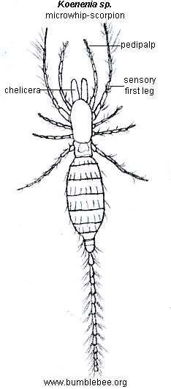
Order 4. Solifugae (=solifugida)
- False spiders. Commonly called sun spiders or wind spiders.
- The body consists of prosoma and opisthosoma.
- Prosoma divided into a large anterior and a small posterior part.
- Opisthosoma of 10 or 11 segments. No spinnerets.
- Chelicerae large and chelate, pedipalpi are elongated and leg-like.
- No poison glands.
- Respiration by trachea.
- A flagellum on each chelicera of male, for sperm transfer.
- Example: Galedodes.
- 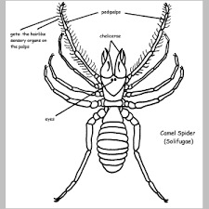
Order 5. Amblypygi (= Phrynichida)
- Flattened scorpion-spiders or taillers whip scorpions.
- Undivided carapace. Large and rhaptorial pedipalps.
- Moderate size chelicerae.
- 12-segmented abdomen without flagellum.
- First pair of walking legs long, whip-like sensory in nature.
- Example: Charinus.
- 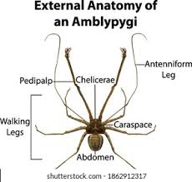
Order 6. Uropygi (=pedipalpi)
- Commonly referred to as a whip scorpion.
- Consist of a pair of eyes.
- Prosomal carapace entire.
- Chelicerae 2-jointed and moderate in size.
- Large, heavy, and usually with terminal pincers pedipalpi.
- 12-segmented opisthosoma. Last segment with a long flagellum or telson.
- Examples: Thelyphonus, Mastigoproctus.
- 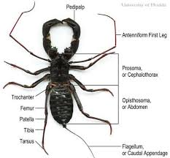
Order 7. Araneae
- True spiders.
- The body consists of prosoma and opisthosoma.
- Prosoma and opisthosoma without visible segments and jointed by a narrow pedicle.
- Prosoma bears 6-pairs appendages.
- Chelicerae 2-jointed, with a poison duct in terminal claw.
- Simple leg-like pedipalps used for a transfer of sperms in males.
- Opisthosoma with 3 pairs of spinnerets. No telson.
- 8 eyes are arranged dorsally in 2 rows on the carapace of the prosoma.
- Respiration by book-lungs or trachea or both.
- Examples: Argiope (writing spider), Aranea (house spider), Lycosa (wolf spider), Agelena (funnel-web spider).
- 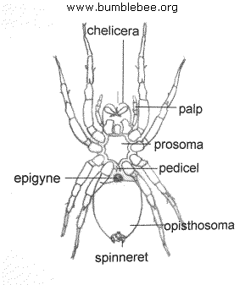
Order 8. Ricinulei (=Podogna)
- Rare, small, tick-like, heavy-bodied arachnids.
- The body consists of prosoma and opisthosoma.
- Prosoma with an anterior hood-like movable plate (Cucullus).
- Opisthosoma 9 segments and connected to prosoma by a pedicle.
- Chelicerae and pedipalpi are chelate.
- The third pair of legs in males form copulatory organs.
- Respiration by trachea.
- Examples: Cryptocellus, Ricinoides.
- 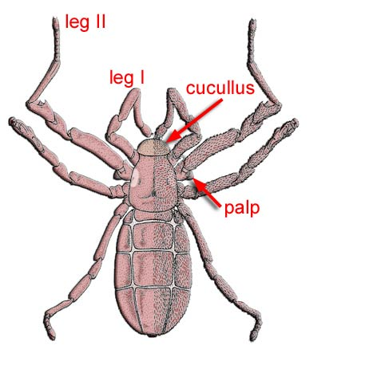
Order 9. Phalangida or Opiliones
- Spider-like Harvest-men, Harvest-spiders, or daddy longlegs.
- Small oval body. Extremely long, slender legs.
- Unsegmented prosoma, opisthosoma bears 10 segments.
- Prosoma broadly jointed to opisthosoma.
- No spinning glands.
- Respiration by trachea.
- Examples: Phalangium, Leiobunum.
- 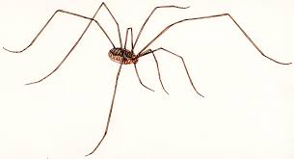
Order 10. Acarina
- Commonly referred to as ticks and mites.
- Free-living or parasitic.
- Small, oval, and unsegmented body in which prosoma is fused with opisthosoma.
- Chelicerae and pedipalpi are small and associated with the mouthparts which are adapted for biting, piercing, and sucking.
- Respiratory organs trachea or skin.
- Examples: Chorioptes (Mites), Sarcoptes (Itch-mite), Idodex (Tick).
- 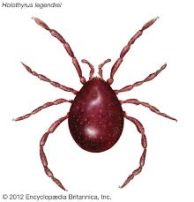
Class 3. Pycnogonida
- Commonly referred to as sea spiders.
- Very small in size.
- The body mainly consists of the cephalothorax, abdomen reduced.
- Short segmented pedipalpi and very small chelicerae.
- Usually 8 pairs of long walking legs.
- Mouth placed on the long proboscis.
- Simple eyes and 4 in numbers.
- No respiratory or excretory organs.
- Sexes separate (Dioecious). Females with a pair of ovigers for carrying eggs.
- Examples: Pycnogonum, Nymphon.
- 