Phylum Mollusca

Mollusca (Mollusks) Characteristics
- They are essentially aquatic mostly marine, few freshwater and some terrestrial form.
- They may be found as hidden parasites in the interior of other animals.
- They vary in size from giant squids and clams to little snails, a millimeter long.
- The body is soft, unsegmented (except in Monoplacophora), bilaterally symmetrical, coelomate, triploblastic.
- They have tissue-system grade of body organization
- Rasping organs, radula usually present, except in pelecypoda.
- They have at least two characters radula and mantle not found elsewhere.
- The body consists of head, foot, mantle, and the visceral mass.
- The body is clothed with one-layered often ciliated epidermis.
- The body is commonly protected by an exoskeleton calcareous shell of one or more piece secreted by the mantle.
- Head is distinct, bearing mouth, eyes, tentacles and other sense organs except in pelecypoda and scaphodoa.
- The ventral body is modified into a muscular plough-like surface, the foot which is variously modified for creeping, burrowing and swimming.
- The body cavity is hemocoel. The coelom is reduced and represented mainly by the pericardial cavity, gonadial cavity, and nephridia.
- The digestive tract is simple with anterior mouth and posterior anus but in gastropods, scaphodos, and cephalopods the intestine becomes U-shaped bringing anus to anterior part.
- The circulatory system is open type except in cephalopods.
- Respiratory organs contain numerous gills or ctenidia usually provided with osphradiuma at the base. The lung is developed in terrestrial forms.
- Respiration is direct or by gills or lungs or both.
- Haemocyanin is their respiratory pigments.
- Excretion is by paired metanephridia (kidney).
- The nervous system consists of paired cerebral, pleural, pedal and visceral ganglia joined by longitudinal and transverse connections and nerves. Ganglia usually form a circumenteric ring.
- Sense organs consist of eyes, statocysts, and receptors for touch, smell, and taste.
- Sexes are usually separate (dioecious) but some are monoecious (hermaphroditic).
- Fertilization is external or internal.
- Development is direct or with metamorphosis through the trochophore stage called veliger larva.
Phylum Mollusca Classification
Mollusca (mollusks) are classified into 6 classes according to their symmetry and the characters of food, shell, mantle, gills, nervous system, muscles, and radula.
Class 1. Monoplacophora (Gr., monos, one+ plax, plate+ pherein, bearing)
- Body is bilaterally symmetrical and segmented.
- Mantle dome-shaped.
- The shell comprises a single piece or valve.
- Flattened limpet-shaped shell with spirally coiled Protoconch.
- Head without eyes and tentacles.
- Mantle encircles the body as a circular fold of the body.
- Foot broad and flat, with 8 pairs of pedal retractor muscles.
- Gills external. 5 pairs of gills in pallial grooves.
- 6 pairs of nephridia, two of which are gonoducts.
- Radula in a radular sac; intestine much coiled.
- Heart of 2 pairs of auricles and a single ventricle.
- Sexes separate (dioecious)
- Examples: Neopilina galatheae.
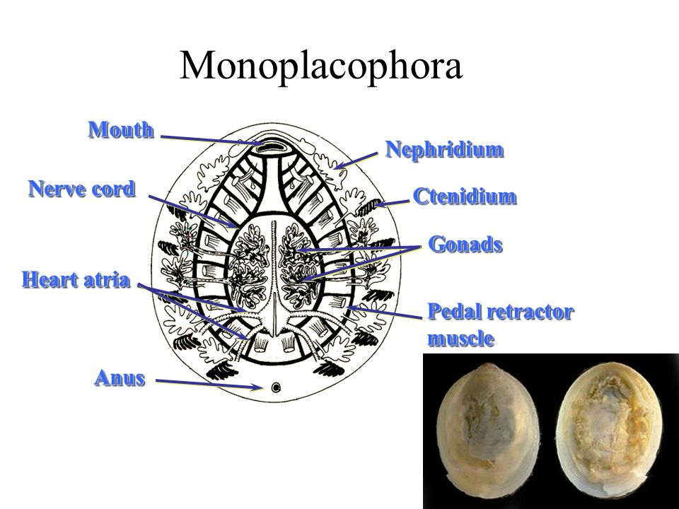
Class 2. Amphineura (Gr., amphi, both + neuron, nerve)
- Body elongated with reduced head.
- Radula present.
- Shell as 8 dorsal plates or as spicules.
- Ventral foot, large, flat and muscular.
- Non- ganglionated nerve ring around the mouth with 2 pairs of the interconnected nerve cord.
- External fertilization: trochophore larva.
Subclass 1. Aplacophora
- Worm-like body with mantle
- No shell and foot.
- Calcareous spicules buried in the cuticle.
- Simple radula; marine cavity posterior, some with a pair of bipectinate ctenidia.
- Examples: Neomenia, Nematomein, Chaetoderma.
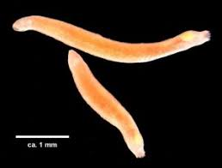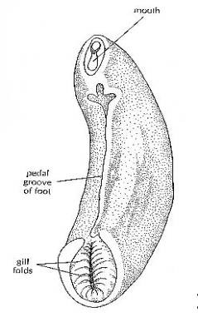
Subclass 2. Polyplacophora
- Dorso-ventrally flattened body; small head
- No eyes and tentacles.
- Radula, mantle, foot and external gills present.
- Posterior mantle cavity.
- Shell as 8 calcareous dorsal plates.
- 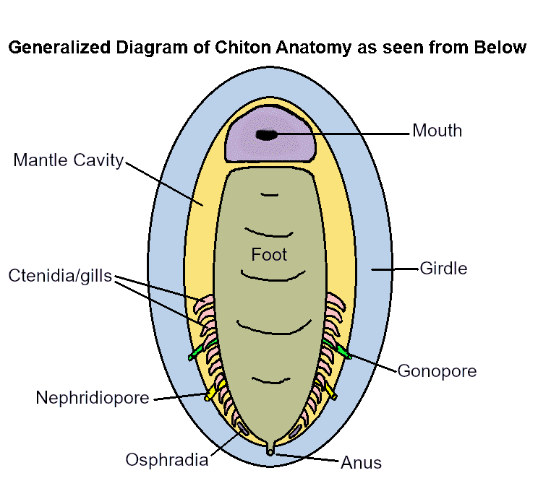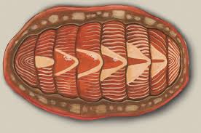
Class 3. Scaphopoda (Gr., Scapha, boat + podos, foot)
- Exclusively marine.
- The body is bilaterally symmetrical, elongated and enclosed in a tusk-shell opens at both ends.
- No head; mouth with tentacles; no eyes.
- Conical foot, radula present; no gills.
- Mantle tubular completely enclosing the body.
- Mouth surrounded by lobular processes or outgrowths.
- Heart rudimentary.
- Kidneys paired; gonad single.
- Sexes separate (dioecious).
- Trochophore larva.
- Examples: Dentalium, Cadulus, Pulsellum.
- 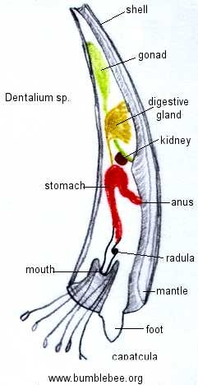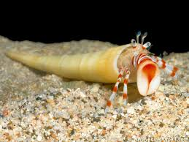
Class 4. Gastropoda (Gr., gaster, belly + podos, foot)
- Marine, freshwater, terrestrial and few parasitic on echinoderms.
- Body unsegmented, asymmetrical typically with univalve, spirally coiled
- Head distinct bearing tentacles, eyes, and mouth.
- The foot is ventral, broad, flat and muscular forming the creeping sole and often bearing dorsally a hard piece, the operculum on its posterior end.
- Torsion (coiling) of body mass at sometimes in development.
- The mantle is a collar-like fold of body wall lining the body leaving a space, the mantle cavity, between itself and the body.
- The buccal cavity contains an odontophore with a radula bearing rows of chitinous teeth.
- The digestive system comprises muscular pharynx, long esophagus, stomach, long coiled intestine, and anteriorly placed anus.
- Respiration by gills (ctenidia) in most forms, through the wall of the mantle cavity in some forms and in many by
- The open circulatory system and heart is enclosed in a pericardium.
- The excretory system comprises metanephridia which are paired in primitive forms and reduced to a single nephridium in most forms.
- Sexes separate (dioecious) in most forms.
- The development includes trochophore and veliger
Examples: Limax, Helix, Partula, Retinella.
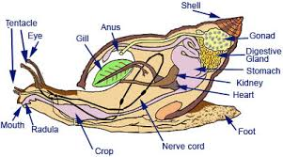
Class 5. Pelecypoda (Gr., pelekus, batchet+ podoa, foot) (Bivalvia)
- Aquatic, mostly marine, some freshwater forms.
- The body is bilaterally symmetrical and laterally compressed.
- Bivalve shells hinged together and mid-dorsally.
- Head is not distinct; pharynx, jaws, radula, and tentacles
- The foot is ventral, muscular which is ploughshare.
- Mantle bilobed, consisting of paired, right and left lobes.
- Gills or ctenidia are paired, one on each side.
- The coelom is reduced to a dorsally placed pericardium.
- The alimentary canal is coiled with large paired digestive glands.
- The heart is contained within the pericardium and comprises a median ventricle and two auricles.
- The excretory organ is paired nephridia or kidneys opens at one end into pericardium at the other end to the exterior.
- The nervous system consists typically of 4 pairs of ganglia i.e. cerebral, pleural, pedal and visceral.
- Cerebral and pleural of each side usually fused into a single Cerebro-pleural ganglion.
- Sense organs are statocyst and osphradia.
- Sexes are separate or united.
- Mostly filter-feeding.
- Development is accompanied by metamorphosis which usually includes a trochophore larva.
Examples: Poromya, Cuspidaria.
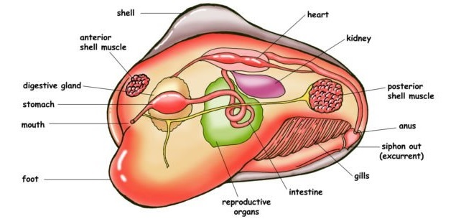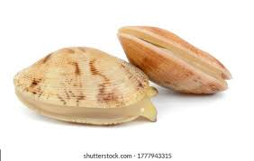

Class 6. Cephalopoda (=Siphonopoda) (Gr., kephale, head+ podos, foot)
- Marine and free-swimming.
- The body is bilaterally symmetrical with head and trunk.
- Body elongated dorso-ventrally.
- Shell external, internal or absent.
- Head distinct and large with well-developed eyes and mouth.
- The trunk consists of the symmetrical and uncoiled visceral mass.
- Mantle encloses posteriorly and ventrally a large mantle cavity.
- Foot altered into a series of suckers bearing arms or tentacles encircling the mouth.
- Moth bears jaws and radula.
- 2 or 4 pairs of bipectinate gills.
- Circulatory system closed, heart with 2 or 4 auricles.
- The excretory system comprises 2 or 4 pairs of nephridia.
- The nervous system is highly developed and the principal ganglia are concentrated around the esophagus.
- Sexes separate.
- Development meroblastic without metamorphosis.
