Phylum Annelida
Characteristics of Annelida:
- They are mostly aquatic; marine or freshwater some terrestrial.
- The body is elongated, triploblastic, bilaterally symmetrical, truly coelomate and vermiform.
- The body is metamerically segmented; each division is called a segment, metamere or somite.
- Body organization is of organ grade system.
- The epidermis covered by thin cuticle.
- The body wall is contractile or dermo-muscular consisting of outer muscle fiber circular and inner longitudinal.
- Appendages (parapodia) are jointed when present.
- Locomotory organs are segmentally repeated chitinous bristles called setae or chaetae, embedded in the skin. It may be bored by lateral fleshy appendages or parapodia.
- The alimentary canal is complete, extending from mouth to anus.
- Respiration occurs through moist skin or gills of parapodia and head.
- The blood vascular system is a closed type. Blood is red due to the presence of hemoglobin or erythromycin dissolved in plasma.
- Excretion is by nephridia, which communicate the coelom to the exterior.
- The nervous system consists of a pair of cerebral ganglia; brain and double ventral nerve cord in each segment (hyponeurian).
- Receptor organs include tactile organs, taste buds, statocysts, photoreceptor cells and sometimes eyes with lenses in some.
- Most of the Annelids are hermaphrodite
- Their development is direct in monoecious form but indirect in dioecious form.
- Larva, when present is a trochophore is characteristics in case of indirect development.
- Regeneration is common.
- Asexual reproduction occurs in some.

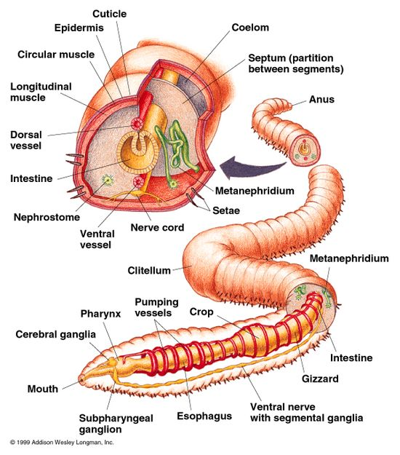

Classification of Phylum Annelida
Annelida are divided into four main classes, primarily on the basis of presence and absence of parapodia, setae, metameres, and other morphological features.
Class 1- Polychaeta (Gr., poly=many, chaeta=bristles/hair)
- Chiefly marine, some freshwater.
- Carnivorous
- Body segmentation is internal and external.
- Head consists of prostomium and peristomium and bears eyes, tentacles cirri, and palps.
- Setae numerous on lateral parapodia.
- The clitellum is absent.
- Cirri or branchiae or both may be present for respiration.
- Sexes separate. Gonads temporary and in many segments, Fertilization external.
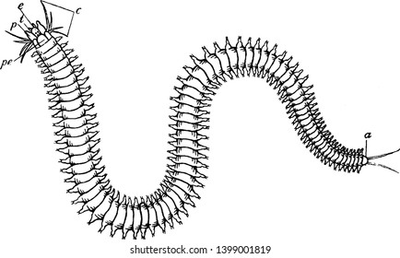
Class 2- Oligochaeta (Gr., oligos=few+ chaete=hair)
- Mostly terrestrial or some freshwater forms.
- Setae few, embedded in the skin.
- Parapodia absent.
- Glandular clitellum present for cocoon formation.
- Hermaphroditic i.e. sexes united.
- Development is direct. fertilization external (in cocoon); no larval stage.
Examples: Pheretima, Eutypheus, Megascolex, Lumbricus.

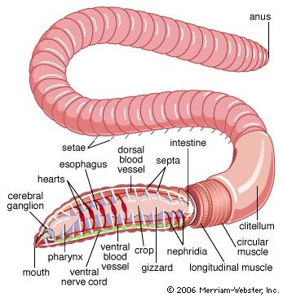
Class 3- Hirudinea (L., hirudo= a leech)
- Mostly ectoparasitic, blood-sucking or carnivorous. Few are marine, freshwater or terrestrial.
- The body consists of a fixed number of segments (33). Segmentation external without internal septa.
- Parpodia and setae are absent.
- Both anterior and posterior ends of the body with ventrally situated suckers.
- The mouth opens on the ventral surface on anterior suckers, while anus opens dorsal to the posterior suckers.
- Hermaphrodite with one male and one female gonopore.
- Fertilization internal.
- Eggs are always laid in cocoons.
- Development is direct without a free-swimming larval stage.
Examples: Hirudo, Hirudinaria,
