DW4
Exercise 1
A beam with simple supports at A and B supports a force F at its center.
- Calculate the cohesion wrench in the cross-section G1near A and deduce the type of solicitation in this area.
- Assuming a uniform distribution of the shear stress in the section G1​, calculate its value.
Neglect the weight of the beam. Given: F=50 kN.
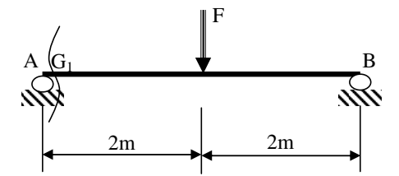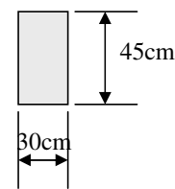
Exercise 2
A punching machine is used to manufacture washers by shearing mild steel sheets.
Calculate the force F required for the cutting operation.
Given:
- Diameter of the washers: d=20 mm
- Thickness of the sheet: e=2 mm
- Shear strength of the steel: τm=70 MPa
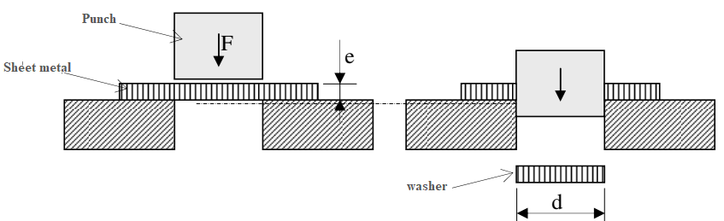
Exercise 3
A shaft A transmits a torque C=2 kN.m to a second shaft B via bolted plates. The shafts are connected to the plates by keys.
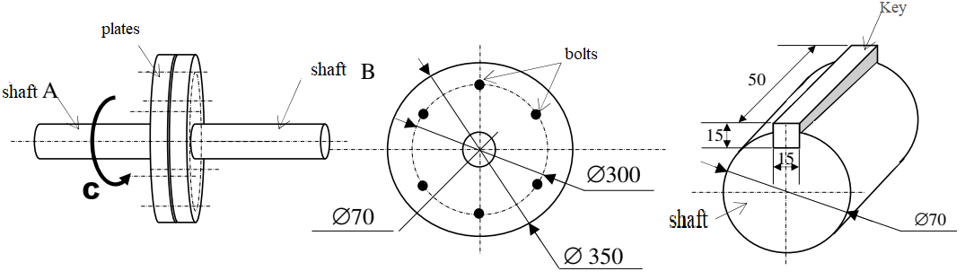
- The bolts are considered as simple sheared pins. Calculate the diameter of a bolt if its shear yield strength is τe=100 MPa.
- Calculate the shear stress in the key.

