Phylum Nemathelminthes
General characteristics:
• The phylum ‘Nemathelminthes’ (Gr; nematos = thread ; helminths = worm) or Nematoda comprises the roundworms.
• Nematodes are ubiquitous and are found in freshwater, marine, as well as terrestrial environments.
• Most of the species of nematodes live a parasitic life, though a number of free-living forms are also present.
• These are triploblastic, bilaterally symmetrical animals with organs system level of body organization with pseudocoel (i.e pseudocoelomate). Pseudocoelom ; False coelom derived from embryonic blastocoel.
• Body is elongated, cylindrical, unsegmented and vermiform.
• Body round in cross section and covered with transparent cuticle composed of scleroprotein.
•A syncytial epidermis ; the nuclei are not separated from each other by cell membranes.
• Body wall has only longitudinal muscles.
• No distinct head, digestive tract complete usually surrounded by lip bearing sense organs include amphids, phasmids, papillae, bristles and ocelli.
• The digestive system is complete with a distinct mouth and anus.
• Both respiratory and circulatory system are absent.
• Excretory system comprised of one or two renette cells or protonephridia.
• Nervous system consists of circumpharyngeal nerve ring and six longitudinal nerve cords. Presence of sensory papillae. (Amphids : in mouth, Phasmids : in anus)
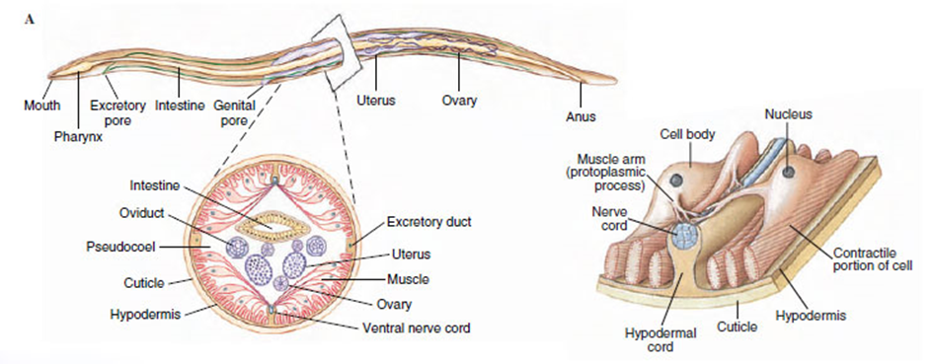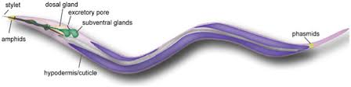
• Sexes are separate (gonochoristic). The male is smaller than females.
•Tubular gonad is present in them. Male genital duct leads into the cloaca. Female genital ducts with a separate opening.
•No asexual reproduction.
•Fertilization is internal
•Development may be direct, with or without an intermediate host or indirect.
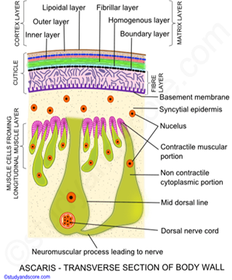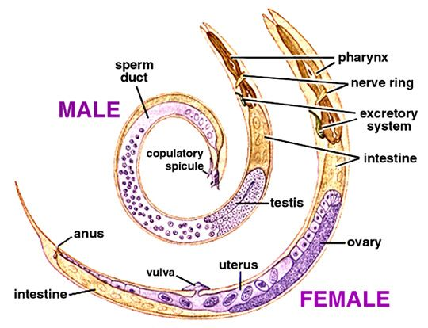

Classification of nemathelmimthes:
Phylum Nemathelminthes is divided into two classes based on the presence or absence of phasmids.
a) Adenophorea or Aphasmidia
• are XiphinePhasmids, the sensory organs in the caudal end, are absent.
• Amphids are variably-shaped and are present behind the lips.
• Excretory canals are absent
• Most species are free living and some are parasitic.
• Free living species include almost all marine forms; and some terrestrial and freshwater forms
• A few examples ; Mermis and Enoplus.
b) Secerenentea or Phasmidia
• Phasmids are present which open through minute pore on each side near tip of tail.
• Amphids are pore-like and are present in the lateral lips.
• Excretory canals are present.
• Most of the species are parasitic in nature.
• Free living species are soil inhabitants.
• A few examples are Ascaris, Wuchereria, Oxyuris, Ancylostoma and Dracunculus
Example:
Ascaris lumbricoides] these species are very large (adult females: 20 to 35 cm; adult males: 15 to 30 cm) nematodes (roundworms) that parasitize the human intestine.
Life Cycle:
Adult worms live in the lumen of the small intestine. A female may produce approximately 200,000 eggs per day, which are passed with the feces . Unfertilized eggs may be ingested but are not infective. Larvae develop to infectivity within fertile eggs after 18 days to several weeks , depending on the environmental conditions (optimum: moist, warm, shaded soil). After infective eggs are swallowed , the larvae hatch , invade the intestinal mucosa, and are carried via the portal, then systemic circulation to the lungs . The larvae mature further in the lungs (10 to 14 days), penetrate the alveolar walls, ascend the bronchial tree to the throat, and are swallowed . Upon reaching the small intestine, they develop into adult worms. Between 2 and 3 months are required from ingestion of the infective eggs to oviposition by the adult female. Adult worms can live 1 to 2 years.
