DW3
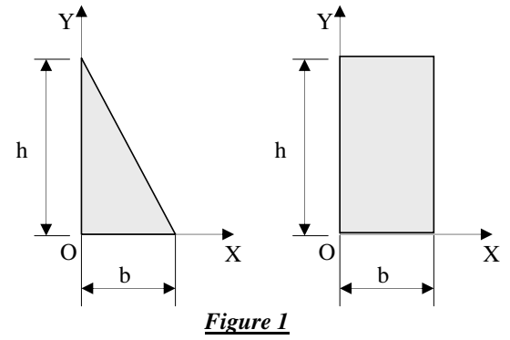
Exercise 1
- Calculate the coordinates XG and YG of the centers of gravity of the sections of Figure 1.

Exercise 2
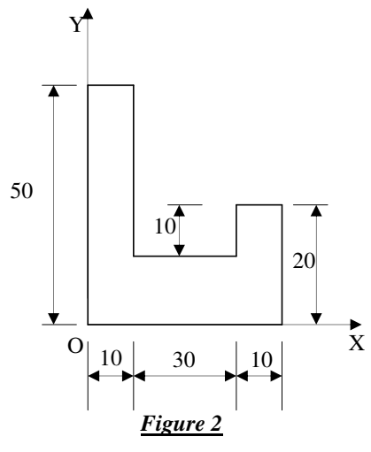
- Calculate the coordinates XG and YG of the centers of gravity of the sections of Figure 2.
- Calculate the quadratic moments IOX and IOY of the section in Figure 2 (cm)

Exercise 3
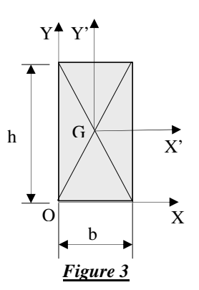
- Calculate the quadratic moments IGX' and IGY' of the section in Figure 3.
- Calculate the quadratic moments IOX and IOY of this section.

