Chapter 5: Pure Shear
- Definition
A beam or a section of a beam is said to be subjected to pure shear if the internal force tensor at each straight section can be summarized as:
$$\left\{τ_{i}\right\}=\left\{\begin{matrix}0 & 0 \\ T_{y} & 0 \\ T_{z} & 0\end{matrix}\right\}$$
where:
- T_{y} ​: Shear force in the y-direction
- T_{z}​: Shear force in the z-direction
This is the general case; particular cases arise when one of the shear forces is zero.
- Shear Stress/Shear Force Relationship
​​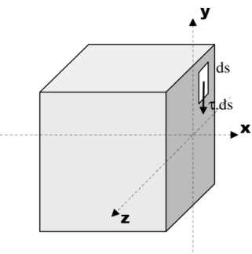
The shear stresses distributed over the cross-section of the beam are statically equivalent to the shear force:
T_{y} = _{s}⌡τ ds
Assuming that the shear stress is uniform across the entire cross-section, we have:
τ=T_{y}/S

In the general case, we have:
$$τ_{(y)}=\frac{T_{y}.A_{(y)}}{b_{(y)}{.I}_{GZ}}$$
where: A_{(y)} = _{s1}⌡y. ds Static moment of section S1
- T_{y}​: Shear force
- b_{(y)}: Width of the beam at distance yyy from the neutral axis
- I_{GZ} ​: Quadratic moment of the section
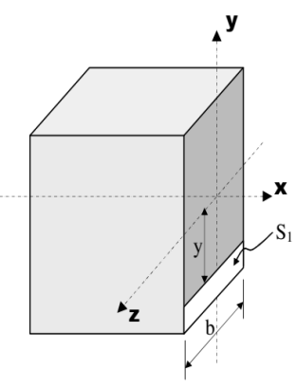

- Shear Deformation
The diagram resulting from the shear test is similar to that from the tensile test; it includes an elastic region and a plastic region.
The elastic region is governed by Hooke's law in shear: τ=G⋅γ

Where:
- τ: shear stress
- G: shear modulus of the material
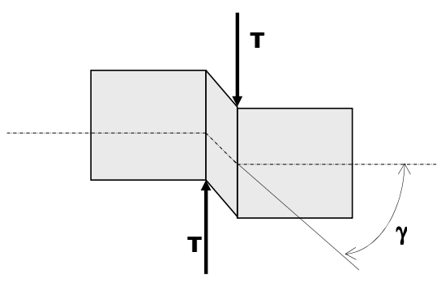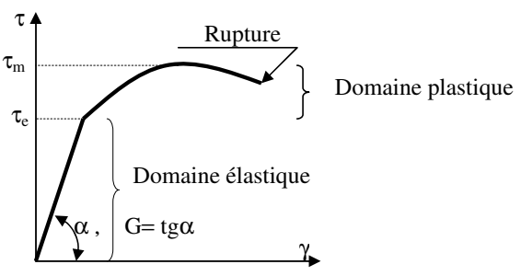
It is noted that G is related to E by the formula: G=E/(2.(1+ν))
Where: ν is Poisson's ratio.
- Design Criteria
The main criterion used to calculate the transverse dimensions of a beam subjected to pure shear is the stress criterion, which requires that the material remains (with a safety factor), within the elastic region:
τ_{max}≤ τ_{e}/s
Where:
- τ_{max}​: maximum applied stress
- τ_{e}​: shear yield strength of the material
- s: safety factor (≥ 1)

