Phylum of Cnidaria

Characteristics of Cnidaria
Cnidaria characteristics are listed below:
- They are also called coelenterate.
- Cnidarians are multicelluar.
- Diploblastic Tissue Organization: They have 2 distinct cell layers: inner endoderm and exterior ectoderm.
- Radial Symmetry: Cnidarians exhibit radial symmetry, meaning their body parts are arranged around a central axis, allowing them to be divided into similar halves in any plane. This symmetry allows them to interact with their environment from all directions.
- Species of phylum cnidaria are aquatic organisms, which means they live in water. Most of them prefer marine water. Few of them live in freshwater.
- They lack respiratory, circulatory, and excretory systems.
- Gastrovascular Cavity: Cnidarians have a central digestive cavity called the gastrovascular cavity. This cavity has a single opening that functions as both the mouth and anus. It aids in digestion and distribution of nutrients throughout the organism.
- They have a primitive nervous system in the form of net nerves
- They have stinging cells called Cnidoblast. These cells are found around the tentacles and mouth of the cnidarians and contain organelles called nematocysts, Stinging cells paralyze prey with poisons.
- They possess a cavity called coelenterates.
- They can reproduce by sexual and asexual reproduction. Asexual reproduction by budding or spores. Sexual reproduction by fusion of gametes of separate or non-separate sexes. The fertilization in sexual reproduction is external.
- They can live in colonies or alone (solitary).
- Cnidaria are heterotrophic which means they obtain energy from another source. They obtain energy in different ways. Some use their toxins to kill the prey and feed on them. Others live symbiotically with other organisms such as algae while others live as parasites on other organisms.

Forms of cnidarian
There are two basic body plans in cnidarians. They are called the polyp and medusa. Both are shown in Figure below. The polyp has a tubular body and is usually sessile. The medusa (plural, medusae) has a bell-shaped body and is typically motile. Some cnidarian species alternate between polyp and medusa forms. Other species exist in just one form or the other.
The body of a cnidarian consists of two cell layers, ectoderm and endoderm. The cellssurround a digestive cavity called the coelenteron (see Figure below). Cnidarians have a simple digestive system. The single opening is surrounded by tentacles, which are used to capture prey. The tentacles are covered with nematocyst cells. Digestion takes place in the coelenteron. Nutrients are absorbed and gases exchanged through the cells lining this cavity. Fluid in the coelenteron creates a hydrostatic skeleton./
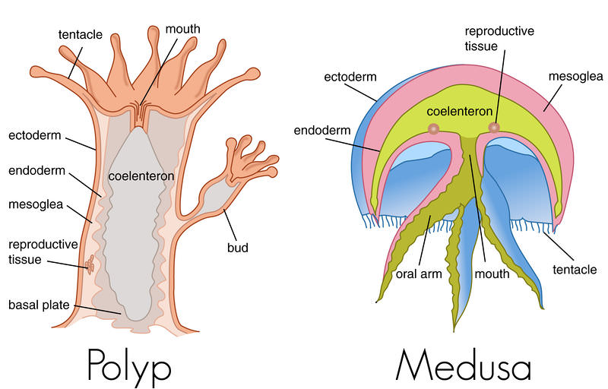
Cnidarian Reproduction
Figure below shows a general cnidarian life cycle. Polyps usually reproduce asexually. One type of asexual reproduction in polyps leads to the formation of new medusae. Medusae usually reproduce sexually. Sexual reproduction forms a zygote. The zygote develops into a larva called a planula. The planula, in turn, develops into a polyp. There are many variations on the general life cycle. Obviously, species that exist only as polyps or medusae have a life cycle without the other form.
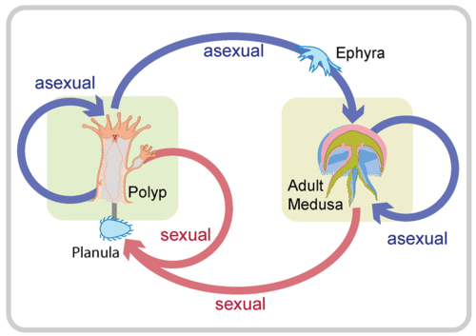

General Cnidarian Life Cycle. Cnidarians may reproduce both asexually and sexually.
Classification of Cnidaria
Phylum Cnidaria is further divided into four main classes:
Hydrozoa: (Gr. Hydros=water, zoon=animal)
Hydrozoans include organisms such as hydroids, Portuguese man o’ war, and fire corals. They typically have both polyp and medusa stages in their life cycle. The polyp form is usually colonial and can form intricate structures, while the medusa form is free-swimming.
Scyphozoa: (Gr. skyphos=cup, zoon=animal)
Scyphozoans, commonly known as jellyfish, are mostly marine organisms that spend a significant portion of their life cycle in the medusa form. They have a bell-shaped body and trailing tentacles armed with stinging cells.
Anthozoa: (Gr. anthos=flower, zoon=animal)
Anthozoans are exclusively polypoid and include organisms such as sea anemones, corals, and sea fans. They lack a medusa stage and are mostly sessile, attaching themselves to the substrate. Anthozoans are essential in coral reef ecosystems.
Cubozoa: Cubozoans, or box jellyfish, are a small class of cnidarians known for their box-shaped bell and tentacles that extend from the four corners. They are mainly found in tropical and subtropical waters and are known for their potent venom.

