DW2
Exercise 1
A concrete pole with a circular cross-section resting vertically on a rigid foundation is subjected to a force F acting along its axis.
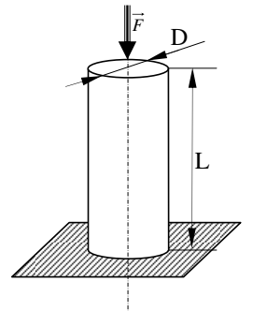
- What type of load is the pole subjected to?
- Calculate the normal stress in the pole.
- Check the strength of the pole.
- Calculate the axial deformation of the pole.
- Calculate the change in length ∆L.
Given: IFI = 10⁶ N, D = 30 cm, L = 3 m, σ_{e} = 25 MPa, E = 10⁴ N/mm².
Exercise 2
A trailer is towed by a steel hitch bar with a square cross-section, and it is subjected to the force F.
- What type of load is the bar subjected to?
- Find the minimum cross-section of the bar so that it can withstand the force F.
- Calculate the change in length ∆L.
Given: F = 8000 N, L = 2 m, σe = 36 daN/mm², E = 2 × 10⁵ N/mm², Safety factor = 3.
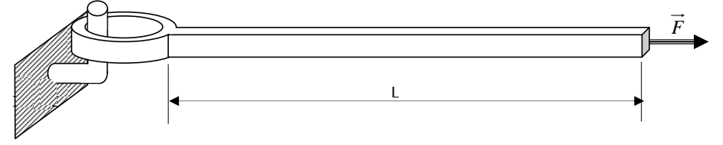
Exercise 3
A steel cable of length L, made up of 7 twisted wires each with a diameter d, lifts a load Q.
- What type of load is the cable subjected to?
- Calculate the stress in the cable.
- Check the strength of the cable.
- Calculate the axial deformation of the cable.
- Calculate the change in length of the cable.
Given: Q = 1.2 t, d = 2.5 mm, L = 10 m, E = 210,000 MPa, σe = 420 MPa, safety factor = 1.2.
