Chapter II: Cell study methods
Tutorial session N° 3: Cellular and subcellular fractionation methods
1- Definition
Cell fractionation methods consist in separating the different components of the cell by destruction of the plasma membrane, in order to analyze their structure and function.
2- The cell fractionation steps
Cell splitting is done in two stages:
- Homogenization: cell grinding.
- Purification: separation of cell organelles by centrifugation or ultracentrifugation.
2-1-Homogenization (or grinding)
Homogenization consists of destroying the plasma membrane (plus the wall of plant and fungal cells). This step leads to homogenate all the containing components of the cell. To obtain an homogenate, the cells are placed in a test tube containing an isotonic solution; one of the following treatments will fractionate this suspension:
- Mechanical: crushing by a piston.
- Physical: with ultrasound or high pressure.
- Chemical: with detergents (acids or bases) or by enzymes.
The grinding medium must meet chemical and osmotic requirements: its pH is neutral and its ionic composition as close as possible to that of the cytoplasm. A 0.25 M sucrose solution is considered isotonic to most vesicular organelles.
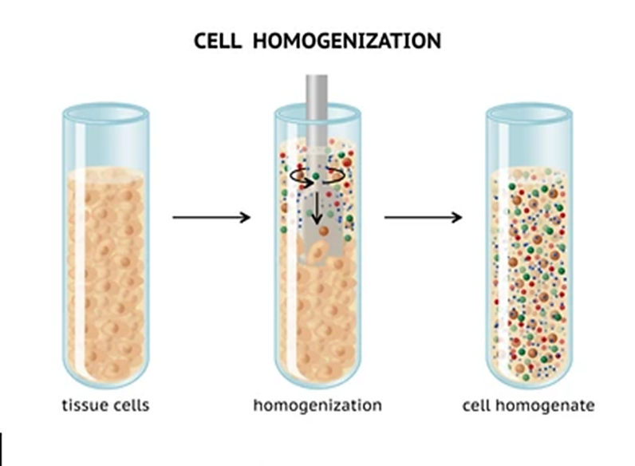
Figure 1: Mechanical homogenization by a piston.
2-2-Purification
Purification consists of separating cell structures into pure fractions by a centrifugation (or ultracentrifugation) technique.
- Differential centrifugation
- Cell homogeneity is subject to a succession of centrifugations at increasing times and accelerations.
- The initial extract is divided into a series of units and supernatants.
- The rate of sedimentation of particles (organelles, macromolecules, etc.) depends on their size, shape and density, so that the largest and densest particles of the homogenate form the first sediment (or pellet).
- The sedimentation rate is defined by the sedimentation coefficient given in Svedberg units (S).
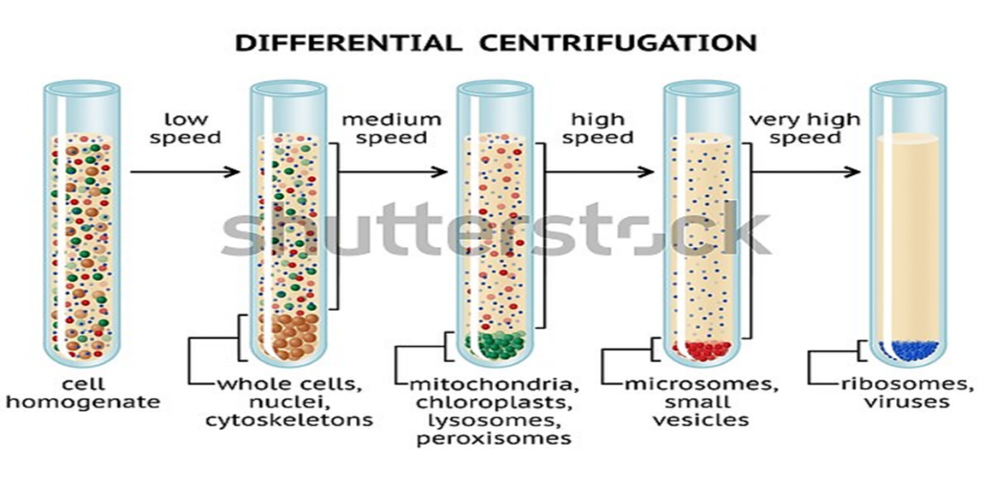
Figure 2: Cell fractionation by centrifugation and differential ultracentrifugation.

- Density gradient Centrifugation
- This technique allows organelles and even small biological particles with very similar sedimentation rates to be separated at one time.
- Density gradient centrifugation consists of depositing a thin layer of homogenate over the sucrose solution, the concentration of which varies steadily and decreasing from bottom to top.
- After centrifugation, each element of the sample concentrates on an area of the tube whose density is equal to that of the element, thus obtaining different bands (the densest layer being at the bottom).

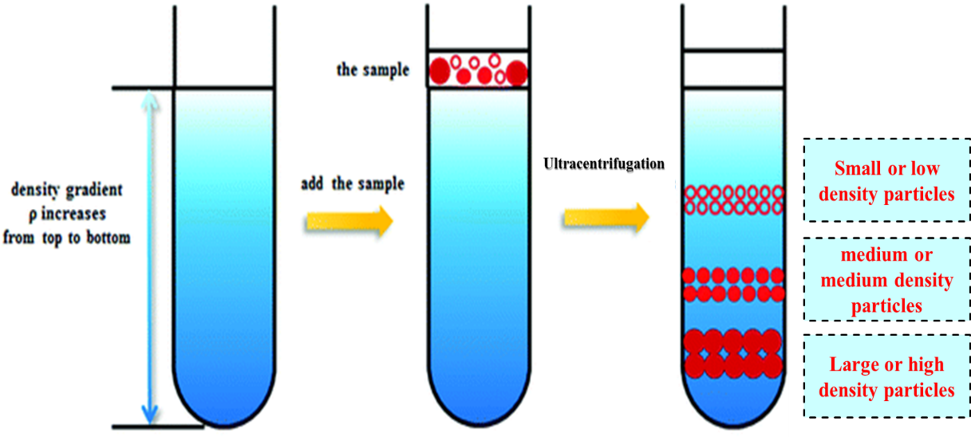
Figure 3: Cell fractionation by ultracentrifugation on density gradient.

