Chapter II: Cell study methods
Tutorial session N° 2: Histological sections preparation techniques

1-Preparation of sections for observation under an optical microscope (Figure 1)
For the classical histological study, the fine sections are prepared in several steps:
a)- Sampling
- The sampling performed on an organ should be done as gently as possible to avoid damaging the tissues.
- Once obtained, the sampling should be immersed immediately in a large volume of fixing liquid.
b) Fixation
- Fixation aims to preserve the structures and harden the specimens.
- It can be done using a fixing liquid or by freezing.
- The most commonly used fixing liquids are formalin and Bouin's solution (a mixture of formalin and picric acid).
- The duration of fixation and the volume of fixing liquid used vary depending on the size of specimens. It is recommended to use a fixing liquid volume equal to 5 times the volume of specimen.
c) Dehydration
- The purpose of dehydration is to remove the water from the specimen.
- Water is removed by passing the specimen through alcohol baths of increasing concentrations (from 50° alcohol to absolute alcohol 100°), and then through xylene or toluene baths. This step prepares the specimen for embedding, since paraffin is hydrophobic.
d) Embedding
- The purpose of embedding is to stiffen the specimen, allowing the creation of thin and regular sections.
- The used embedding medium is paraffin, which solidifies the specimen.
- Immerse the specimen in liquid paraffin maintained at 56°C in an oven.
- After 4 hours of embedding, the liquid paraffin is poured into a small metal mold called "Leuckart bars". After cooling, a solid paraffin block is obtained, inside which the sampled specimen is embedded.

e) Sectioning (Microtome)
- Paraffin block sections are made using a microtome, which allows obtaining thin slices of 2 to 5 µm in thickness, arranged in a regular series in the form of ribbons.
- The sections are collected on glass slides.

- Deparaffinization
- The glass slides are placed on a heating plate (at 45-60°C) for 15 minutes to liquefy the paraffin.
- Remove the paraffin by passing the slides through toluene or xylene baths.
g) Rehydration
- To rehydrate the samples and remove intracellular paraffin, the slides are immersed in a series of decreasing degrees alcohol baths. First, the slides are placed in 100% alcohol for a few minutes, then transferred to 95% alcohol, then to 90% alcohol, and so on until reaching 50% alcohol.
- Finally, the slides are immersed in distilled water to completely remove the paraffin.
- Coloring (staining)
- Coloring increases the contrast in order to differentiate the different cellular constituents.
- The sections are colored using different types of stains. The appropriate dyes for the study are used.
- Microscopic assembly and observation
- The colored sections are mounted between blade and coverslip with a synthetic resin. “Canada balsam” whose refractive index is close to that of glass. We thus obtain a histological preparation ready to be observed under an optical microscope.

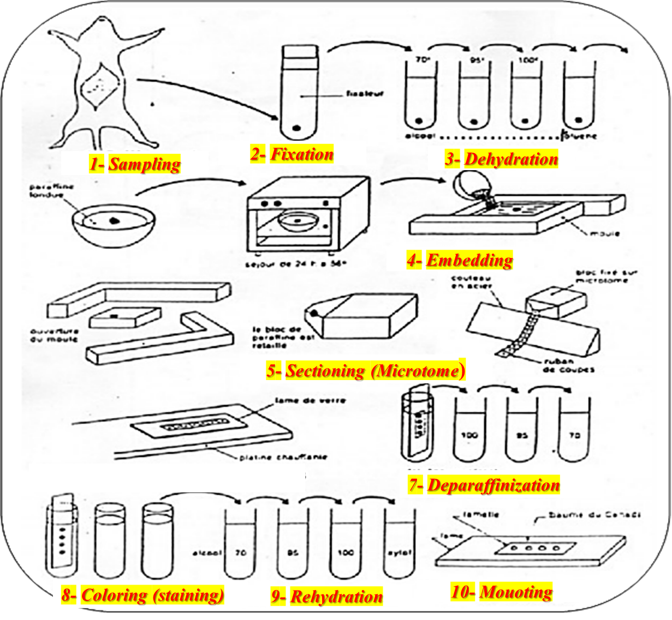
Figure 1: Preparing of sections for optical microscope observation.
2-Preparation of sections for observation under an electron microscope (Figure 2)
The manipulation sequence is similar to that described for optical microscope:
a)- Fixation
- It is usually done in glutaraldehyde, followed by post-fixation with osmic acid (osmium tetra-oxide OsO4).
b)- Dehydration
- The samples will be passed through increasing concentrations of ethanol then through propylene oxide.

c)- Inclusion
- The samples are included in a resin (araldite) which allows the sample to solidify, through their polymerization.

d)-Cutting (Ultramicrotomy)
- The resin blocks containing the sample are cut using an ultra-microtome equipped with a glass or diamond knife, which makes it possible to obtain ultrathin sections of approximately 80 nm in thickness.
e) Contrast
- Cell sections are collected on a copper grid.
- The grid is dipped in a heavy metal solution (uranyl acetate and lead citrate) to darken cellular structures and increase contrast.
- The grid is then introduced into the TEM for observation.
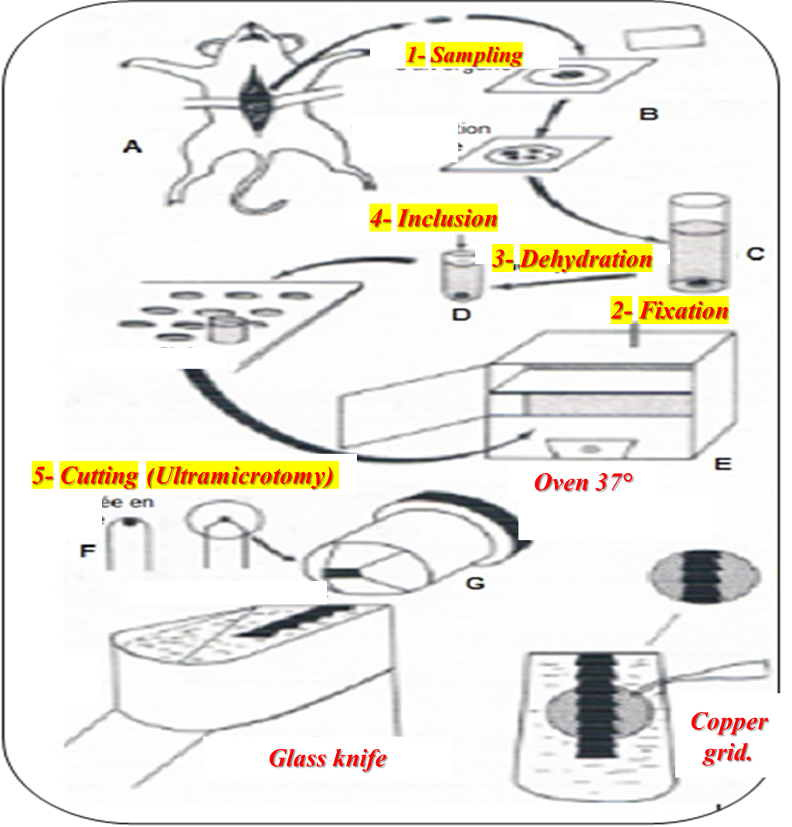
Figure 2: Preparation of sections for observation under transmission electron microscope (TEM).

