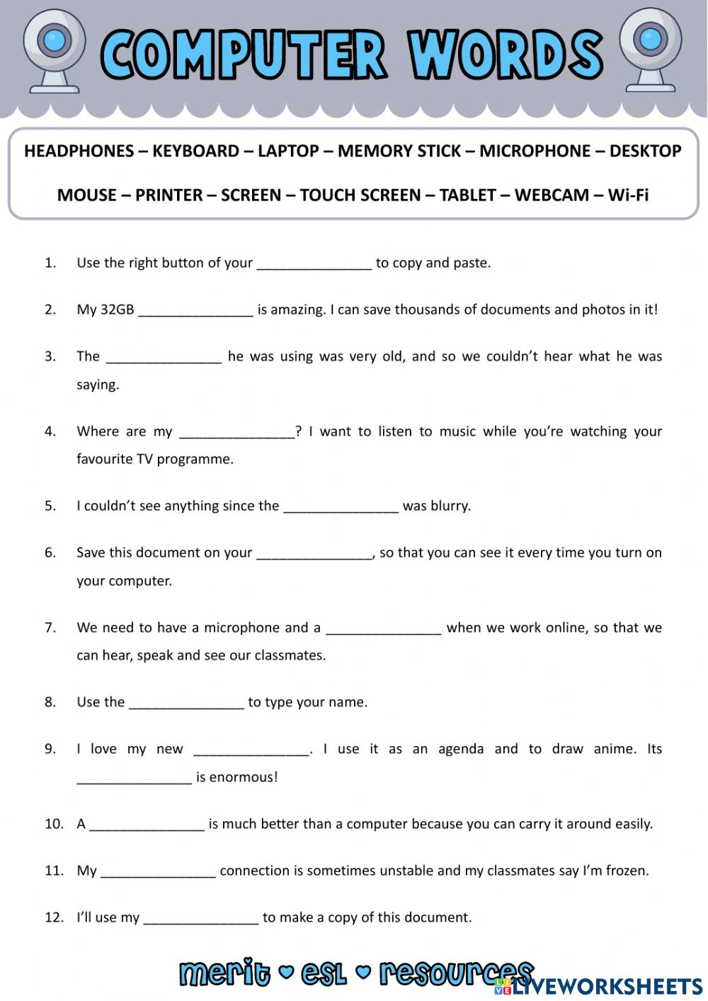

Answers :
- Mouse
- Memory stick
- Microphone
- Headphones
- Screen
- Desktop
- Webcam
- Keyboard
- Tablet
- Touch screen
- Laptop
- Printer

